Hilary – Level 3 Modern Pilates Instructor based in South Manchester, England

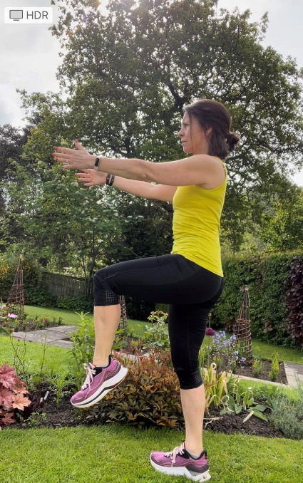 | 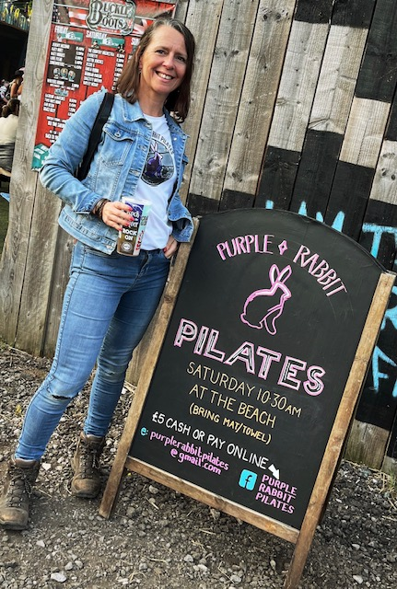 | 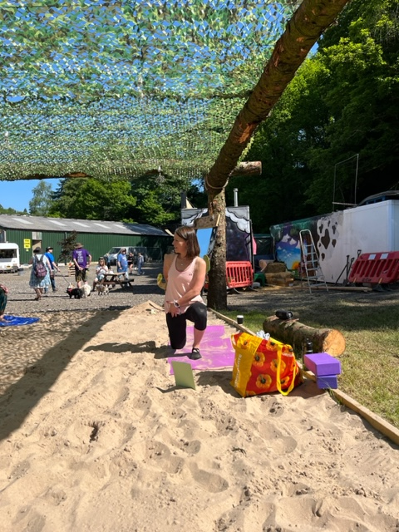 | 
Hilary’s love of Pilates developed whilst seeing a physio for a shoulder injury and she saw the results immediately - light bulb moment! Her passion grew and, with a desire to spread the love and pursue a major career change, she qualified as a modern Pilates teacher in 2018.
Pilates can work for everyone no matter what level of fitness as it improves stability, mobility, strength and flexibility throughout the body.
Pilates is crucial in maintaining good physical health at all stages of life as well as supporting more demanding forms of exercise. It is also fantastic for rehabilitation from injury in conjunction with physio therapy. My plan is to run, hike & bike into my old age!

