
Access statement - Pool
The Pool is accessed from the Visitor Centre Reception.
The clear opening width of the door from the changing room to Poolside is 840mm.
The opening force for the door is light.
Access to the pool side is step free.
Poolside showers are provided.
On entry the poolside is 1400mm wide.
Access into the pool is by stepped ladder.
Pool hoist available to users who require assistance.

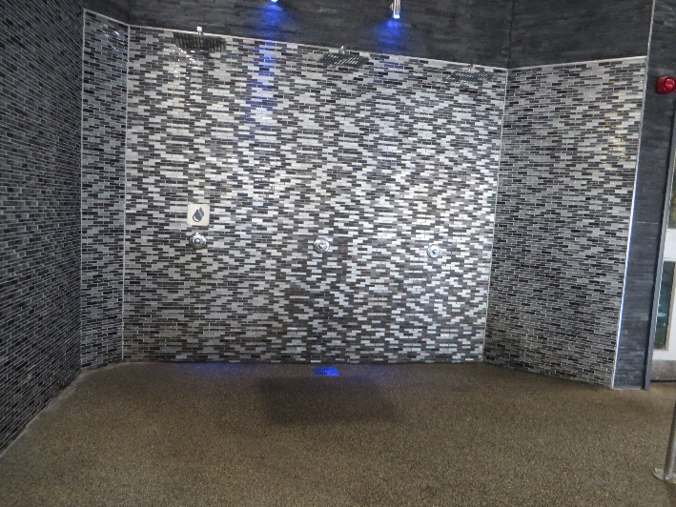 | 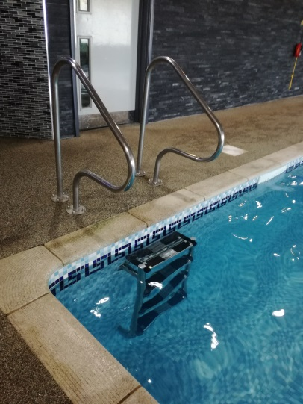
1. Poolside showers | 2. Stepped ladder access
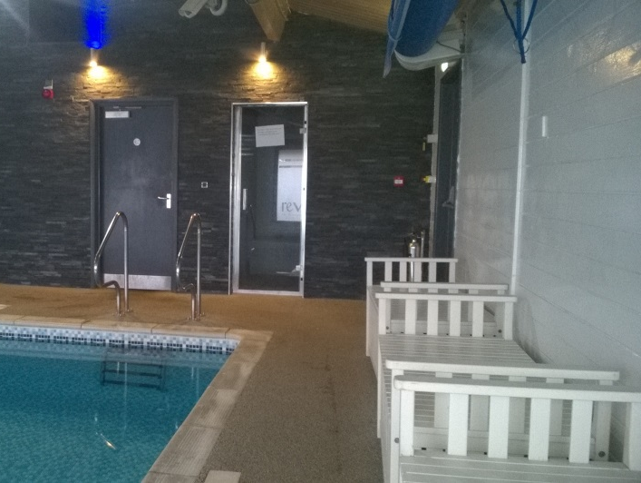 | 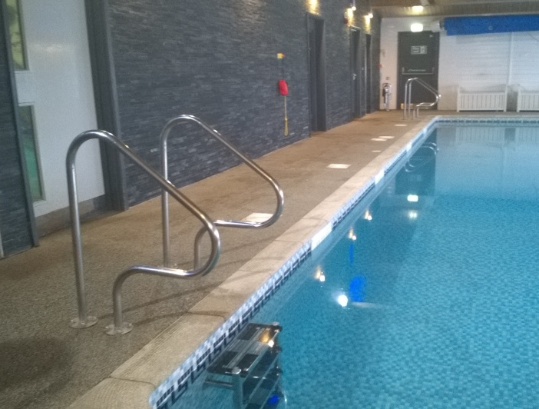
3. Pool side seats. | 4. Pool side
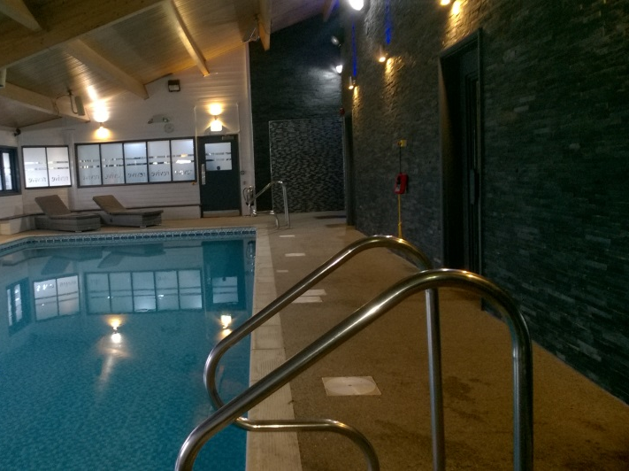 | 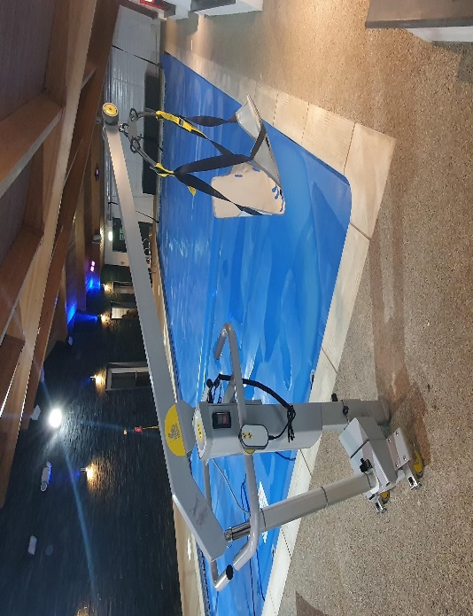
5. Poolside | 6. Pool Hoist

