
Charge your marker before classes start:
Charging a marker means teaching your dog that a specific sound (like a clicker or the word “Yes!”) predicts a reward. This helps in training by making communication clearer.

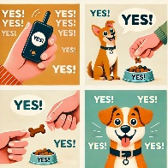
Step 1: Choose Your Marker
• A clicker (a small device that makes a clicking sound)
• A verbal cue, such as “Yes!” or “Good!”
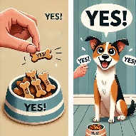
Step 2: Prepare High-Value Treats
• Use small, tasty treats your dog loves.
• Keep them ready so you can reward instantly.
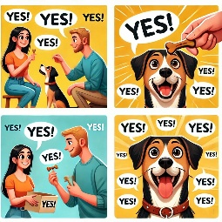
Step 3: Say the Marker & Give a Treat
1. Say “Yes!” (or click the clicker).
2. Immediately give a treat.
3. Repeat this without asking for any behaviour.
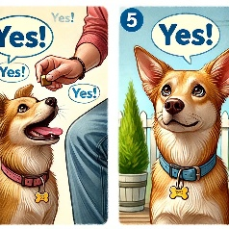
Step 4: Repeat 10-20 Times
• The dog starts to associate the marker with rewards.
• No need for commands yet—just build the connection.

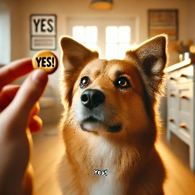
Step 5: Test the Marker
• Say “Yes!” or click without showing a treat first.
• If your dog reacts (like perking up or looking for a treat), the marker is charged!

Now You’re Ready to Train!

Once the marker is charged, you can use it to reinforce good behaviour—mark the exact moment your dog does something right, then reward.

