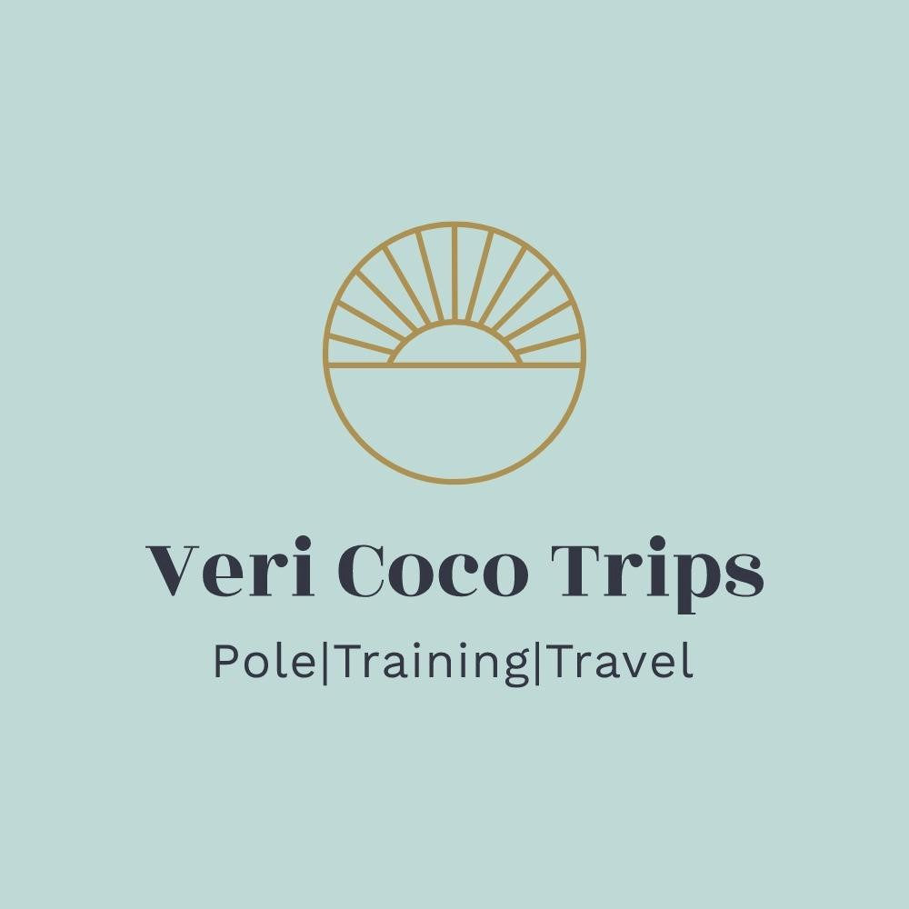
Veri Coco Trips – Lost In The Alps 2024 - Terms and Conditions
Lost In The Alps is a pole camp operated by Veri Coco henceforth referred to as “we” or “us”.

GENERAL
Lost In The Alps is a pole camp experience including pole, stretch and strength/conditioning workshops photoshoots and any other activities and excursions specified as part of your trip. The experience commences and ends on the dates and times specified on your trip itinerary.
Lost In The Alps is aimed at beginner-level through to early advanced polers. Please advise us of your training background and experience as we want to ensure our workshops can cater to all levels present.
To complement our offer, we arrange shared accommodation on your behalf (unless a solo supplement has been offered/paid) and airport transfers (at an extra charge) for specified and previously agreed flight times. Non-scheduled supplementary activities that you’d like us to arrange on your behalf will incur a supplement/payment as and when the activity is undertaken, i.e. you will cover the cost of your additional activity and any requirements you may have on your additional activity, such as your own lunch on a daytrip, as well as transport.
If you are booking onto the camp with another person, or a group you’d like to share accommodation with, you must advise us of this at least 28 days before departure so we can do our best in ensuring you can share.
Details of any additional costs that are not included in Lost In The Alps package are outlined below:
- The total package is based on you booking and paying for your own flights.
It is your sole responsibility to book your flight and we are not liable for any charges your flight may incur, any cancellations your flight may be subject to, missed camp days due to flight changes or booking issues, or additional overnight stays required as part of flight delays or cancellations. We will advise you of the flight options that are most cost effective for yourself. Transfers are available at an additional cost and can only be offered/booked if you are using one of the selected flights we have advised our groups are booking. If you choose to book on an alternative flight that has different arrival times or dates as the one specified by us, we will not be able to offer airport transfers to the resort.
- any food and drink that you choose to purchase. We respectfully ask you not to drink alcohol prior to and during workshops as no equipment may be used after alcohol consumption.
- any additional excursions or activities you choose to undertake outside of Lost In The Alps itinerary.
- any 1-2-1s or private sessions you wish to undertake with instructors while on your camp. You can arrange any private tuition in any discipline while on the camp by speaking to your instructors directly and they will be able to advise you on availability, times and pricing. If you arrange for private tuition, please ensure you have settled the balance with your instructor directly, before your private session commences.
- any additional professional photoshoot images aside from the number of edits included in your package. As standard, we include six free edits which you will be able to book. Additional images can be purchased from the photographer direct. For any images over the six included edits, you will be prompted for payment upon completion of the image gallery, which will be emailed to all camp participants 8 - 10 weeks after camp has completed. Please be aware that photoshoot slots are 15 minutes. Photoshoots will be available to book, along with your workshops around 8 weeks prior to travel. Please note that due to ever changing weather, we may need to re-schedule to an alternative time slot, should the conditions be unsuitable as originally planned.
- any of our additional ‘paid’ extras made available while on your camp - shower shoots.You can arrange these while on the camp by speaking to the organizers directly and they will be able to advise you on availability, times and pricing. If you arrange a ‘paid’ extra, you will be required to pay the balance with the photographer via paypal or bank transfer at the time of your booking.
The following equipment is available at each photoshoot location:
- Pole (38mm stainless steel static R-pole)
When it comes to photoshoots, please bear in mind that:
- It may be hot, it may be cold, it may be windy, it may be sunny.
- You may feel tired, sore and bruised from the training you have done leading up to it
- Poles may feel more slippy than usual due to sweating/climate conditions
- These are on location shoots, we cannot provide a fine art photoshoot due to the outdoor nature
- Other participants will be there at all shoots
- Photoshoots are held in public locations, please expect interested onlookers. Of course we ensure the environment is safe and comfortable but please be aware that other people will be around and present. Vaujany is a family resort and on our mountain shoot there is a cafe/restaurant in view. Onlookers may want to take photos and unfortunately being in a public setting, we are unable to stop this. At the Chalet our terrace is visible from the main road. With this in mind we will have to ask that no thongs are worn on either of the photoshoots and that top halves are modestly covered with a sports/pole top.
- Photoshoot prep sessions are available on camp and one 15 minute session MUST be booked/attended before your photoshoot slots, by ALL. . This is so you can perfect and practice your poses with an instructor and photographer present. We recommend keeping it simple. We will ask that you prep 3 poses per shoot and 2 back back up poses (so 8 poses total).
WIFI is available at your accommodation and may also be available at various cafés/restaurants in the
resort.
Participation in workshops and for our complimentary offer is entirely voluntary. You can stop at any time. You must advise us/your instructor prior to participation in any workshop or activity of any injuries or other conditions that may prevent you from safely taking part. If we believe a participant to be unsafe in workshops or during any other activity included as part of the experience, we will respectfully advise you of your limits. We reserve the right to ask anyone who continues to display unsafe practice or dangerous behaviour to leave or discontinue participation in any activity that we deem them unsafe in.
Pole grip is of course fine, but please be considerate to other camp participants. Clean your pole after use, especially if you have applied grip, this applies to workshops, open training sessions, prep sessions and photo shoots.
We want you to enjoy a nice trip, so we appreciate being informed of any issues that may arise in resort, please speak to us directly so we can rectify immediately.

PAYMENT
Your place on the camp is confirmed when your deposit payment is received via PayPal or bank transfer. For those of you who prefer an alternative payment method, please ask for BAC’s details. Deposit payments are strictly non-refundable and non-transferable.
Monthly payment plans are available through Eazy Collect. An admin fee will apply for any payment plan option. This will be £40 for the 6 month plans. This will be incorporated into your total price.
If you have sign up to a monthly payment plan and fail to pay your monthly installments without notifying us in a timely manner prior to missing or stopping your installments, or you miss a payment by more than 28 days, your space will be cancelled, and no refunds will be given for any payments made
thus far.
For payment in full options a payment request will be sent to you via email a week or so prior to the payment being due. If the balance is not paid within 10 days of the due date, a late fee of £25.00 will be applied to your account.

CANCELLATION
In the event of you cancelling your booking, no refunds will be issued. The trip is fully non-refundable.
If the camp is running full, we will do our utmost to sell your space and offer you the ability to transfer any funds (less the non-refundable deposit) to another trip. If we are not able to re-sell the space we are not able to offer any refunds - we will have paid for all hotel/workshops spaces and not able to get a refund ourselves.
Veri Coco holds no responsibility for missed and delayed flights or missed transfers. No refunds are given or alternative itineraries made for any part of the camp not attended by yourself as a result of delays by a
third party, i.e. your flight provider or means of travel you choose to arrive at your UK departure airport.

TRAVEL INSURANCE
It is your responsibility to organize your own travel, health and sport insurance. You MUST ensure that your insurer covers you to participate in pole and aerial classes, and any other fitness activities that may be included in your chosen retreat/camp - ie skiing etc. Travel insurance is a requirement, and you will be asked to refrain from participation until you can produce proof of the adequate cover. Prior to the retreat/camp, evidence of relevant insurance must be provided by sending a screenshot of your insurance cover and policy number. We may ask you to provide further proof that pole/aerial classes are covered within your policy. Please ensure you have the correct cover in case of disruption or cancellation of the event. If camp cannot go ahead as scheduled due to circumstances beyond our control, we will endeavour to offer alternative dates to provide camps at a later date.
A suggestion of providers who cover pole and aerial abroad are:
https://www.sportscoverdirect.com/sports-travel-insurance/
https://www.protectivity.com/sports-travel-insurance/
https://www.truetraveller.com/policyoptions (please check which pack includes aerial arts – extreme pack suggested)
You are required to forward your travel insurance document to Veri Coco at least 7 days before your departure date.

REFUNDS
Veri Coco is not liable for any disruption to the camp activities due to factors outside of our control i.e natural disasters, equipment lost in transit, illness, pandemics or bad weather. We will try to provide alternatives where possible and reserve the right to change the camp itinerary to accommodate
alternatives.
Veri Coco is not liable for any additional costs incurred by you in the event that any of our camps are cancelled due to circumstances beyond our control; this includes flight tickets, loss of work, travel and other expenses. We will ensure to offer transfers of the camp to a later date at no additional charge. No refunds are given for any activities you choose to sit out on while on the camp, or are unable to participate in due to circumstance, illness or injury.
LIMITS OF LIABILITY
Veri Coco is not liable for:
- Any activity you choose to undertake at your accommodation outside of workshop hours, or elsewhere in the resort is at your own risk, including use of the hot tub, sauna or posing for photographs on surfaces that are not intended for this purpose. Veri Coco is not liable for any accident or injury resulting from such activities.
- Any accident or injury during off site activities included as part of the trip. For our off site activities, we select locations that are public, accessible and provide facilities (food, drinks, toilets) for your well being and comfort. The mountain area for our photoshoot location is public.
- Any accident or injury arising at your accommodation and at any other premises. This applies to activities you wish to plan and undertake outside of those specified in your itinerary, as well as any scheduled complementary activities listed in your trip itinerary.
- Any changes in the itinerary we may have to make to compensate for bad weather. We want to ensure you get the most out of your experience, so this may mean we change the day and time of outdoor activities such as the photoshoots.
- Ensuring you have travel insurance and the appropriate cover, this is your responsibility. Please be advised that you agreed to purchasing travel insurance at the time of booking your camp with us. If you need medical attention and do not hold travel insurance, any direct medical costs are strictly payable by yourself in cash/by card at the time of treatment.

CONDUCT
Veri Coco is not liable for any additional activities you wish to plan outside of our itinerary.
We politely ask you to respect the premises and report to us any accident or damage immediately.
Do not use glassware and crockery in hot tub or sauna.
Please respect and abide by your accommodation rules and reception times. Please report to the organizers any issues you might have with your apartments or accommodation. In the event of you wanting to seek alternative accommodation, we are happy to help or advise but any upgrades or changes to accommodation in the resort are payable by yourself.
We trust all participants to be responsible adults who know their limits and act maturely. We are not responsible for how you behave while you’re on holiday. Please be considerate to others, camp organizers, instructors and the staff at your accommodation and generally in resort.

WORKSHOPS
The aims of our pole and aerial fitness, dance and stretch classes are to improve cardiovascular fitness, muscular strength and endurance, flexibility, and to learn new pole, aerial or dance moves. All sessions begin with a warm up. We will then learn a series of new moves and transitions. This will on occasion be followed by a routine or combinations. We finish with a cool down, incorporating stretches to improve
flexibility.
Please notify your instructor BEFORE the session of any injuries, illnesses or medical conditions, or if you feel that you are unable to take part in any element of the session. Throughout class, participation is completely voluntary, and any information given to your instructor is private and confidential under data protection legislation. Please ask as many questions as possible before and during the session, especially if you do not completely understand any move, stretch or position that is demonstrated.
Your instructor will always demonstrate safe technique, spotting and execution of moves as per current professional standards, and any adverse outcomes from wrong execution of moves are therefore under the individual participant's culpability. As with all exercise, pole and aerial fitness, stretch and yoga classes carry an element of risk. Pole and aerial fitness sessions may involve hands on spotting to ensure safety and minimize risks. If you do not want to be spotted by another individual, you must inform your instructor. You may experience some bruising or burn from pole and aerial equipment, and feel achy or sore for a few days after a session. Sessions have been designed to minimize risks, and with continued practice your body will become conditioned to the movements involved. If, at any point during the session, you feel pain or discomfort, you MUST notify your instructor immediately.
A lot of our students enjoy documenting their progress via videos and photos. Often they choose to upload these to social media which may then be shared by Veri Coco Trips and The Pole Fitness Academy on social media platforms. Please inform your instructor if you do not want to be seen in the background of a fellow student's photo or video to ensure fellow class participants are aware not to accidentally film anyone who does not want to be recognised. By participating in workshop photography/videography and/or by tagging Veri Coco and/or hash tagging photos on social media with #vericocotrips or any other affiliated hashtags, you hereby release all rights to Veri Coco for promotional purposes, unless otherwise explicitly stated by yourself.
You agree to remove all rings, bracelets, necklaces and watches before participating in any of our pole and aerial sessions. Please do not moisturize before the pole workshops, open training sessions, prep sessions or photoshoots and do not wear any zips or long sharp nails before using aerial fabric, such as
pole silks..
Please be aware that some sessions may be taken outside and that temperatures may be warm. We will endeavor to hold workshops and other physical activities during cooler times of the day whenever
possible.

HEALTH QUESTIONNAIRE
You hereby agree:
- to remove all rings, bracelets, watches and necklaces prior to taking part in any of our classes.
- not to moisturize before a pole workshop, open training session or photoshoot
- to report to your instructor BEFORE your session commences, of any injuries, aches and pains, pregnancies or any other conditions that may prevent you from safely taking part.
- no long sharp nails if you are taking an aerial yoga or other aerial fabric class.
- to inform your instructor of any circumstance that may require tweaking of the lesson content/activity.
You hereby agree to seeking medical advice PRIOR to taking part in any of our classes if you suffer from:
- Heart conditions or chest pain.
- High or low blood pressure.
- Faintness or dizzy spells.
- Asthma.
- Diabetes.
- You are postnatal.
- Have had any operations in the last year.
- Have had/are having any recent injuries.
- Bone or joint problems.
- Are taking prescribed medicines or dietary supplements.
- Have any other medical conditions not previously mentioned.
To ensure the safety of our class participants, Veri Coco/your instructors reserve the right to offer you lesson content that differs from other participants in the group.
Depending on your medical history, we may need a doctor's note for clearance to take part in our pole, aerial fitness, stretch or dance classes.
If you are taking prescribed medication or supplements, please ensure you bring enough for the duration of your stay. There are pharmacies in the resort, as well as several clinics and doctor’s offices.

DECLARATION
During the booking process on BookWhen, you will be asked if you agree to our terms and conditions. By selecting YES, you are agreeing to the terms and conditions laid out above. By selecting NO, we will not be able to accept your booking and this will be cancelled and email notification sent to you.

