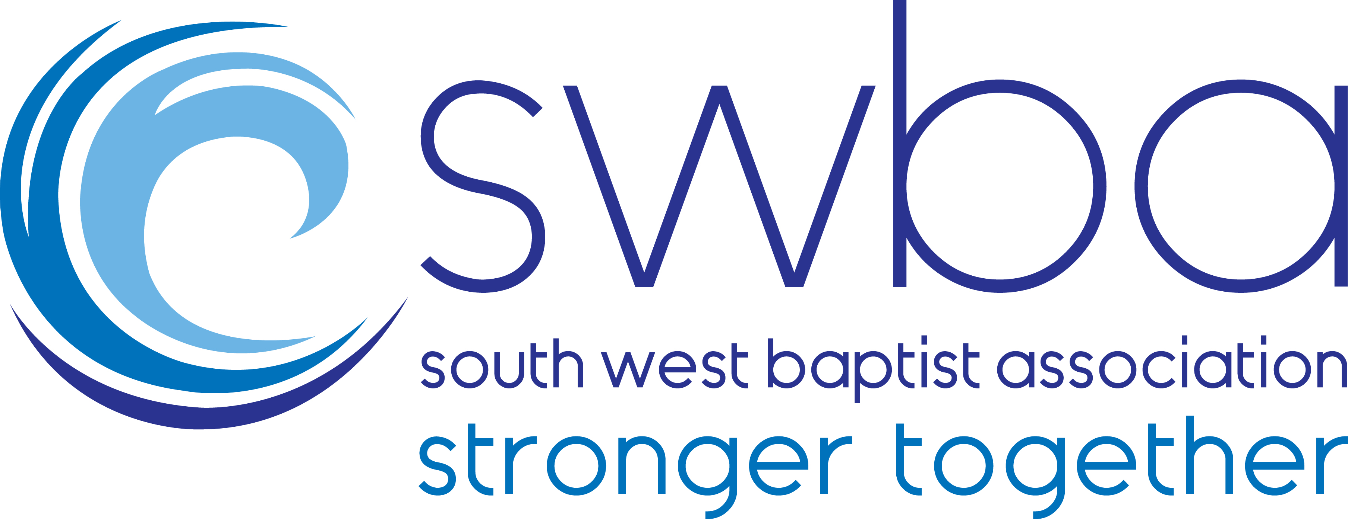
SWBA Ministers’ Conference
The Esplanade Hotel, Newquay
Monday 3 – Wednesday 5 February 2020

BOOKING FORM

PERSONAL DETAILS

Your name (as you wish it to be on your badge):
Name of church or organisation:
Email:
Telephone:

RESERVATION Resident or Day Visitor?

Resident (Please delete what does not apply)
I will attend the whole Conference by myself
My spouse and I will attend the whole Conference together

Spouse’s name (if attending) ___________________________________________

Day visitor
I will attend at the following times: (Please delete what does not apply)
Minister Monday afternoon/evening Tuesday all day Wednesday morning
Spouse Monday afternoon/evening Tuesday all day Wednesday morning

ROOM ALLOCATION

All rooms are en-suite and single occupancy unless you are coming with your spouse.
If you are coming with your spouse, please indicate your preference below by deleting
what does not apply.

We prefer a Twin bedded room
We prefer a Double bedded room

DIETARY REQUIREMENTS
If you have any dietary requirements, please give details below:

ADDITIONAL NEEDS
Please tell us here if you have any access/disability needs e.g. ground floor room, or any other additional need.

BABIES & CHILDREN
If you wish to bring a baby or toddler, please give the name and age of the child at the time of the Conference and state if you would like a cot and/or highchair provided.

PAYMENT Charges are per person

Resident:
Minister £180
Spouse £120
Additional supplement for seaview room £20 total per room
Seaview rooms are limited and will be allocated on a strictly ‘first come first served’ basis on receipt of booking form and payment. More information about seaview charge in the Information Letter.

Day Visitor:
Monday afternoon/evening: £50 (includes dinner)
Tuesday all day: £70 (includes lunch and dinner)
Wednesday morning: £40 (includes lunch)

Additional Gift:
We would also like to ask each church to consider making an additional voluntary gift to assist ministers who would like to attend but whose church cannot afford to pay the full cost. We use these gifts to offer a number of part-funded places each year.

Minister £ ……….
Spouse £ ……….
Seaview supplement £ ……….
Additional gift to help others £ ……….
£ …......... TOTAL

Please select one option below by deleting what does not apply.

I enclose a cheque (made payable to South West Baptist Association)

I confirm that an online payment has been made by myself or my church
For online payments please put “Conference” and your surname as the payment reference.
Account name: South West Baptist Association
Sort code: 40-52-40 Account number: 00014168

Please return this form by post or email with payment by Friday 10 January to:
Kathy Browne, SWBA, 36-38 Wonford Street, Exeter EX2 5DL or kathy@swbaptists.org.uk
Please save a copy of your form if sending by email.

Confirmation of your booking
Confirmation will be sent once payment has been received.
Payment in full is required at the time of booking.

Cancellations
Please see our cancellation & refund policy in the Information Letter.

