ELLINGHAM INCLUSIVE WATER SKI & WAKEBOARD
Charity No 1188126
How to make a booking
Add dates to your ‘shopping basket’ (‘Select’ button on the right)
Go to your basket (click on trolley icon at top of page)
Click Book Now to start entering your details
Click Pay by Card or Complete Booking to finish

- Go to the booking website: https://bookwhen.com/eiww
* Please note that if you are booking for more than one person and each needs to pay separately then you will need to book all the sessions for one person and pay before moving on to the next person. *

- The system works like a shopping basket and checkout. Click on the first date and time period you want to book on the left hand side of the page and then click the blue Select button on the right. This puts the session in your basket (look at the top right to see how many sessions you have selected).

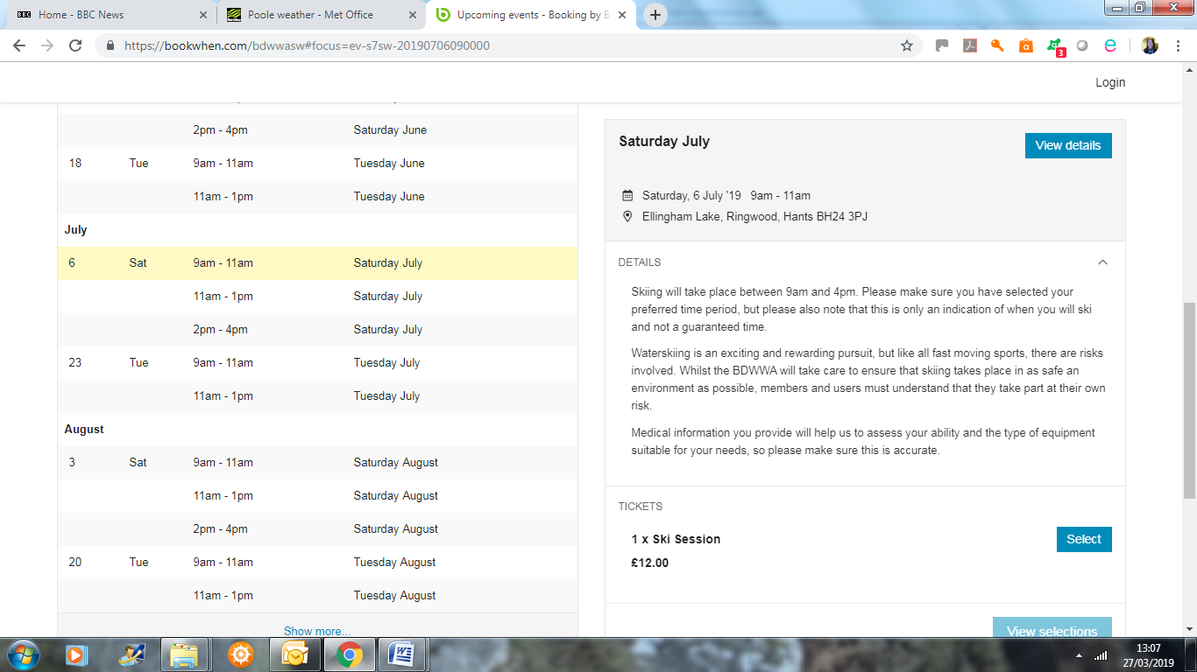

- Continue to book other dates and time periods, clicking the blue Select button each time.
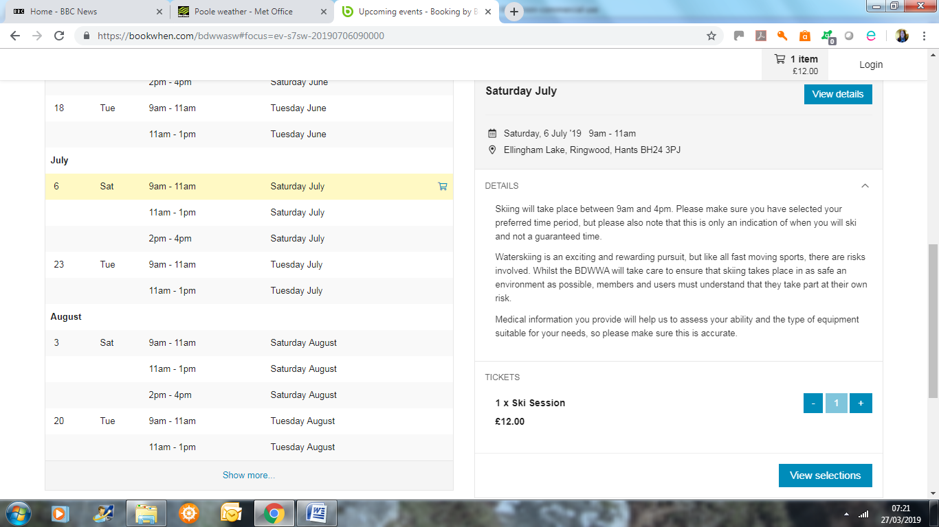
- When you have selected all the required dates click View Selections (or the shopping basket icon at the top) to go to a list of all your dates. You can delete any dates from the list or go back and add other dates.
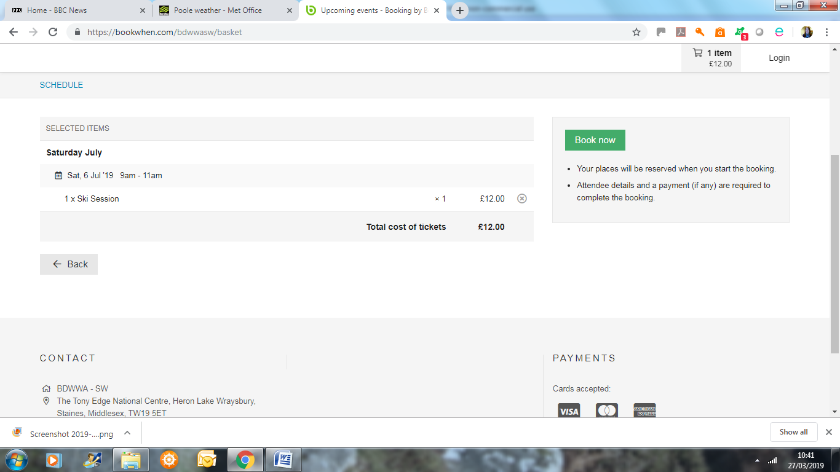

- When you have finished selecting dates, click Book Now to complete your booking.
- Enter the email address where confirmation details should be sent. (NB If you are booking for the residents of a supported living house, this should be the manager or Senior of house, to ensure that all communications are received.) Click Continue.

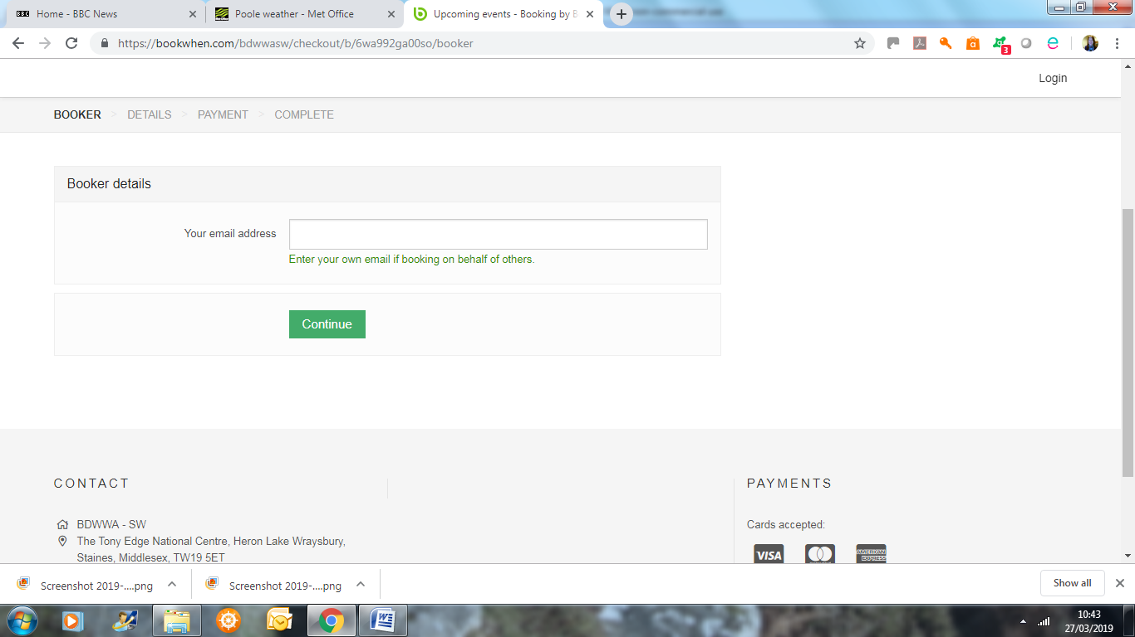
- Enter the contact information for the person you are booking for. (You do not need to enter an attendee email address unless you want them to receive information about the booking as well)
.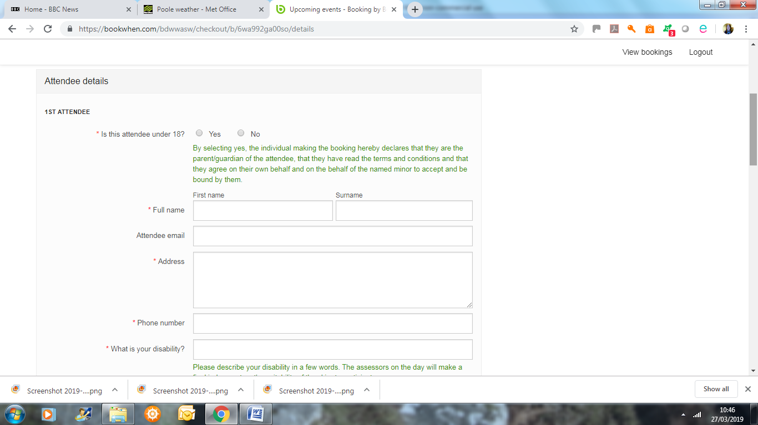

Answer all the ability and health questions about the person you are booking for.

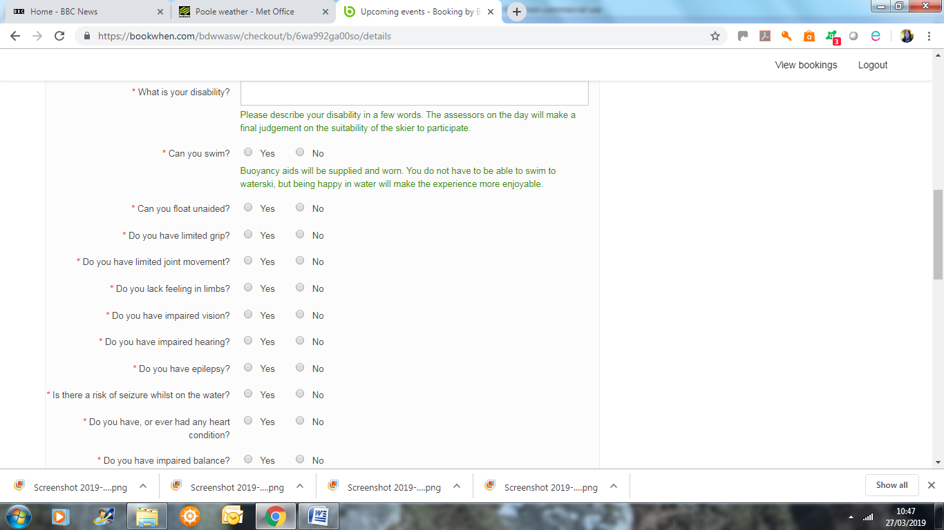

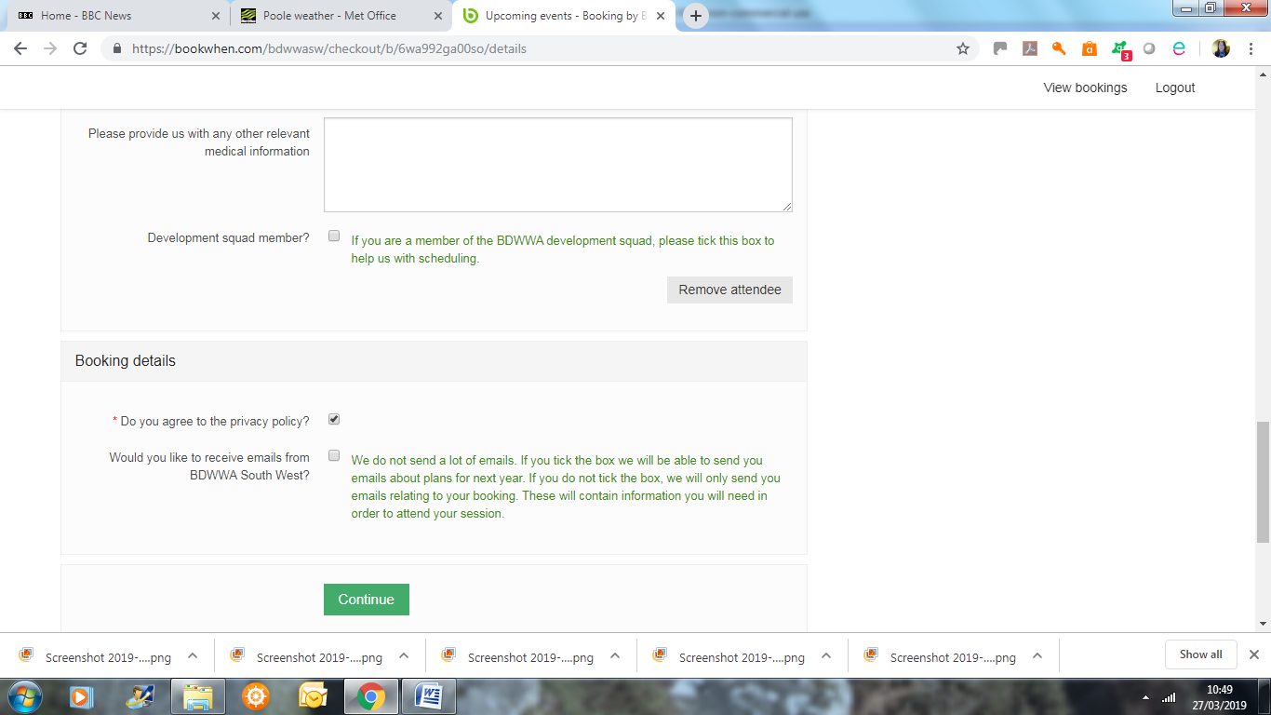

Complete the data privacy questions and then click Continue (ignoring the option to add another attendee).

- Select Pay by Card if the person you are booking for has a credit or debit card. You will be taken to our secure payment partner to enter payment details. Skip step 9.
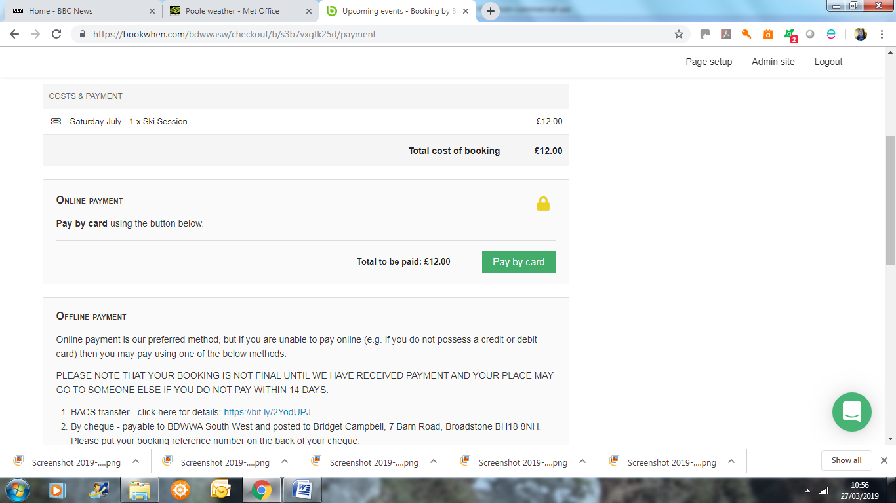
- If you cannot pay by card then scroll down to the Offline Payment information, click on the link to the instructions for paying by bank transfer or note the instructions for paying by cheque and then tick ‘Agree offline payment terms’ and click Complete Booking.
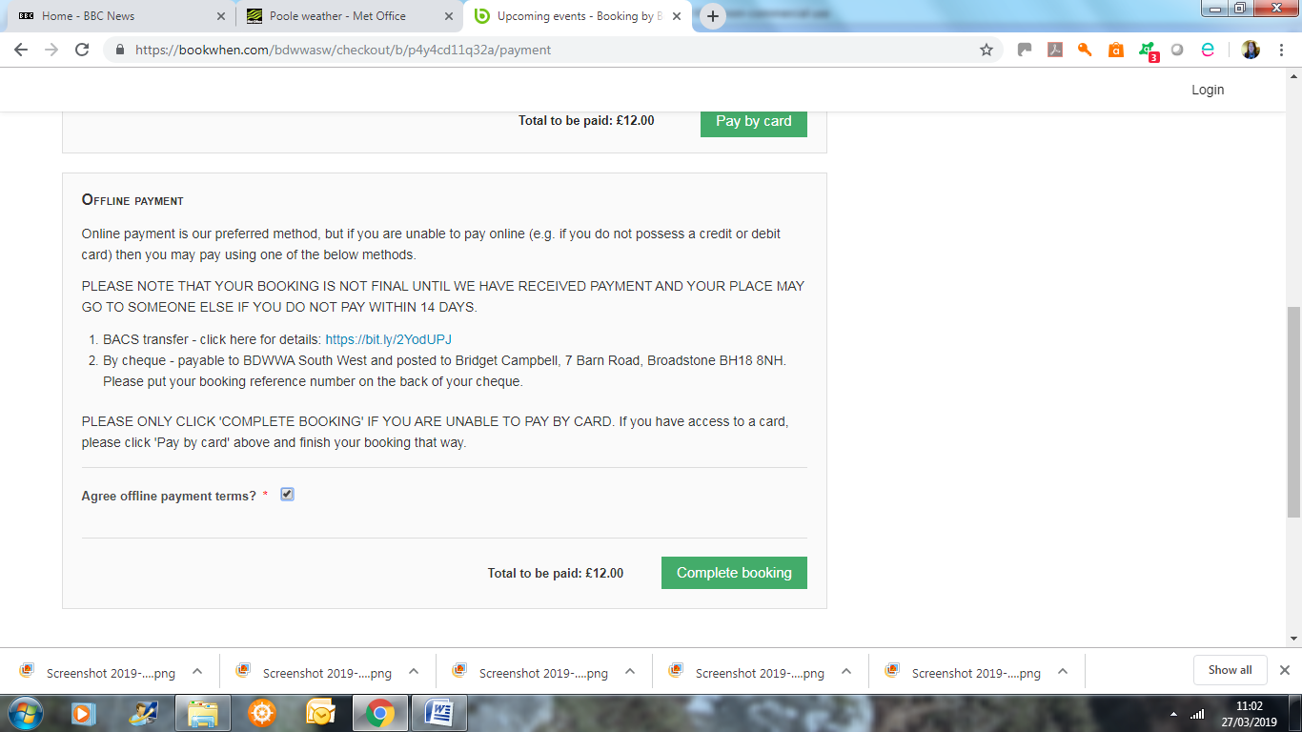

- You will get a reference number for your booking and will be asked to set up a password. This is optional but will mean that the system remembers the attendee details for future bookings.

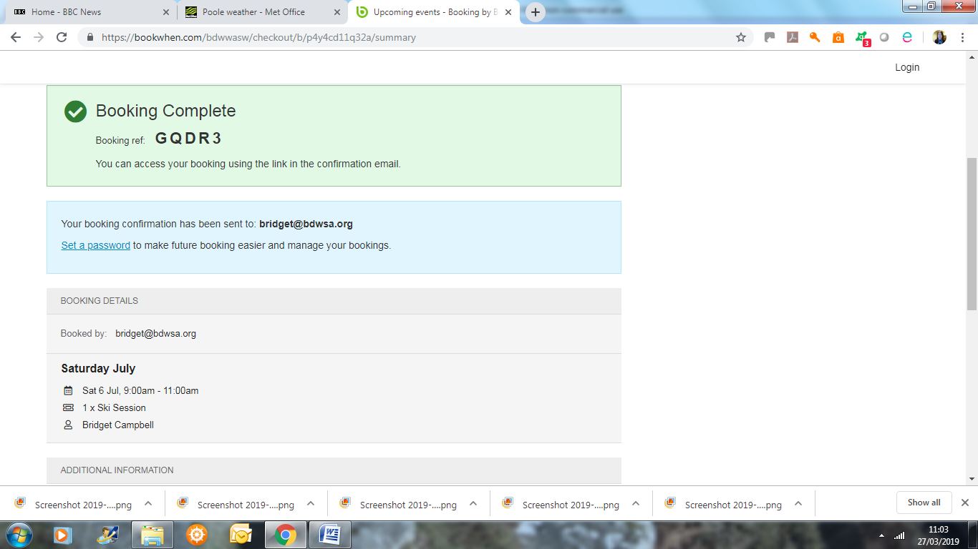
- A confirmation email will be sent to the main contact email address.
- If you want to book sessions for another person click on the ‘Return to Schedule’ link at the bottom of the page and repeat the process from step 3. The system will remember your booking contact details for the other attendees.
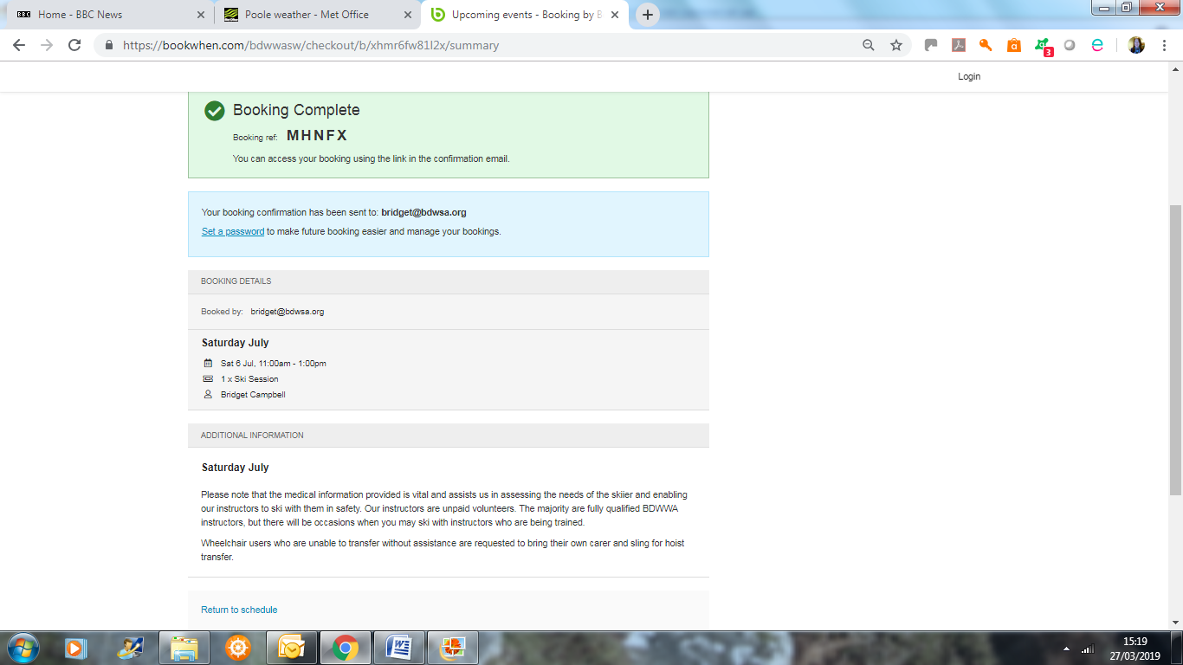

- You can use the View Booking link in the confirmation email to return to view your booking at any time. If you did not set up a password before, you can click the link in the blue box on the right hand side to set up a password. If you want to book further sessions then click Open Schedule and start again from step 3.
