West Lothian College – 5K Race 2026
Route Description – 5K Run (5000 Metres)
This five-kilometre course has been accurately measured and will be fully marshalled throughout. The route comprises a variety of terrains, including tarmac paths, trail sections, and brief road segments. Participants are reminded that this route incorporates shared public pathways—please be courteous and give way to other users at all times.
Caution is also advised on uneven surfaces, particularly on trail sections and gradients.
Key Safety Information:
- The route is shared with the public—please give way where appropriate.
- Take extra care on uneven or sloped sections of the course. There are three notable short hills throughout the course.
- Marshals will be positioned throughout to assist and ensure runner safety.
- First aid and hydration facilities will be available at the start/finish area.
The West Lothian 5K Road Race is a Scottish Athletics licensed event and will be held under UK Athletics Rules of Participation.
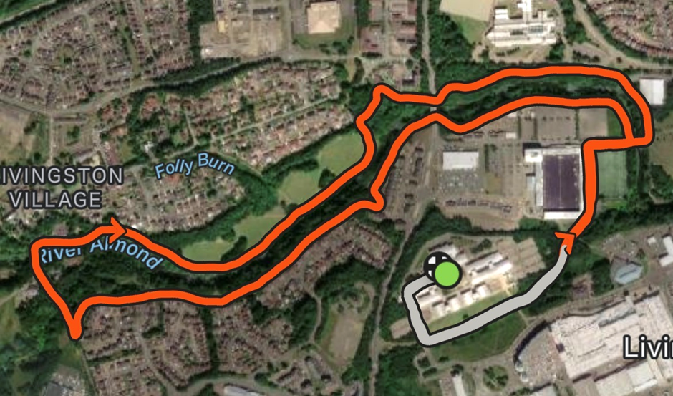
Runners will start the race outside Building 1 on the college campus. From there, they will follow the public footpath at the bottom of the campus leading towards Livingston FC Stadium. Participants will run around the outside of the stadium’s astro pitch before turning left onto the River Almond Trail just before the blue bridge.
The course then follows the River Almond Trail in a clockwise direction. Runners will continue along the trail until reaching Charlesfield Lane, where they will turn right and join the public roadway heading towards the Livingston Inn. After crossing the bridge, runners will turn right, pass the public MUGA pitch, and rejoin the River Almond Trail.
The route continues along the river until runners turn right just before the West Lothian Indoor Bowling Club. They will then take another right to cross the blue bridge, heading back towards the college. From Livingston FC Stadium, runners will retrace the same route back across the campus grounds, finishing at the same location as the start line outside Building 1.

