Namaste and Welcome to Hazel Lily Yoga
A Holistic, Nurturing Approach to Yoga, Wellbeing, and a Happier You

Qualified Sanatan, Classical Hatha, Jnana & Raja Yoga Teacher | Yoga Alliance Professionals Certified Teacher (400 hours)| Yoga Alliance Professionals Insured

Important information about Hazel Lily Yoga In-Person Yoga Sessions & Covid-19
As of 28 March 2022 all legal requirements (in relation to in-person yoga) have been eased:
Recommendations and actions to best keep our yoga community safe…
- Keep Hazel up to date of any existing or newly developed health issues / concerns
- Agree to the below Hazel Lily Yoga Class Attendee Agreement prior to sessions
- Please bring your own mats and blankets for hygiene reasons
- Window vents to be kept open where possible to maximise movement of fresh air
For the safety of both student and teacher …
- Strongly advisable to remain at home and not attend the class if experiencing, or have experienced in the last 7 days, any Covid-19 symptoms
- Wash or sanitise your hands prior to the class
- Bring your own yoga mat, blanket & water bottle
- Book and pay prior to the yoga session
- If you are unable to attend please let Hazel know ASAP
- Advisable to clean your mat before and after class using wipes, or yoga mat spray
- Antibacterial wipes will be available for you to take before/after the class
And, as always please …
- Wear comfortable clothing for gentle movement (eg. t-shirt + jogging bottoms)
- Arrive on time – 5 minutes before for is ideal
- Be kind to your body. Listen to your body and know your limitations.
- If you have any physical or health issues please let me know ASAP
- Enjoy your time with Hazel Lily Yoga ☺
Hazel Lily Yoga Class Attendee Agreement:

I confirm I am 18 or over, and I will take responsibility for my own body in class and if I do have health issues I have consulted with my GP and my GP is happy for me to attend yoga classes. If there is any update to my health I will inform Hazel Lily Yoga ASAP. I am aware of the increased risks of partaking in yoga classes within the current climate, and take personal responsibility to ensure risks are minimised for myself and others by adhering to Welsh Government legislation and recommendations outlined in Hazel Lily Yoga guidance at all times. I understand Hazel Lily Yoga Classes are non-refundable / transferrable. Transfers may be considered if unable to attend due to developing covid-19 symptoms.

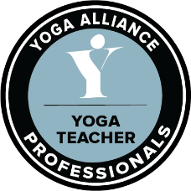
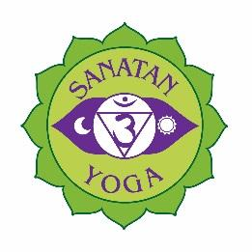
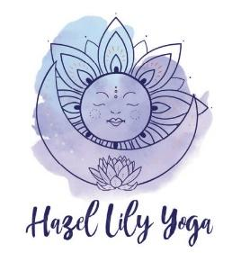
Contact Hazel Lily Yoga: website: hazellilyyoga.weebly.com| mobile: 07791 608314 | e: hazellilyyoga@gmail.com

