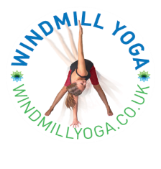
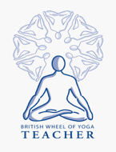 Yoga moves, bends, stretches and empowers bodies and minds!
Windmill Yoga classes will bring the benefits of yoga to children in a fun and playful way. Through games, postures, story-telling and child-friendly relaxation techniques, the children will benefit from:
- Improved balance and body awareness
- Improved posture and alignment
- Increased concentration, focus, attention span and memory
- Increased confidence and self-esteem
- Increased creativity and imagination
And they will learn skills to enable them to:
- Calm and clear the mind
- Reduce tension, stress and anxiety
- Lead a fit and healthy lifestyle
- Sleep!
Children can wear school. Yoga is practised barefoot.
General Class Structure:
- Settling in
- Sun Salutations sequence
- Story/theme/game
- Calming/Relaxation
- Please complete the form below and return to the school office or to me, via email.
_____________________________________________________________________________

Little Windmills Yoga Registration Form

All information given will be treated in the strictest confidence and stored in accordance with Data Protection legislation.

Child’s Name: | Age/ Date of birth:  (please circle) Reception Year 1 Year 2 Year 3 Year 4 Year 5 Year 6
Home telephone number:  Mobile number: | Name and number of person(s) to contact in case of emergency  Name: Number:  Name: Number:
Known allergies/ physical limitations/ concerns:  Permission for photos, may be used on social media. Yes/No | Parent/ Carer Signature:  Date:

