
EVENT LOCATION AND GETTING HERE
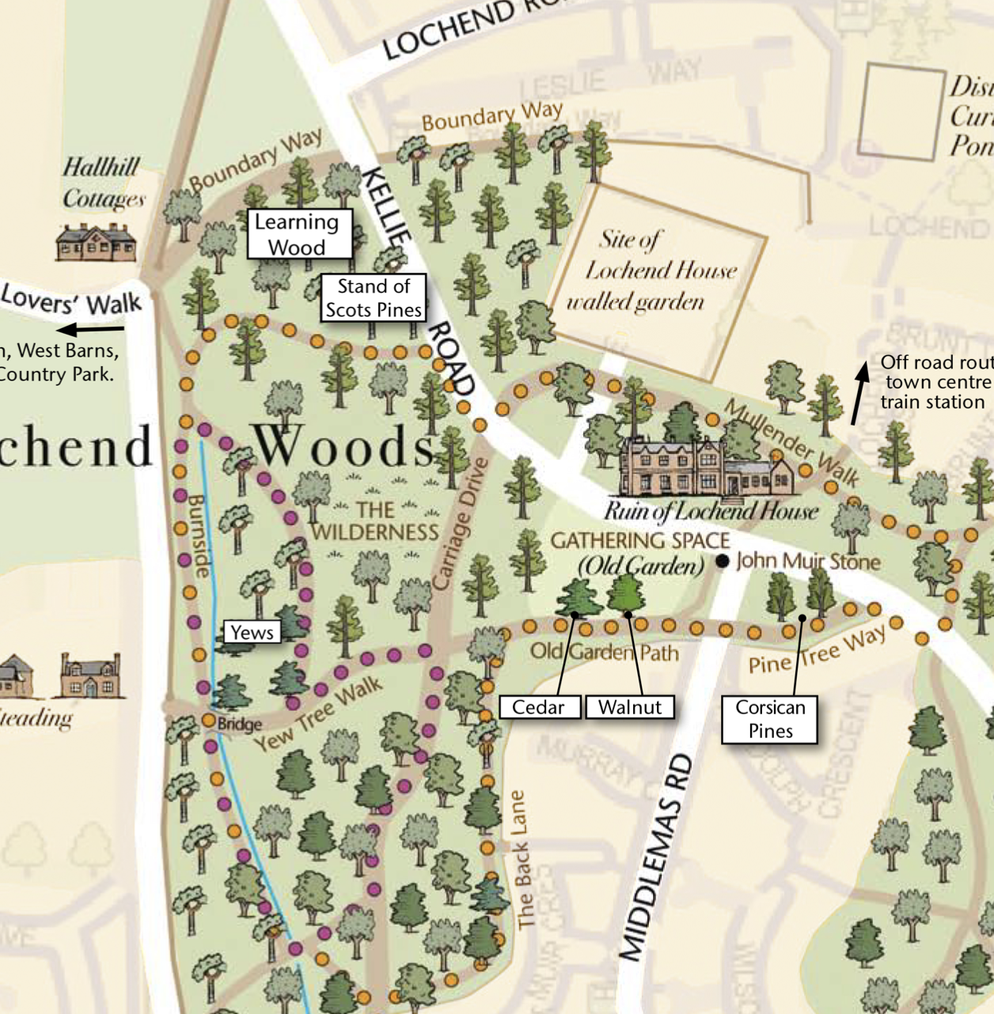
We’ll meet event attendees on Kellie Road (between Middlemass Road and Halhill) – just look out for the Wilder green flag and trailer. We’ll be based in the Wilderness Area where there is plenty of space to offer Shelter and fire. Please consider your journey to the woods – if possible come to us on foot or by bike. If driving please park at Halhill which is a short walk away! Please avoid parking on Kellie Road particularly at the Middlemass Road junction. Thanks.

