**21st Oct to 26th Oct 2023 (five nights)**

**Lower Largo, Fife, Scotland**

**Teacher: Annamaria Sacco – Body Symphonies**

*Join us for a holistic retreat on the beautiful Fife coast that will nourish your body, mind and soul.*

A highly experienced and warm-hearted teacher, Annamaria skilfully weaves aspects of yoga philosophy and physiology into her asana and pranayama classes.

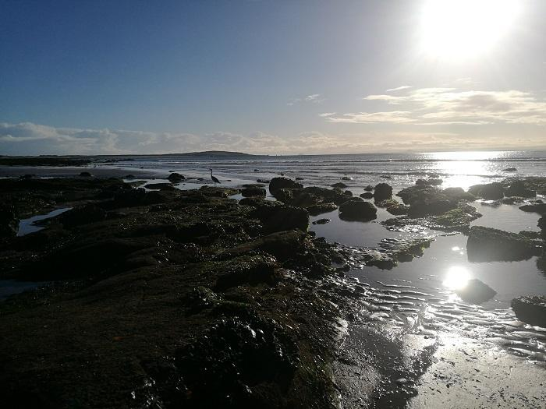We aim to create a friendly and welcoming environment. You’ll have time to yourself for quiet reflection. Take a walk along the coast, enjoy the beautiful beaches and wide-open skies, or chill out with a book in the luxury accommodation. If you’re feeling brave you can even take a dip in the sea.

If you’re a foodie, this is the retreat for you. On retreat we nourish ourselves both through the practice and diet. Using local, seasonal produce we cook delicious meals together, all vegetarian and often gluten-free. We can cater for some allergies and intolerances.

The retreat is located in an impressive house by the sea, converted to offer a modern and spacious venue for yoga and relaxation. Accommodation is in comfortable twin rooms, most of them ensuite.

**Level**: open to all 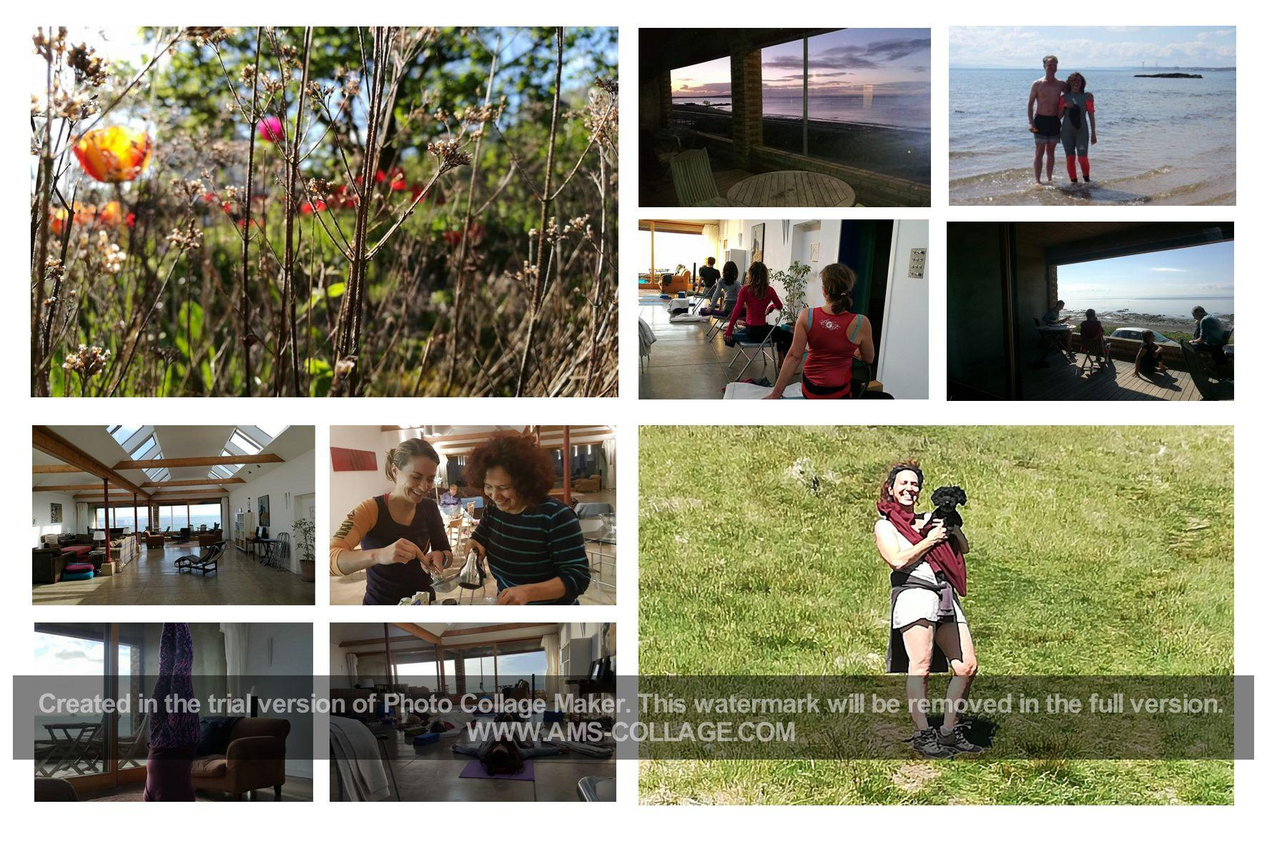

**Cost: full price** £650**. Single** room £790. Please note that single rooms are limited and are offered on a first come first served basis.

**Arrive**: evening of Saturday 21st October. **Depart**: from 10am on Thursday 26th November.

**Format**: Three classes per day. Three vegetarian meals per day plus dinner on arrival, and breakfast and one class on the last day. Maximum of 16 participants.

**Travel**: Lower Largo is about an hour and a half from Edinburgh by car. The nearest train station is Kirkcaldy. We can arrange transport from the station on arrival for a small additional cost. 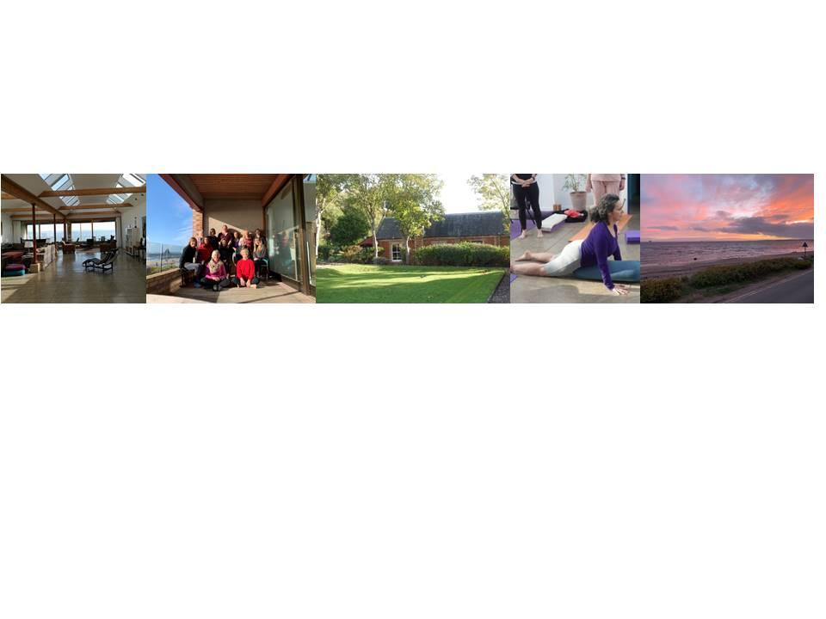

**About Annamaria Sacco**   
Annamaria started practicing Iyengar Yoga in 1991 and became an Iyengar yoga teacher over 20 years ago, reaching Level 3/mentor level. Over the years Annamaria studied with several senior Iyengar yoga teachers all over the world, as well as the Iyengar family in Pune, and completed a three-year remedial yoga course. Her main inspirations in Yoga are Firooza Ali Razvi and Christian Pisano. The way Annamaria teaches now, although rooted in the Iyengar tradition, has moved away from it to embrace her own practice, what her students have taught her, as well as her own life experience and how Yoga has been woven throughout. Her teaching voice focuses on encouraging an individual spirit of listening, of enquiring, of feeling through the body to reach the soul. Her main teaching ambition is to foster independent, feeling, discerning spirits.   
Annamaria is also a craniosacral therapist and has studied core process psychotherapy and other specialised trainings over the years.

**Registration for YOGA RESIDENTIAL RETREAT FIFE 2023**

|  |  |
| --- | --- |
| Name |  |
| Address |  |
| Contact Phone no |  |
| Email |  |
| Yoga Experience |  |
| Health Issues |  |
| Date of registration |  |
| Cost | Full price: **£650 Twin room. Single room** £790 |
| Deposit due now | **£250** by bank transfer.  Please use **FAS23**as a reference, followed by your surname.  Sort code: 835100  Account number: 10435683  Bank: RBS  Account name: Annamaria Sacco |
| Balance due | Ten weeks before the retreat: 14th August 2023  **Terms & Conditions**  The deposit is non–refundable unless you can find someone to take your space, or if we have someone to replace you from a waiting list. |

Please email this form to retreats@bodysymphonies.co.uk or post to the address below.