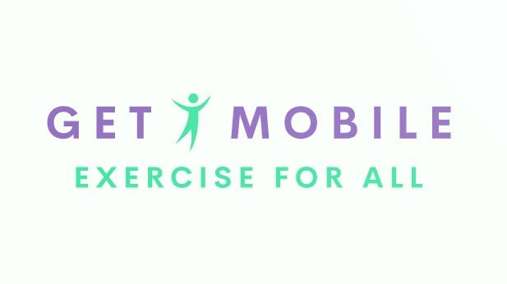

Physical activity readiness questionnaire (PARQ) and you
Our classes are designed to increase your heart rate gradually. Offering low impact and high impact options to suit your needs. The instructor will be aware of your physical fitness level and ensure you are working at the right pace for you.
Regular physical activity is fun and healthy, and more and more people are starting to increase their daily activity levels. Being more active is very safe for most people. However, some people should check with their doctor before they make drastic increases to their activity levels.
If you are planning on becoming much more physically active than you are now, start by answering the seven questions in the box below. If you are between the ages of 15 and 69, the PARQ will tell you whether you should check with your doctor before you start. If you are over 69 years of age and you are not used to being very active check with your doctor.
Common sense is your best guide when you answer these questions. Please read the questions carefully and answer each one honestly: check ‘YES’ or ‘NO’.

 | YES | NO
Has your doctor ever said that you have a heart condition and that you should only do physical activity recommended by a doctor?
Do you feel pain in your chest when you do physical activity?
In the past month, have you had chest pain when you were not doing physical activity?
Do you lose your balance because of dizziness or do you ever lose consciousness?
Do you have a bone or joint problem (for example, back, knee or hip) that could be made worse by a change in your physical activity levels?
Is your doctor currently prescribing drugs for your blood pressure or heart conditions?
Do you know of any other reason why you should not do physical activity?
Do you have Asthma?
If you answered YES to one or more questions:
Talk with your doctor by phone or in person before you start becoming much more physically active or before you have a fitness appraisal. Tell your doctor about the PARQ and the questions to which you answered ‘YES’.
- You may be able to do any activity you want – as long as you start slowly and build up gradually. Alternatively, you may need to restrict your activities to those which are safe for you. Talk with your doctor about the kinds of activities you wish to participate in and follow his/her advice.
- Find out which community programmes are safe and helpful for you.

If you answered NO to all questions:
If you answered ‘NO’ honestly to all PAR-Q questions, you can be reasonably sure that you can:
- Start becoming much more physically active – begin slowly and build up gradually – this is the safest and easiest way to go about it.
- Take part in a fitness appraisal – this is an excellent way to determine your basic fitness so that you can plan the best way for you to live actively. It is also highly recommended that you have your blood pressure evaluated. If your reading is over 144/94, talk with your doctor before you start to dramatically increase your physical activity levels.

DELAY BECOMING MUCH MORE ACTIVE:
- If you are feeling unwell because of a temporary illness, such as a cold or fever, wait until you feel better.
- If you are or may be pregnant talk to your doctor before you become more active.

PLEASE NOTE:
If your health changes so that you then answer ‘YES’ to any of the above questions, tell your fitness or health professional. Ask whether you should change your physical activity plan.

“I have read, understood and completed this questionnaire. Any questions I had were answered to my full satisfaction”.

Name: Signature:

Date:

Signature of parent or guardian (for those underage):

Phone number:

Email:

Next of Kin: Phone number:

NOTE: This PAR-Q is valid for 12 months from the date of completion and becomes invalid should your condition change so you would answer YES to any of the above questions.
Adapted from PAR-Q (2002) The Canadian Society for Exercise Physiology

