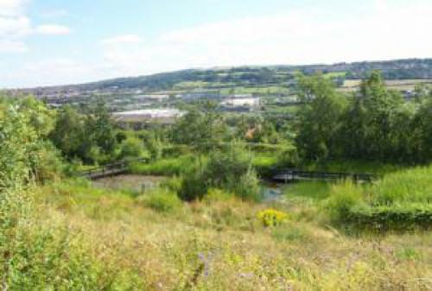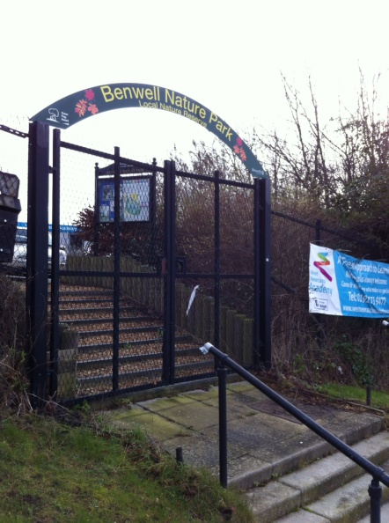

**Benwell Nature Park**

Benwell, Newcastle

NE4 8XT

Tel: 0191 278 7878

Benwell Nature Park is owned by Newcastle Council and is currently used by West Newcastle Academy.

The main car park for West Newcastle Academy is on Armstrong Road and is available for parking (see X on map), although be aware school pick up is a busy time and spaces may be limited. Alternatively on street parking is available on Atkinson Road (B1305). Do not park on Pipe Track Lane or in the old car park at the Nature Park as this is hazardous for children leaving the local schools.

We are on Stagecoach bus route 1 from Central Station in Newcastle. Telephone Nexus Traveline on 0871 200 2233 for up to date information.

As the site is in use by the primary school, we will meet at 3.45 in the old car park at the Nature Park, standing clear of the school gates.

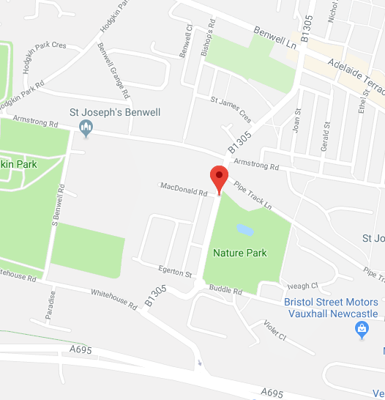



OS Grid ref: NZ216638

**Nearest hospital**

RVI, New Victoria Wing, Queen Victoria Road, Newcastle Upon Tyne, NE1 4LP

0191 2336161