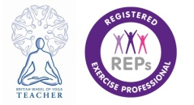
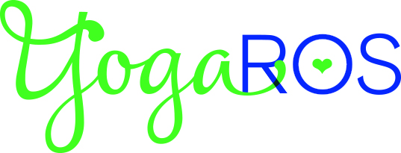
Hi – I am Rosalyn Griffith, owner of YogaRos, and I’ve been involved in Yoga and Pilates for over 18years and teaching both disciplines for almost 14years. I am highly trained and experienced with a passion for Anatomy, Embodiment and Mindfulness, providing you with clear alignment guidance while facilitating your own inner awareness. You will also benefit from my skills as a Somatic Movement Education Coach as I would love YOU to reach your Full Potential.
YOGA involves the practice of Asanas (postures) which help to bring about a strong and sound body while training the mind. You will experience a renewed sense of wellbeing and calmness while revealing your own inner strength. Moving the body mindfully during yoga class promotes flexibility and suppleness with the release of muscular tension. Practicing Pranayama (breathing techniques) promotes feelings of equilibrium and clarity due to the close relationship between the flow of breath, stress, and your emotional mindset. Each class closes with guided Conscious Relaxation in Savasana (the supine relaxation pose).
PIILATES is a great way to strengthen your body’s core muscles - a corset of inner muscles that help to support your spine - and enhance your posture at the same time. It is a slow, controlled form of exercise that brings benefits to your overall posture, body strength and breathing. The movements are designed to tap into the deeper muscle tissues in the body by strengthening the abdominal, shoulder girdle and pelvic girdle muscles while bringing awareness and concentration to these areas. Regular weekly attendance is essential in order to learn the Method and gain the most from your own practice.
Regardless of your age or fitness level you can try YOGA or PILATES with YogaRos as they are safe low-impact forms of exercise BUT PLEASE CONTACT ME IF YOU HAVE A HEALTH HISTORY OF BACKPAIN or any conditions that may affect your participation. If you decide to join my classes on a Regular Basis you will be required to complete a Health Form.
- Please bring your own Mat (though I do have spares for newcomers)
- Bring a Blanket for Yoga. It’s important to feel warm enough to relax.
- Do wear warm comfy layers that enable you to move freely.

My Mission: To deliver high quality teaching and clear guidance in Yoga, Pilates and Somatic Movement so that you live better in Your Own Body-Mind and enjoy enhanced Inner and Outer Wellbeing. To consistently inspire you to move towards freedom from pain and tension in mind-body-emotions. To facilitate change within you.

