

**JOINERS FORM**

‘A warm welcome to the world of Hartbeeps specialist musical workshops for babies, children and

grown-ups too! Please complete and sign this form and return to your session leader, with thanks’

|  |
| --- |
| **Your Child’s/Children’s Name and Date of Birth** |
| **Parent/Carer’s Name and Address** |
| **Parent/Carer’s Telephone (mobile) and Email Address** |
| **SESSION APPLIED FOR Programme name(ie: Baby Beeps)/Day/Venue/Time** |
| **Do you or your child/children have any special requirements?** |
| **How did you hear about Hartbeeps?** |

**General**

At Hartbeeps we want to ensure that both you and your child/children receive all the information, guidance and

encouragement that youneed to experience a truly magical time. We encourage you to listen to Hartbeeps songs at

home or when out and about(buy online at www.hartbeeps.com) so your child/children can start to recognise and enjoy

the songs we sing in session. Hartbeeps sessions are sometimes held in venues with hard surfaces and, although

mats are provided, you may like to bring a smallblanket to lay your baby on. The Hartbeeps environment is both relaxed

and social, however to show respect for the whole group we ask thatgeneral chatter be kept to a minimum, this ensures

that the focus is kept on the children. We do try to provide facilities for you to socialiseafter the session. If your baby

becomes restless or needs feeding or changing during the session, please feel free to do so. If young babysleeps or

older baby or toddler simply observes, they are still experiencing the session. The session leader will start on time and

we askthat you arrive at least 10 minutes before your session to avoid any disruption during the session. Mobile phones

must be either off or onsilent. We ask that no food is consumed during the Hartbeeps session, unless for medical reasons.

**Health & Safety Notice**

Dear Parent/Carer

Risk assessments are undertaken by your session leader at every Hartbeeps venue. As parents and carers we are sure you are aware

that although every effort is taken to ensure that our environment is safe and the props used are in good condition and age appropriate,

accidents can occur to children in the safest of environments. Please ensure that you supervise your child at all times during the session

as Hartbeeps cannot be held responsible for accident or injury incurred during our classes or at any other time in our venues.

Many thanks for your co-operation in this matter.

Your Hartbeeps Session Leader.

**Insurance and PVG**

Session leaders have public liability cover with an extension of up to £5,000,000, along with a valid criminal records check

Weekly workshops are payable in advance either through the pay as you go option or monthly option. Sessions are non-refundable

and non-transferable.

I have read and agree to the above.

**Signed:___________________________________________**

**Date:_____________________________________________**

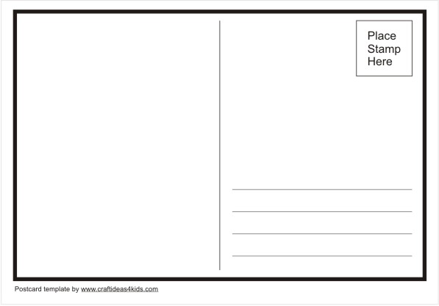

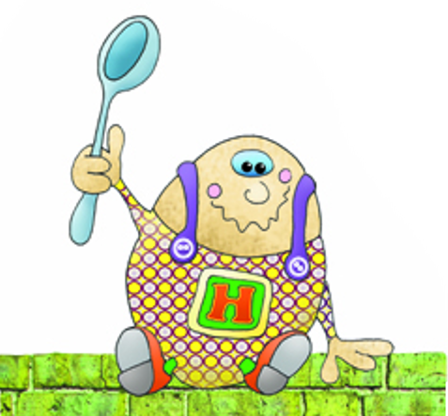



DEAR GROWN-UP

In order to find your way down the rabbit hole to join your child in their magical world, you should make a conscious transition from the daily constraints of adulthood into their world and set some time aside to partake in their imaginary play. For children, imagination can mean that a set of pots and pans can be an entire orchestra and a bluebell forest a fairy kingdom. Your challenge is to reach out to your child and enter his or her world”.

**About Hartbeeps**

Since 2003 Hartbeeps has been delivering its unique blend of original music workshops and mini productions to 1000’s of babies and young children, challenging accepted definitions of ‘baby and toddler’ music classes; we create innovative, multi-sensory and highly interactive productions for the very young. By transforming everyday environments into colourful, tactile ‘wonderlands’ we invite our participants to join us in a world of the imagination. Using clever state of the art music production, original music composition, sound effects, songs and sound plays, lighting effects, innovative props and puppetry together with a vast array of multi-sensory techniques, we create original and highly specialised experiences for our young Hartbeepers.

