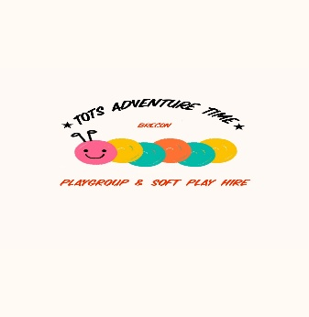

Bouncy castle policy at Tots Adventure Time Brecon
1. Purpose
This policy is in place to ensure the safe and enjoyable use of the bouncy castle during our Play & Stay sessions. We follow guidance from the Health and Safety Executive (HSE), and all equipment must comply with UK safety standards and hold a valid inspection certificate (PIPA)

2. Equipment & Insurance
- The bouncy castle complies with BS EN 14960 safety standards.
- It has a valid PIPA tag Declaration of Compliance.
- The hire company holds appropriate public liability insurance.
- The inflatable is securely anchored and set up by a competent person.

3. Supervision (Very Important)
- Parents/carers are responsible for supervising their own children at all times.
- Children must not use the bouncy castle without a parent/carer present.
- The session lead may limit numbers on the inflatable for safety.

4. Safety Rules
To keep everyone safe, we ask that:
- Shoes, glasses, jewellery, and sharp objects are removed.
- No food, drinks, toys, or dummies are taken onto the inflatable.
- No pushing, rough play, climbing on walls, or somersaults.
- Children of similar size use the castle together where possible.
- No face paints or any glitter!
- SOCKS must be worn at all times.
If a child is not following the rules, we will ask them to come off the bouncy castle.

5. Illness & Hygiene
- Please do not allow your child to use the bouncy castle if they are unwell.
- Parents/carers should ensure children use the toilet beforehand where possible.

6. Accidents & Emergencies
- In the event of an injury, use will stop immediately.
- A first aider will be contacted if necessary.
- An accident form will be completed if necessary.
- You are responsible for your child at all times. This is not down to tots adventure time Brecon!
We want this to be a fun, safe session for everyone. Thank you for supporting us by supervising your child and following these guidelines.

