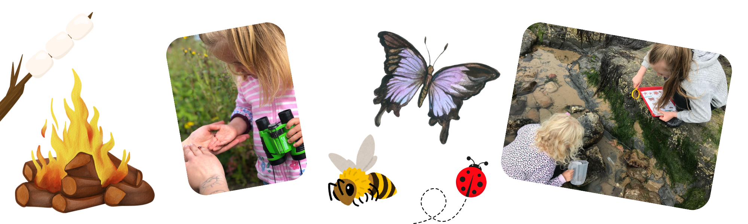
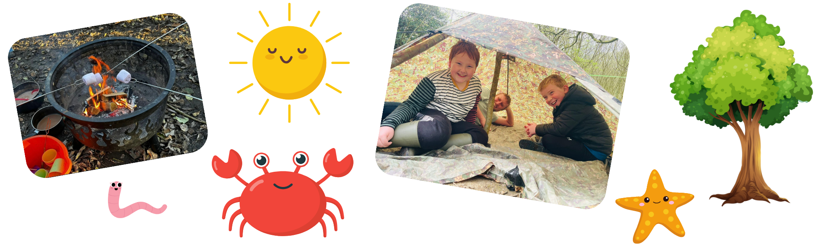
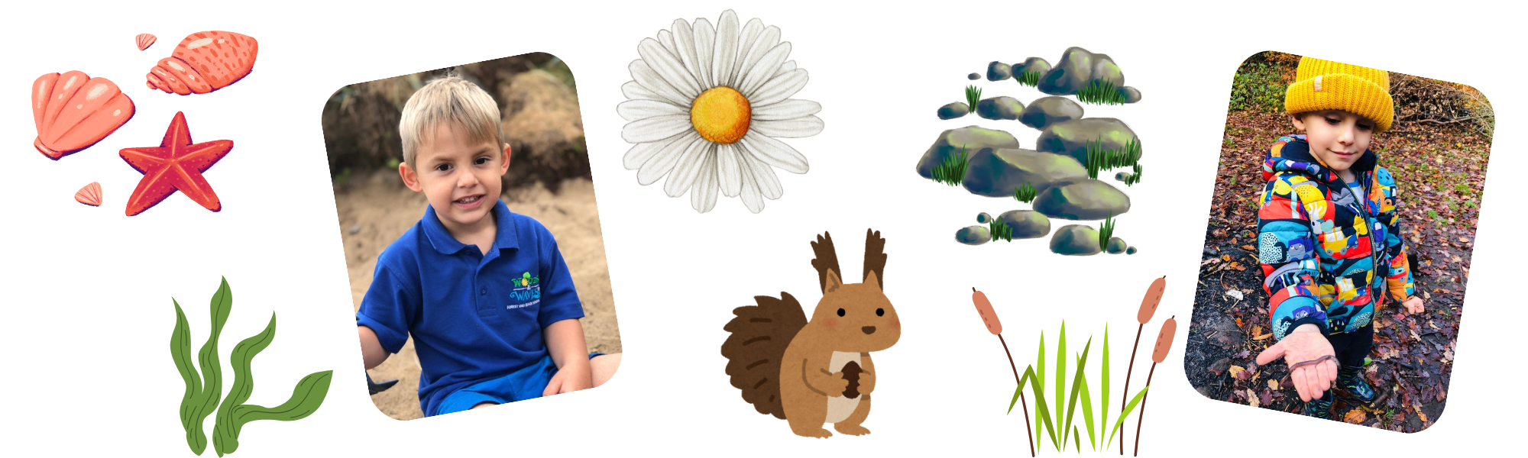

Woods & Waves Vision Statement

To create a future generation who have a strong connection to nature and respect and care for the natural environment, who are resilient, curious, and confident learners.

We follow the Forest School principles and believe that our vision can be achieved by:

- Providing a natural environment for learners to explore, either in a woodland, at the coast, or in another natural environment.
- Delivering sessions regularly to enable learners to benefit fully from the forest school approach, and to allow practitioners to plan, observe, adapt, and review, in turn informing future programme development.
- Running sessions led by qualified Forest and Coastal school Leaders who seek to continually update their knowledge and skills and who regularly reflect on their own learning and practice.
- Responding to the needs and interests of learners through a learner-led pedagogical approach where the vital role of play and choice is central and supporting learners’ holistic development by providing opportunities for social, emotional, intellectual, physical, and spiritual growth.
- Enabling learners to take supported risks and make their own decisions, recognising that this promotes resilience and raises self-esteem.
- Providing sessions where families experience and learn about nature together, enabling relationships to be strengthened.

Roles and Responsibilities

The roles and responsibilities of our Forest/Coastal School leaders are as follows:

- Promoting a positive attitude to the seasons and the weather, and to the environment and its inhabitants.
- Informing participants about how they can look after the natural environment.
- Sharing knowledge of the natural environment.
- Running of the session.
- Demonstrating and explaining activities.
- Offering guidance and support with activities.
- Delivering the planned activities with flexibility; following children’s lead by expanding on things which ignite their curiosity and engage their interest.
- Noting participants responses to activities to inform future planning and practice.
- Promoting equality by encouraging all participants to join in and offering adaptations and alterations to enable them to do so, whist respecting personal choice if participants choose to opt out of some activities.
- Promoting health and safety, including making participants aware of hazards at the location where the session is being held, and those associated with specific activities.
- Acting responsibly and in-line with risk assessments to reduce the risk of any hazards.
- Dealing with and recording any accidents, emergencies, near misses and acts of discrimination, and reporting these to the management.
- Ensuring that the site is ‘left as it is found’ and that the impact of running sessions is a low as possible, and encouraging participants to be aware of and involved in this practice.
- Supporting the manager to ensure that the plan in place for the sustainable management of the Forest School site is upheld and followed.

The role of adult participants who are supporting their children/young people is as follows:

- To supervise the child/children they are attending the session with.
- To be aware of hazards and act responsibly to reduce risk.
- Treat all other participants with kindness and courtesy, valuing everyone’s contribution.
- Report any accidents/near misses to the group leader.
- Report any acts of discrimination, they witness or are a victim of to the group leader.
- Provide themselves and their child/children with appropriate clothing and footwear for exploring the forest/coast and in accordance with the weather.
- Set a good example to children in terms of promoting health and safety and being respectful of the environment and its inhabitants.
- Follow the Forest School approach and encourage the child/children they are supporting to manage problems, try new activities, and test out their own ideas.

Health, Safety, Welfare and Operating Procedures

Food and drink

Parents are asked to bring a water bottle for their child for throughout the session, in-line with our environmental sustainability policy parents are encouraged to use re-useable bottles rather than single-use plastics.
A snack will be provided for children during sessions lasting more than an hour and a half, this may include fruit/biscuit, or something cooked on the campfire.

Hygiene and toileting

Participants will be made aware of where the nearest toilets and hand-washing facilities are. It is advisable for parents/carers to encourage their child/children to use the toilet before the session begins. A handwashing area with soap will be available which participants should use before handling/preparing/eating food and as and when needed.

Personal clothing

Participants are asked to dress themselves and their child in appropriate footwear and clothing for woodland and coastal exploration and in accordance with the weather. It is advisable to wear several layers of clothing as the weather can be changeable. Waterproofs are advisable if rain is forecast, in colder weather a hat and snood are advised as well as warmer layers of clothing. It is not advisable to have bare feet on the beach, in the sea or when rock-pooling, due to hazards which could cause injury. Beach/water shoes or wellies are great for rock pooling and paddling, and beach/water shoes or trainers are great for activities on the sand. For activities in the woodland wellies or walking boots are advised, or trainers if the ground is dry.

Personal Protective equipment

The Forest School Leader will provide any personal protective equipment needed to carry out tasks safely. This may be safety gloves for tool use and fireproof gloves for campfire cooking.

Behaviour and conduct

We expect all participants to act in a way which does not intimidate others or spoil others enjoyment of the sessions. We value diversity and ask that all participants treat each other with kindness and courtesy, recognising and valuing the contribution of everyone within the group.

Dogs

Dogs, except for recognised Service/Assistance Dogs supporting someone attending the session, are not permitted. Please ask to see our Dogs Policy for further information.

First Aid Procedures

All our Leaders hold a relevant and up to date first aid qualification.
There will be a first aid kit at each session.

Any incidents which require first aid to be administered to a child or adult will be dealt with by the group leader in the first instance. If the parent/carer wishes to administer first aid to themselves or their child, they are asked to make the group leader aware of this before the group leader begins to administer first aid treatment.

All incidents requiring first aid and/or resulting in injury will be recorded in the accident book, the parent/carer is asked to sign to state that they agree with the group leaders account of events and first aid treatment administered.

‘Near-misses’ will also be recorded by the group leader; a ‘near-miss’ is an incident where no injury to a person or damage to property or the environment was sustained on this occasion but could be if the incident happened again. The recording of ‘near-misses’ enables us to build up a picture of any risks we have not recognised and take actions to reduce these risks.

Emergency and Serious Incident Procedure

At Woods & Waves we complete thorough risk assessments to minimise risk as far as possible, however, from time-to-time emergency situations and serious incidents may still occur.

The group leader will always have a mobile phone on their person during sessions for use in an emergency.

In the instance of an emergency or a serious incident during a session, this will be dealt with and accurately recorded by the group leader who will inform the manager (Rebecca Lamb). If necessary, the manager and directors will deal with the incident further.

The manager will report all emergencies and serious incidents to the HSE (Health and Safety Executive).

Operating Procedures

We have various sessions to cater for different age groups, all sessions are inclusive of those with additional needs, and we also provide sessions specifically for those with additional needs.

Session details including dates and times will be advertised on our Facebook page where a booking link will be provided.

Booking of sessions is on a first-come-first-served basis, where sessions are funded, to ensure lots of families can benefit, there may be a maximum number of sessions that can be booked by one family.

Payment – Payment should be made when the booking is made for the booking to be secured. Unfortunately, we are unable to issue refunds for any sessions which you cannot attend.

Funded sessions/places – Please give as much notice as possible if you cannot attend a session which you have booked, this will enable another family to book the place.

Cancellation

In the event of a session been cancelled by Woods & Waves, for any reason, participants will be informed as soon as possible and will be offered a refund or a space on another session. Participants should make sure they check their emails for any updates, we will also send text messages to those whose numbers we have.

In the event of a family been unable to attend a booked session, we regret we are unable to offer a refund, however if four days’ notice of cancellation is given (by emailing woodswaves2022@gmail.com or messaging us on 07533366410) we can move your booking over to a session of the same value or less, or a session of a higher value if you send payment for the additional cost. Without the required four days notice we will be unable to move your booking.

For bookings on a: | Cancellations must be made by:
Monday | 6pm the Thursday before
Tuesday | 6pm the Friday before
Wednesday | 6pm the Saturday before
Thursday | 6pm the Sunday before
Friday | 6pm the Monday before
Saturday | 6pm the Tuesday before
Sunday | 6pm the Wednesday before

Funded sessions: If you have booked a funded session and do not let us know you are unable to attend, or regularly cancel, at short notice, any funded sessions you have booked, we reserve the right to withdraw your ability to book further funded sessions for a length of time determined by ourselves. This is to ensure that our funded sessions are having maximum benefit to families.

Insurance

We have a high level of insurance cover provided by Birnbeck Insurance Services.

Tool Use Procedures

The Forest School Leader will check tools weekly and discard of any tools which are damaged.

There are procedures for checking tools in and out at the beginning and end of any activity which involves the use of tools, a tool checklist will be used. As children become more familiar with the use of tools, they will take responsibility (with support from parents and with the oversight of the Forest School Leader) for checking tools in and out.

Tools will be wiped clean with a cloth or small brush after each use.

Tools will be stored with any safety covers supplied on the tool.

Participants will be shown how to use tools safely and how to clean and store tools; Safe use of tools demonstration will include:

- How to take off and replace any safety cover for the tool.
- How to transport the tool safely.
- Use of a suitable and stable area.
- Safe working (body) position.
- How to use each tool.
- How to clean each tool.
- Tool storage.

Campfire and Campfire Cooking Procedures

Campfires will be used when there is a purpose such as for warmth or for cooking.

The Forest School Leader will discuss with participants the importance of fire safety and the rules around campfires including moving around slowly when in the campfire area.
Whenever we have a campfire we have available a burns first aid kit, a fire blanket and a bottle of water.

Contact Information

Manager: Rebecca Lamb
Phone number: 07533366410
E-mail address: woodswaves2022@gmail.com
Facebook page: @woodswavesforestandbeachschool

Please get in touch with any comments, complaints, compliments or queries.
Please get in touch if you would like to see our full policies and procedures, and/or our risk assessments.

