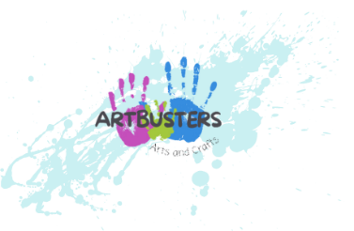 Terms and Conditions
Registration
All parents/carers must complete our registration form in full before a child can be accepted at a club. Registration forms can be obtained from he Club directly or via email info@artbusters.co.uk
Any changes to the information contained on the registration form, whether it be contact details, medical details, change of address etc., must be notified in writing by the parent or carer as soon as possible to the Club Manager.

Bookings
Parents agree to book and pay for the sessions in advance.
Please ensure that a minimum (where possible) of 2 weeks notice is given to change prebooked arrangements. It is not possible to swap days or refund monies due to non-attendance once booking has been made.
If a child is collected late, parents will be invoiced for the extra staffing costs (unless discussed with Club Manager) Any costs incurred by Artbusters relating to the recovery of fees will be added to any amount outstanding.

Behaviour
All children are expected to behave appropriately at the club. Parents will be informed if their child’s behaviour is inappropriate.

Child Welfare
In the event of an emergency, parents consent to seeking of any emergency medical advice or treatment in the future during the running of the club.
Any child who has suffered diarrhea, sickness, high temperature/fever or conjunctivitis must be kept away from the club for a period of 48 hours after such condition has ceased.
Any child suffering from headlice must be kept away from the club until the hair has been fully treated and cleared. Should any child suffer from any of the above whilst at the club, the staff will contact and ask the parent/carer to come and collect the child as soon as possible.
Unless stated in the allergies section of the form, I give permission for Artbusters staff to use antiseptic wipes and/or plasters should they be needed.
Parents are asked to familarise themselves with the Artbusters policies which are available upon request at info@artbusters.co.uk or contact 07946307748
If you require our Covid Policy, please contact info@artbusters.co.uk

