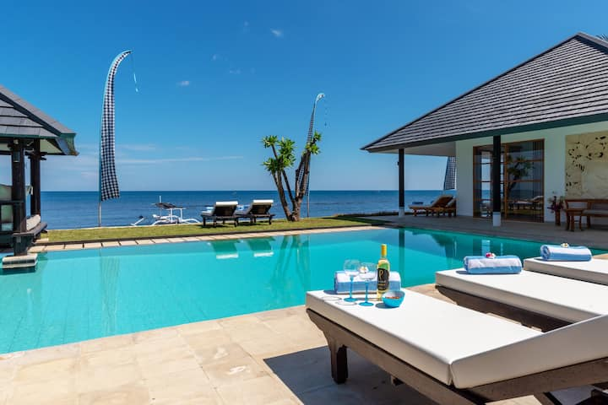
BALI YOGA & LIFE COACHING RETREAT
7 Days of Pure Yoga, Connection & Transformation
March 18th 2027

Your Invitation
Join us for an unforgettable 7-day beachfront yoga retreat in the peaceful north of Bali, near Lovina — a hidden gem known for its black sand beaches, dolphin sightings, waterfalls, and sacred temples.
This retreat is designed to help you slow down, reconnect, and realign. Through daily yoga practices, nourishing food, breathtaking nature, and two powerful group life coaching sessions, you will create space for clarity, growth, and deep restoration.

Your Beachfront Villa
Our private beachfront villa near Lovina offers:
• 10 ensuite bedrooms (shared twin or private options)
• Choice of garden or sea view rooms
• Two swimming pools
• A fully equipped private yoga studio
• Dolphins visible right from the garden
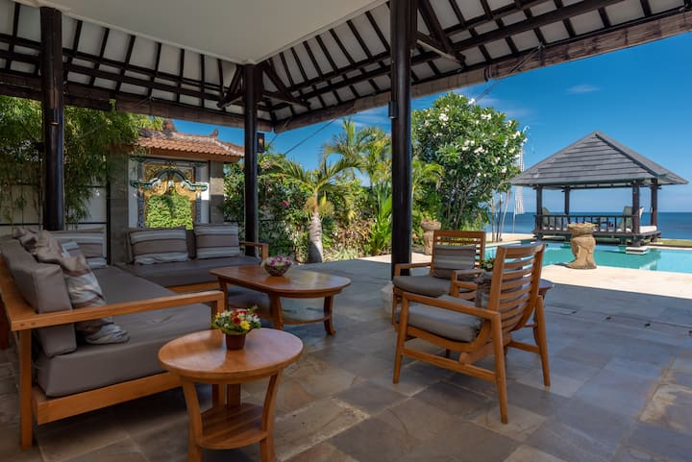
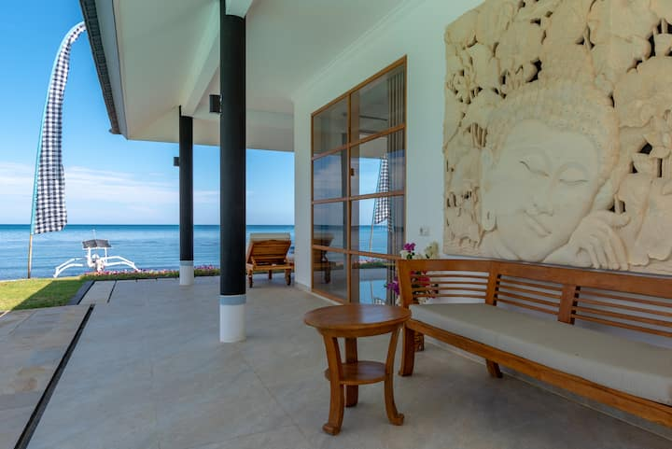
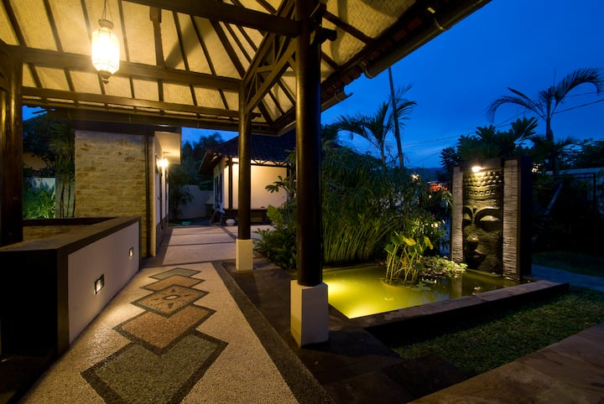
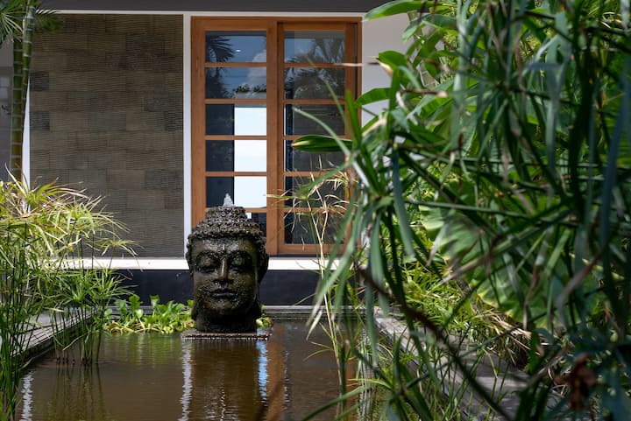
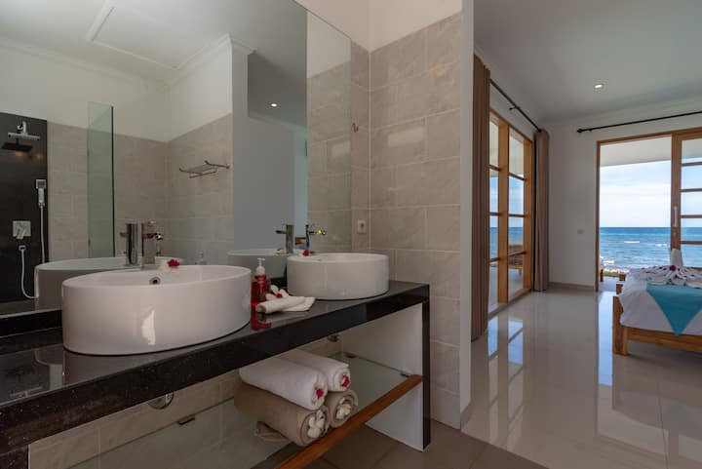
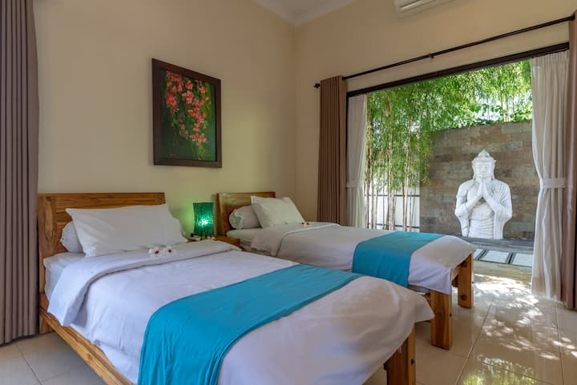
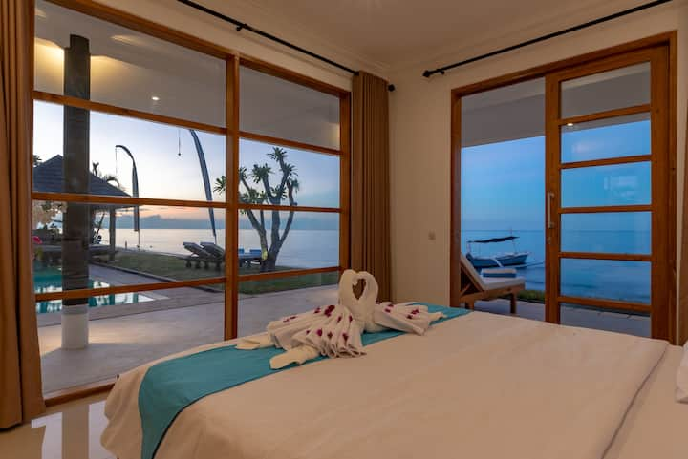
All meals (except during our Ubud day trip) are freshly prepared by a local Balinese chef, offering nourishing, wholesome cuisine.

Our Journey Begins
Upon arrival at the airport, private transfers will take us north to Lovina. On the way, we will visit:
• Jatiluwih Rice Fields (UNESCO heritage site)
• Ulun Danu Beratan Temple on Lake Beratan
After soaking in Bali’s iconic landscapes and culture, we arrive at our beachfront sanctuary.

Retreat Flow

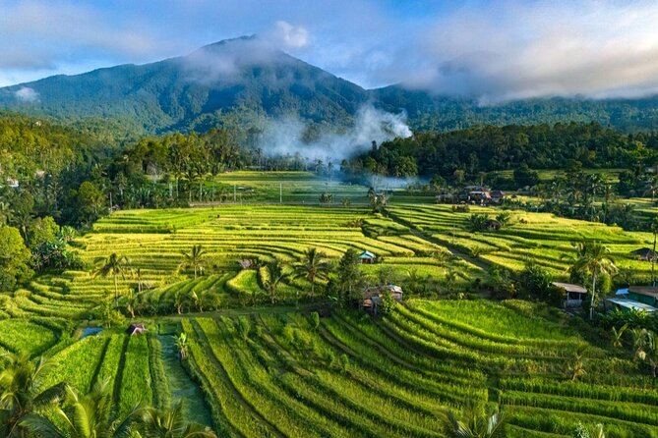
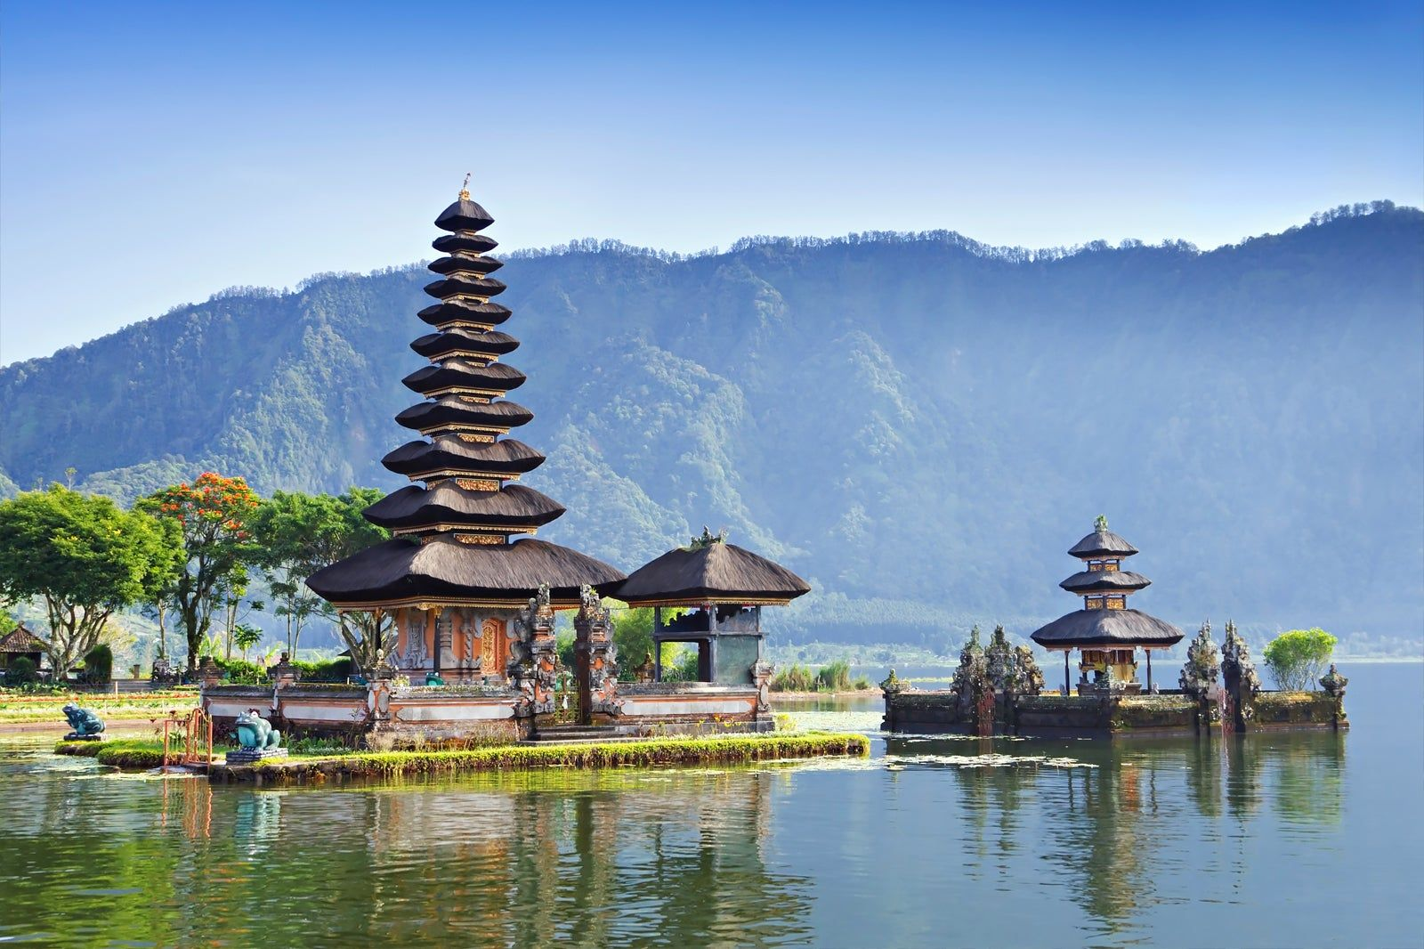
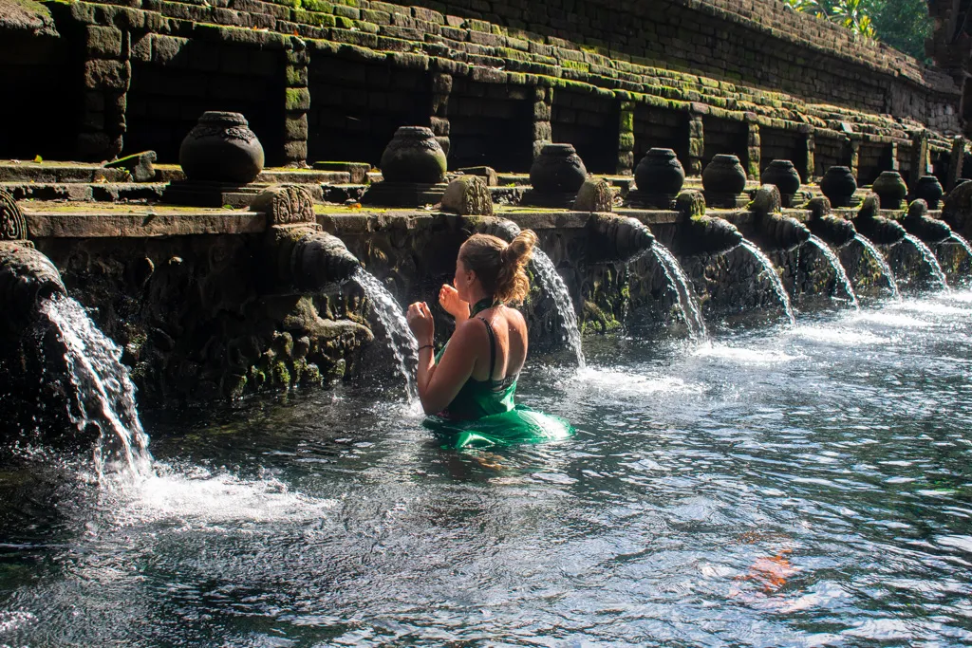
Days 2–3: Unwind and Arrive
Gentle yoga practices, ocean views, sunshine, swimming, and space to simply be.
Day 4: Ubud – The Yoga Capital
We travel to Ubud, stopping at Tirta Empul water temple for a sacred water purification experience. In Ubud you will enjoy free time to explore yoga shalas, visit the Monkey Forest, experience traditional Balinese massage and spas, wander artisan markets, or simply absorb the atmosphere.
Days 5–6: Explore & Restore
Back at the villa, we continue our yoga journey and explore local wonders if you wish such as:
• Dolphin boat trips
• Gitgit Waterfall
• Brahmavihara-Arama Monastery
• Optional Mount Batur sunrise hike
Throughout the week, you will participate in two transformational group life coaching sessions to help integrate insights and create meaningful change.

What’s Included
• Airport transfers (arrival & departure in Bali)
• Return trip to Ubud
• Visits to Jatiluwih Rice Fields, Ulun Danu Beratan Temple & Tirta Empul
• 7 nights beachfront villa accommodation
• Daily yoga sessions
• 2 group life coaching sessions
• Daily meals prepared by our local chef (except Ubud day)

Accommodation & Pricing
Pricing varies depending on:
• Shared or private room
• Garden or sea view
Garden view shared room single bed £950pp
Garden view private room £1250
Garden view shared bed £900pp
Sea view shared room single bed £1050pp
Sea view private room £1350pp
Please note, flights are not included and the prices can be various starting from £550-£1000 from London.

Optional 3-Day Southern Bali Extension – Self Cost
Extend your journey with a 3-day stay in Southern Bali at the beautiful De Moksha Yoga Resort. The cost is around £40p per night with breakfast. Its absolutely gorgeous place, I’ve personally been there.
https://www.villamoksha.com/
• Access to their yoga classes and studios
• Peaceful resort setting
• On-site support for tours and local exploration
Perfect for those who wish to continue their practice or explore more of Bali.

Are You Ready?
This retreat is more than a holiday — it’s an experience of presence, connection, and transformation.
Spaces are limited to ensure an intimate and personal atmosphere.
We can’t wait to share this journey with you.
Get in touch with me: 07808834702 or drop us an email

