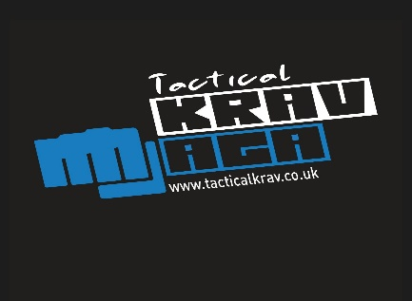

Privacy Notice (this page is to be retained by data subject)

Your Personal Data
Tactical Krav will be what’s known as the ‘Data Controller’ of your personal data processed in relation to Tactical Krav or IKMF, for the purpose of providing Krav Maga classes to you and also to promote Tactical Krav. This Privacy Notice explains how Tactical Krav will process your personal data.

Why we need it
We are collecting your basic personal data in order to provide Krav Maga classes to you and to promote Tactical Krav for marketing/promotional purposes in the ways which are specifically detailed and consented to in the accompanying signed and dated consent form. We will only collect data that we need in order to fulfil and oversee this purpose.

Legal basis for processing your data
We must have a legal basis for processing all personal data. In this instance, the legal basis is ‘Consent’.

What we do with it and who we share it with
All the personal data you submit is processed by our admin team to enable us to provide Krav Maga classes to you. Your data may also be shared with IKMF HQ, Israel, in the event of seminars, gradings or other events requiring registration with IKMF.

How long do we keep it for
Your data will be retained by Tactical Krav for up to three months after the last class attended. After this time, data will be securely deleted. However, I understand that some images, recordings or written comments may be kept permanently once they are published and be kept as an archive with Tactical Krav.

What are your rights?
You can request access to the information we process about you at any time. If at any point you believe that the information we process relating to you is incorrect, you can request to see this information and may in some instances request to have it restricted, corrected or, erased. You may also have the right to object to the processing of data and the right to data portability.

As we are using ‘Consent’ as the legal basis to process your personal data, you also have the right to withdraw your consent at any time

If you wish to exercise any of these rights, please contact info@kravmagaayrshire.com.

Complaints
If you wish to raise a complaint on how we have handled your personal data, you can contact Ewan Risk who will investigate the matter. Ewan can be contacted on 07976467259.

If you are not satisfied with our response or believe we are not processing your personal data in accordance with the law, you can complain to the Information Commissioner’s Office (ICO) https://ico.org.uk/.

Contact details
If you have any questions relating to this consent form or the way we are planning to use your information please contact: Ewan Risk/ Cheryl Sharp at info@kravmagaayrshire.com.

Media Consent Form

Tactical Krav is committed to controlling and processing personal information in accordance with the General Data Protection Regulation (GDPR) and the Data Protection laws. The personal data collected as detailed below will therefore be controlled and processed in line with the relevant Data Protection laws and Regulations in the way(s) and purpose(s) detailed in the accompanying Privacy Notice.

I consent to my personal data being used in each of the following formats: (tick all that you consent to)
Photographic images – printed and digital
(I understand that images may contain metadata including personal data which could be accessible to others when images are processed/shared, including beyond Tactical Krav.)

Film/video images and audio

Written comments/testimonials

I consent to this personal data being used (processed) in the following ways: (tick all that you consent to)
Tactical Krav web pages
Email and online marketing including e-newsletters; online and email adverts; online advertorials and editorial features in digital publications
Social media posts
Printed materials including leaflets; flyers; posters; banners; brochures, magazines and prospectuses;
Messenger apps such as, but not limited to, Facebook Messenger, Whatsapp & similar apps we may use to communicate with class attendees as a group or individually, for the purpose of sharing information quickly. An example of when we may do this, is if we have to change the time or venue of a class at short notice.
Teaching materials

Signed: Print Name:

Date: Email:

