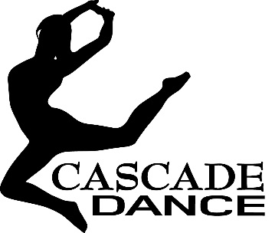
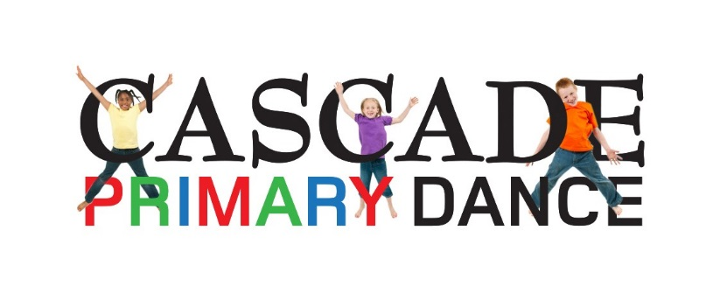

Dear Parents / Guardians,
With the success of our Primary Dance Collaboration this term, we invite you to attend a free trial class for our brand new Cascade Junior Dance Company starting in May!
This company is for year groups 4, 5 and 6 (8 – 11 years) and will run in the Dance Hut at Knole Academy on Thursday afternoons.
The Junior Dance company is a gifted and talented company for young dancers in partnership with The Knole Sports Partnership. The sessions will offer fun and friendly dance training, a chance to learn news styles and prepare dancers to perform!
Join the company and compete in the Cascade Championships on Saturday 6th July!

Free Trial Date: Thursday 2nd May 4 - 5pm
Register your child’s place via www.cascadedance.co.uk/news (follow the links)
This trial date is open to all to experience the class, learn a routine and meet the teacher! Places are limited, so please register your child online. If the dancers enjoy the class and want to continue they can sign up to the term (below)

Dance Term Information
The company will then run the following week for an 8 week term…..
Thursdays 4 - 5pm in the Dance Hut at Knole Academy, Sevenoaks
Dates: 9TH May - 4th July
Cost: 8 Week Term = £36.00 (paid in full on the first day of term)
Uniform: Dancers to wear all black to their dance classes, black leotard, leggings or black shorts and footless tights. Bare feet, hair up.

Contact
Contact Sam Blackden for more information via sb@cascadedance.co.uk
07540 724 027

