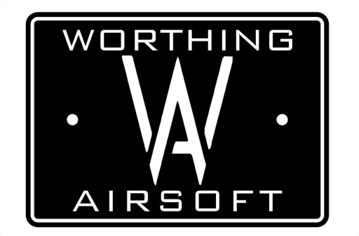
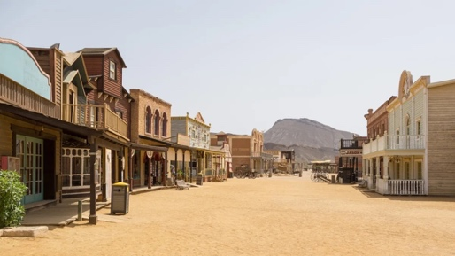

Wild West Worthing
The Lazy W

A free roaming day of western based game play.

Three factions:
Cowboys, - salt of the earth, available to multitask, (Red bandana)

Lawmen, - those that do the bidding of the Sherriff, keep the peace and uphold the law. (Black bandanna)

Outlaws, - desperados that will steal, cheat and Rob anyone to get what they need to get by. (Green bandana)

What guns can I use?
The game is set in the 1890s when America had settled after the civil war and weapon technology was coming on in leaps and bounds. Most notionally the pump action shotgun had been invented.

This is a filmsim event so if it looks right from 10 feet away then it's good enough for us.
We will allow all revolvers though we prefer single action.
We positively encourage Winchester repeater rifles although ammo will be severely restricted.
Shotguns, lever action will be encouraged but pump action will be allowed, the shotgun must be full length, full stock and spring or gas powered.
No Breachers and no hpa drum mags.
Finally we will allow a VSR style rifle with no scope, but it must be fitted with a single shot adapter, please let us know in advance if you want to use a VSR so we can print the adapters.
Anything with a full auto capability, will be burned as witchcraft.

What do I wear!
Well anything civilian from the charity shop. This is filmsim where no one will tell you your kit is wrong, while we ask you to try and put effort into your kit and certainly nothing military the only requirement we do ask is you get a bandana to be correct with your faction.

Red for cowboys, black for law dogs and green for outlaws. All players are to have one robbable pouch or pocket so if you're shot but dead or not, you can be robbed by your attacker but not necessarily killed. Cowboy hats are the best but aussie leather hats, bowlers or toppers can be worn.

We ask all players to wear a hat of sorts to show if you are in game or not. Going back to respawn with your hat off means you're not a target. You can be in game and take your hat off to "Parley" with another faction, though they don't always respect that.

Bounties can be set on individual players by the Sherriff, those doing wrong can expect to be hunted.

How do I survive? What's the point of the game?

Well money of course, you need cash to survive. There are several ways to earn money.

Making whiskey.
There will be four containers around the site with coloured cards in. You need these to make whiskey. The more different colour cards to your brew, the more money it's worth. Once you have your cards you need to take and hold the brewery. You can brew on the hour and the half hour. You must hold the brewery for 15 mins, there will be a clock provided. Once you've brewed your whiskey, you must take it to the general store to sell it before you start again.
You can of course be robbed at any time for ingredients or product so be on your guard.

Prospecting
there is a stream on site (hopefully) you can hire a pan for an hour from the store and go panning for nuggets and sell them back.
There's diamonds in there hills, you can buy maps from the store that may lead to the location of diamonds, but they won't be easy to find.
Fur trapping, there's areas on site where rare animals may be found, shoot them and bring back the fur and you'll get a bounty.
Bounty hunting, if a price is put on someone's head, there will be a value to bring them in Dead or Alive!

