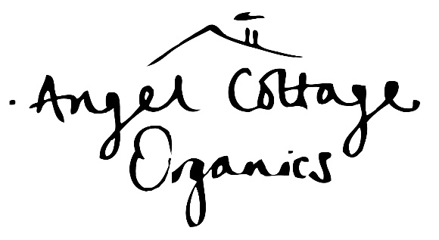

PLACES TO EAT

Dinner on your first night and a substantial lunch everyday are included in your course fee. The following places to eat have all been recommended to us for your evening meals on Tuesday, Wednesday & Thursday evenings. Please check with each venue for their current opening hours.
The Ibberton, Ibberton, DT11 0EN. 01258 817956 www.theibberton.com
“a good meal and lovely atmosphere”
The Green Man, King’s Stag, DT10 2AQ. 01258 920022 www.greenmankingsstag.co.uk
Fellini’s, Hazelbury Bryan, DT10 2ES. 01258 817974 www.fellinipizzeria.co.uk
“very nice and generous”

The Cross Keys, Sherborne, DTDT9 3BJ. 01935 508130 https://www.thecrosskeyssherborne.com/

The Clock Spire, Milborne Port, DT9 5BA. 01963 251458
https://www.theclockspire.com/
“Expensive and rather slick for country dining but very excellent food”

Angel Cottage Organics, Haddon Copse Farm, Fifehead Neville, Dorset, DT10 2 AQ
www.angelcottageorganics.co.uk info@angelcottageorganics.co.uk 07810 628504

