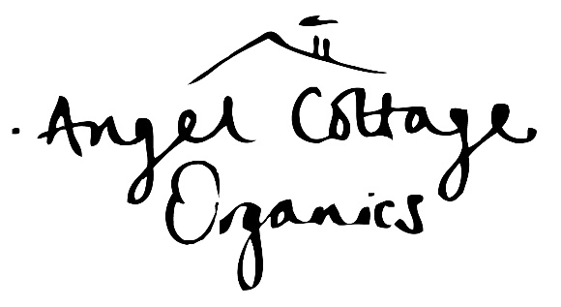

ACCOMODATION LIST

There are two options for staying at Haddon Copse Farm, offering you a fully immersive painting experience.

Option One: Hire a bell tent – our beautiful bell tents are sited in our campsite field with a panoramic view of the Dorset Downs. Each tent is available for single occupancy or for two to share and are equipped with comfortable futon-style mattresses You need to bring your own bedding, towels, etc. and a camping chair is also a good idea. There are two private wet-room style loos and showers just a very short walk from the bell tents.

Option Two: The Retreat Hut - Tucked away in a small orchard on the farm with glorious views of the Dorset Downs, The Retreat Hut is perfect glamping accommodation and is fully equipped for your stay, including an outdoor ‘Campers’ Kitchen’. The wet-room loos & showers are just a short walk through the orchard from the Retreat Hut.

Both options include breakfast every day. Lunch and afternoon tea every day and supper on the first night are included in your course fee meaning you just need to make arrangements for your own evening meals on Tuesday, Wednesday and Thursday evenings (see our separate Food List).

If you don’t want to stay in one on the farm then here are some local accommodation options that we recommend:

Gorse Farmhouse Bed & Breakfast, Fifehead St Quintin - http://www.gorsefarmhousebb.co.uk/
“Excellent”

Lower Fifehead Farm Bed & Breakfast, Fifehead St Quintin - http://www.lowerfifeheadfm.co.uk/

The Old Rectory, Hazelbury Bryan - http://www.oldrectoryholidays.co.uk/index.html

Star Farm Self-Catering Cottage, Hazelbury Bryan - www.starfarmcottage.co.uk
Locketts Farm, Droop
“Sleeps 4. 7 minutes away. Very lovely and quiet and views.”

Oak Tree Barn, Hazelbury Bryan
Willow Tree Farm Studio, Stoke Wake - these are both recommended and can be found on www.airbnb.co.uk/

Droop Farm Cottage, Hazelbury Bryan - Telephone : 01258 818115 e-mail : tracey@ajar-of.co.uk

Belview Cottage, Fifehead Neville - www.belviewcottagedorset.co.uk
“Very comfortable, well equipped and spotlessly clean. Have to book from Friday to Friday but so convenient in every other way.”

Plumber Manor Country House Hotel, Sturminster Newton, DT10 2AF www.plumbermanor.co.uk
“Expensive but really comfortable and excellent food. Really worth going to dinner here but it might set you back a bit!”
“Friendly, old-fashioned hotel. Very comfortable and traditional. Quite expensive.”

Newton House B&B, Sturminster Newton https://www.newtonhousesturminsternewton.co.uk/#
“lovely rambling house, delightful hosts. Nicely quirky.”

Rose Cottage B&B, Sherborne, DT9 3PH www.rosecottage-sherborne.co.uk

The Cross Keys, Sherborne, DTDT9 3BJ. 01935 508130 www.thecrosskeyssherborne.com

Please don’t hesitate to contact us if you require any further information.

Angel Cottage Organics, Haddon Copse Farm, Fifehead Neville, Dorset, DT10 2 AQ
www.angelcottageorganics.co.uk info@angelcottageorganics.co.uk 07810 628504

