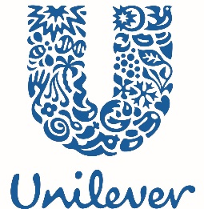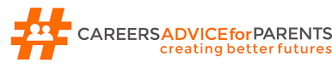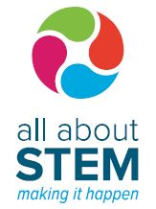

Media Permission Form
Careers Advice for Parents ‘INSPiRED Teenager’ Sessions
10th & 17th October 2018
Unilever Port Sunlight R&D Site

I give permission for my image, and that of my child, to be taken during the above-named sessions in photographic and video formats.
I understand that the images/footage may be used by the project partners (Careers Advice for Parents, Unilever and All About STEM) for publicity purposes relating solely to the ‘Careers Advice for Parents INSPiRED Teenager’ sessions.
In addition, I understand that the images/footage may be shared with the government departments and organisations responsible for funding the programme for purposes relating to the programme.

Full Name: ………………………………………………………………………………………………………………………………………………..………………….

Child’s Full Name: …………………………………………………………………………………………………………………………………………………………

Signed: ………………………………………………………………………………………………………… Date: …………………………………………………….

