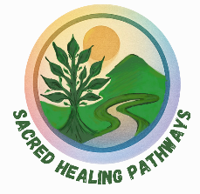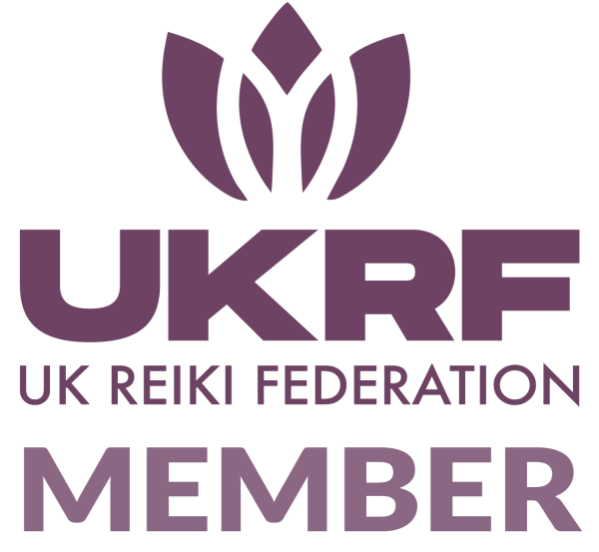
Sound Bath Disclaimer Notice
Anna-Marie Jackson
Reiki Master Practitioner and Sound Healing Practitioner
Client Awareness
To ensure I can provide the best treatment for you, please read the following notes and confirm that you have read and understood them by signing where indicated. Thank you.
Sound Healing and Sound Baths are holistic energy therapies that promote relaxation, balance, and overall wellbeing by supporting the body’s natural healing processes.
These practices are complementary therapies and are not substitutes for medical or psychological treatment. If you are currently under medical or psychological care, please continue to follow the advice and treatment plan provided by your healthcare professional.
Practitioner Role:
I understand that the practitioner, Mrs. Anna-Marie Jackson (Sacred Healing Pathways):
- Is a qualified energy healing practitioner, not a medical doctor, psychologist, or licensed healthcare provider.
- Does not diagnose, prescribe, or claim to cure any condition.
- Offers sessions intended to complement — not replace — professional medical care.
Client Responsibility:
- I will inform the practitioner of any relevant physical, emotional, or mental health conditions prior to my session (such as epilepsy, pacemaker, pregnancy, recent surgery, or sound sensitivity).
- I acknowledge that I am participating voluntarily and take full responsibility for my wellbeing before, during, and after the session.
- I understand that healing responses vary, and feelings such as warmth, tingling, emotional release, or deep relaxation are natural effects of energy work.
Contraindications:
Sound Healing and Sound Baths are generally safe for most people; however, please discuss with the practitioner if any of the following apply:
- Pacemaker or other implanted electrical device
- Epilepsy or sound sensitivity
- First trimester of pregnancy
- Recent major surgery or injury
Confidentiality
All information shared during the session will be treated as strictly confidential and used solely for the purpose of providing the service.
Declaration
I am aware that Sound Healing and Sound Baths involve no diagnosis of condition or the prescription of medical substances. I also understand that any prescribed medical treatment will not be interfered with.
I have read and understood this disclaimer. I consent to participate in Sound Healing Sound Bath sessions with Sacred Healing Pathways and I understand that the treatment given is done so with my full and complete acceptance.

Signed.................................................................................. Date..............................

Print Name..................................................................................................................

Practitioner Signature: ______________________ Date: ___________________________

