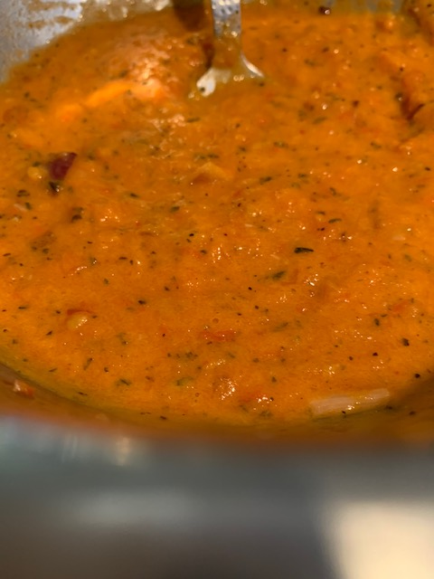
Tomato Based Sauce
Firstly, this sauce is gluten free, dairy free, wheat free, no added salt, sugar, preservatives, or colouring
The colour of your sauce will be so vibrant it will leave you wondering what goes into the shop brought brands to make them the bright red colour
The base for your sauce is tomatoes, onions, and peppers. You need more tomatoes than peppers and more peppers than onions - (add more if you want to make a bigger batch), roughly chop and place in a baking tray. Drizzle with olive oil, salt and pepper and roast on a medium heat for approx. 20 mins. You can add garlic if you wish. I have added spring onions and radishes before (it’s a great way to clear out the salad and veg drawer in your fridge)
Once roasted, allow to cool then blitz (use a hand blender, a food processor, or a potato masher) You can make smooth or chunky, the choice is yours. Portion into containers and freeze – DONE
Suggestions –
Add Basil for a pasta dish
Add Oregano for a pizza base sauce
Add Cajun spices for fajitas
Add stock (vegetable or chicken) for soup
Add chilli powder for a chilli con carne
Add curry powder for a curry
Add coconut milk for a Thai dish
SimpliciB www.simplicib.co.uk 07542 829039 social media: @Simplicib

