Access to the car park is from Day House Lane; the turning is just before the Richard Jefferies Museum off Marlborough road:
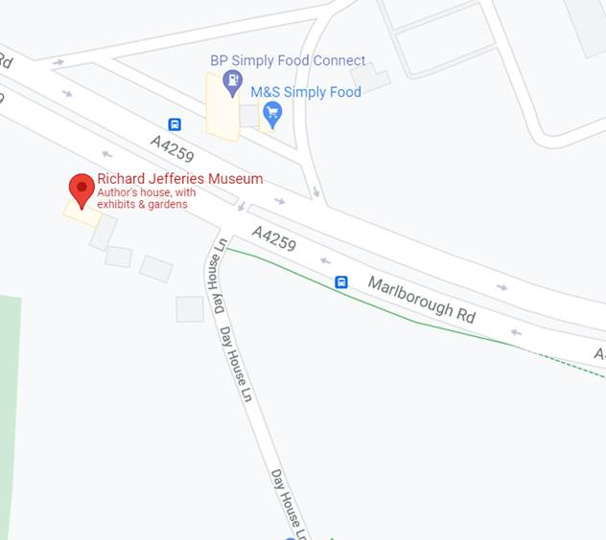

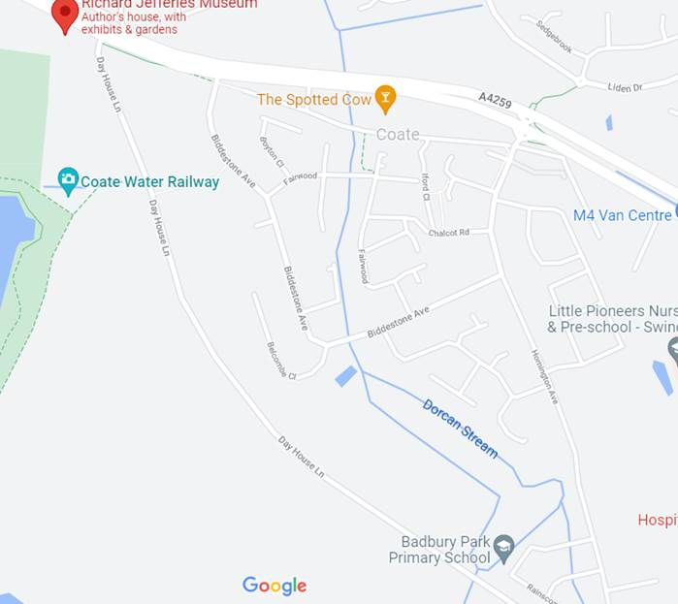
Keep following Day House Lane for 800m or so and you will find the car park on the left hand side:

