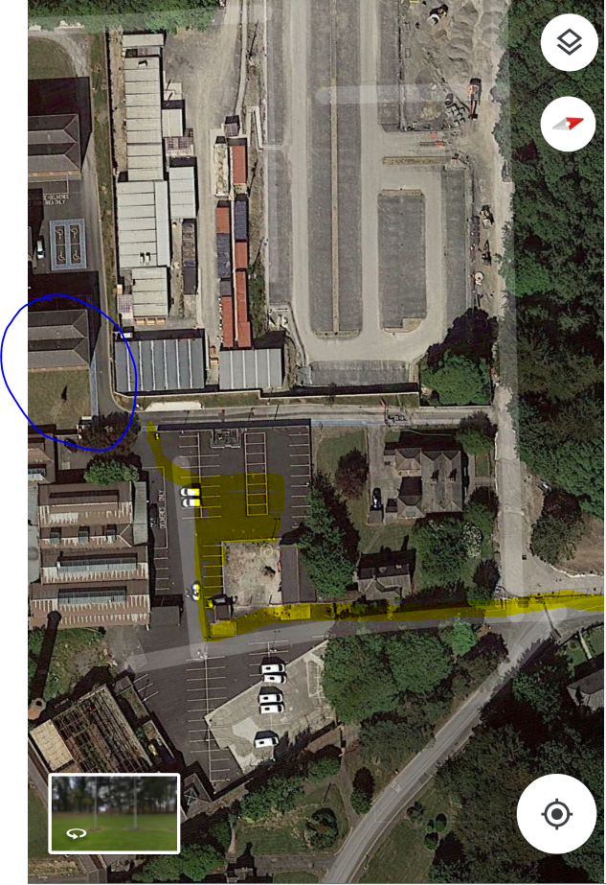
Avenue to /from Portrane Road
Entrance to car park
Car Park
Tayleur House

