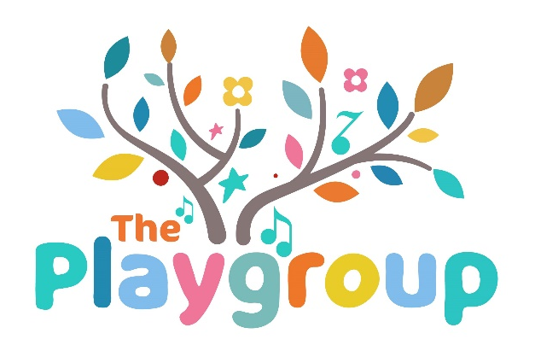
Terms and conditions
We work hard to create a clean, safe and fun environment for our customers. We politely ask you to read the terms and conditions of our classes and booking site. If you have any further questions, please contact us at theplaygroupsouthtyneside@gmail.com
Help us to keep our staff and customers safe by following a few simple procedures:
BOOKING
Please be aware that tickets booked are non-refundable. If you are unable to attend a class, please contact us at least 48 hours before the event and we will transfer your ticket to a new class.
1 standard ticket gives admission to 1 adult and 1 child unless you have multiples (please see multiples policy). You can bring an additional adult or sibling at a charge of £1.50 if there is space available.
Please declare any allergies or medical conditions for you or your little one on the booking form. If any new conditions emerge, please let us know as soon as possible, so we can do everything we can to make our class space safe for you.
You are responsible for your children’s safety when attending our space and children must be always supervised vigilantly by a responsible adult.

ON ARRIVAL
If possible, do not to arrive too early, we use our turnaround time to sanitise equipment, mats and props and set up the room before you arrive.
Kindly remove your shoes when entering the area to help us keep spaces as clean as possible. This also prevents injury if we are moving around the room and children are on the move.
Supervise your child at all times, most of the equipment we provide is baby friendly. However, some props and decorations are unsuitable for babies and toddlers and could become a choking hazard if they become damaged or broken. Your class teacher will alert you to any items at the start or during the session.
If any of our equipment or props become damaged during the session, please hand all parts directly to the teacher, so it can be disposed of safely.
In the event of a fire alarm, please listen carefully to instructions from your class teacher to ensure you follow the correct escape route and assemble in the correct area.
No food or drinks are to be brought into the session, this excludes baby milk, baby food and water bottles.
Finally, please enjoy tour time with us, we like to get the housekeeping out of the way upon booking, so we can just enjoy our day
Many thanks in advance for your cooperation.

The playgroup
x

