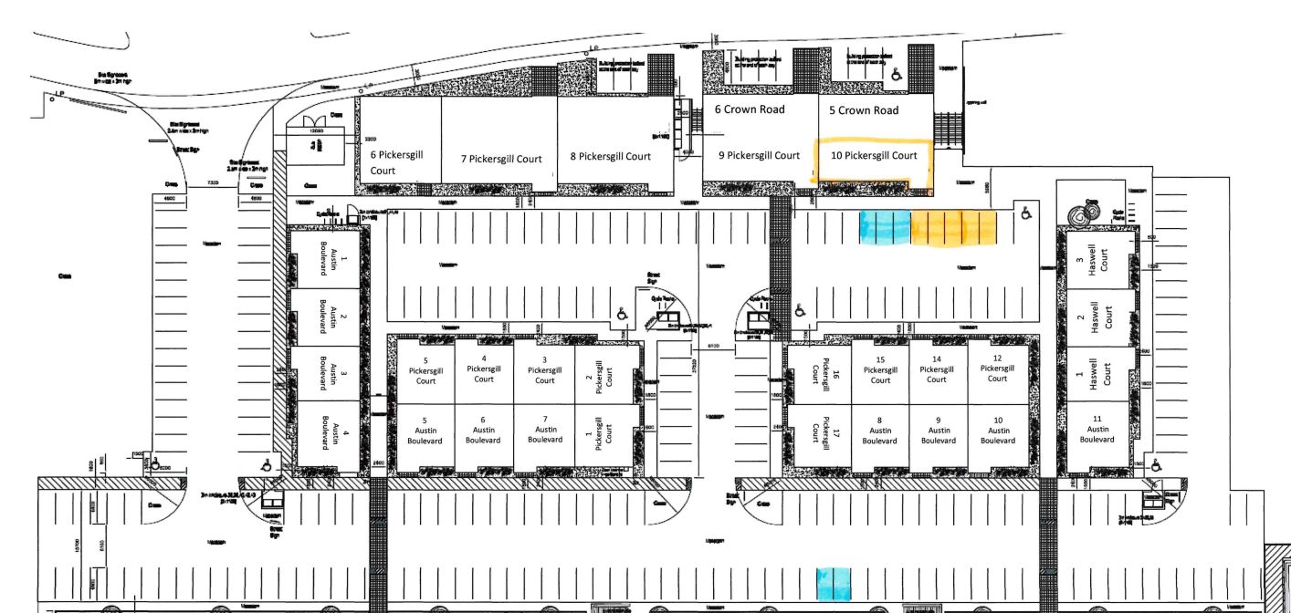

FREE BAYS (NO PERMIT NEEDED)
PAY TO PARK, £1 PER HOUR (PAY ONLINE VIA QR CODE ON THE SIGN)
** OR FREE ON STREET PARKING (OUTSIDE OF THE BUSINESS ESTATE) **
PARKING INFORMATION!
We pay for GREEN bays for our customers to use for FREE, at busy times you may need to use the overflow PAY FOR PARK in the YELLOW bays £1 per hour. Please use the parking map to ensure you are in the correct bays to avoid penalty notices.

A copy of this parking map can be found on our booking page as an attachment to the event or on social media for reference.

