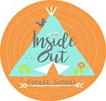 | Inside Out - Child/Young person Consent Form for Forest School activities  To the parent or guardian  We treat this form with the strictest confidence
Child’s Full Name(s): |  |  | Male | Female
Child’s Date of Birth: |  |  | (Please circle)
Please provide 2 contact details in case of emergency
Name: |  | Name:
Relationship to child: |  | Relationship to child:
Email: |  | Email:
Mobile Phone: |  | Mobile Phone:
Work Phone: |  | Work Phone:
Home Phone: |  | Home Phone:
How did you hear about Inside Out Forest School?:
Which school does your child currently attend?:
Allergies & Medical Information
Does your child/young person suffer from any illness, or allergies, (including food) or have any special educational needs that may affect him/her when taking part in group activities? If yes, please provide details:

Does your child/young person require the routine use of any medication? If yes, please provide details:

Please note that if your child needs to take medication during the sessions this will need to be self-administered or a family member or carer would need to come with them to administer.
Please tick the box if you are happy for us to capture the excited faces of children on camera for our website, publicity, social media etc.
Name of adult, 16 years or over, who will be collecting
your child/young person at the end of the session:

Agreement
I understand that Forest School sessions, by their very nature, take place on sites with naturally occurring hazards and may include activities which are challenging, and /or require participants to take assessed risks. Participants shall be aware of and accept these risks and agree to be responsible for their own actions and involvement.

I will ensure my child will be adequately and safely equipped and clothed for the activities planned. This includes warm, waterproof clothing and footwear, sun cream etc. I accept that my child may not be allowed to take part if the leader considers them to be unsuitably attired. I understand that Inside Out Forest School cannot be held responsible for loss or damage to personal items and clothing.

I understand that all safety rules and procedures must be followed, and that every effort will be made, by the Forest school Leader, to ensure the safety of my child. I also consent to the named child receiving any necessary medical treatment for any injury or illness whilst attending our summer camp sessions.

In the event of illness or accident, I authorise the Forest School leader to sign on my behalf any written form of consent required by hospital authorities, if the delay required to obtain my own signature is considered inadvisable by the doctor or surgeon concerned.

I agree not to send my child to forest school if they show any symptoms of COVID 19 and understand that I will be asked to collect my child if they exhibit symptoms during a session. Inside Out accepts no responsibility if a child starts to exhibit COVID symptoms whilst at a Forest school session.

I understand that Inside Out will not issue refunds if a child becomes ill or misses pre-booked sessions due to being quarantined.

If the information given on this consent form should change, for any reason, I will inform the Forest School leader.

Parent/Guardian Signature*: | Date:
Please sign to acknowledge agreement and return to the Forest school Leader as soon as possible or on the day of the activities.

Due to the nature of some of the activities your child will not be able to take part unless the forest school leader has this consent form!

If you are completing this form electronically, please type your name in the signature section to agree to our terms and conditions and email your form to insideoutforestschool@gmail.com

Forest School Kit List
Please keep the kit list for your information (The pictures are for guidance only).

To every session whatever the weather!  - Waterproof coat  - Wellies/sturdy footwear  - Waterproof trousers  - Change of clothes  Please be aware that clothing may get dirty or damaged so I would advise children to wear older garments. |  |  |  | Lots of layers to keep warm, depending on the weather/season.  - Vest  - Long sleeved top  - Fleece/sweatshirt/jumper/hoody  - Jacket  - Warm socks  - Gloves/winter hat/scarf  - Sun hat/sun cream, insect repellent
To minimise the risk of scrapes and nettle stings, I would advise, even in the warm weather, that the children wear long trousers and a long sleeved top, also bring a waterproof coat to every session. It’s better to come prepared than to get caught short in the British weather!

As the saying goes…there’s no such thing as bad weather, just the wrong clothes!

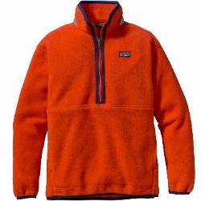 | 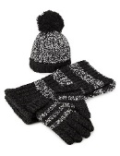 |  |  | 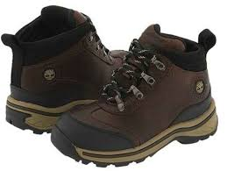 |  | 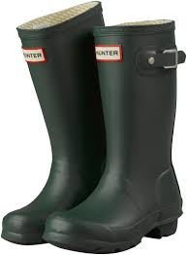
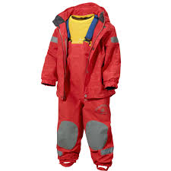 | 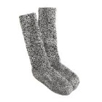 |  |  | 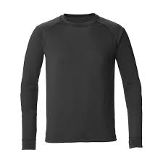 |  | 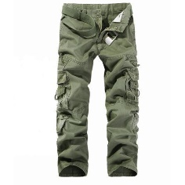
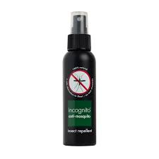 |  | 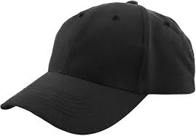 |  |  | 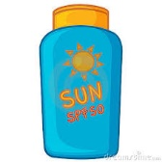
Contact Esther Brock
07979 381833  insideoutforestschool@gmail.com  www.insideoutforestschool.com |  |  | Facebook @Insideoutforestschool  Twitter @IOforestschool  Instagram @Insideoutforestschool

