PINKFOX

LIMITED TO 130 DOGS
£20 per dog for 3 runs

VENUE
Pickering Grange
Ellistown Terrace Road, Ellistown
Leicestershire LE671EZ

Date of the show 20th October 2024

ENTRIES:
Entry Form: TO ADD
Alternatively you can enter via our website www.BeehappyIDA.co.uk
If you require a paperform Entry Form then please contact Kelly (details below)

Open: 28/09/2024
Entries in before the closing date: 13/10/2024

SHOW:
Show Manager - Sian Mapp
No arrivals before 8am
Judges briefing and course walk start at 9am
Judging begins at 9:30am

ENTRIES AND ENQUIRIES TO
Kelly Roscoe - Show Secretary
info@pinkfox.co
Tel: 07396857133
Email: info@pinkfox.co

DIRECTIONS TO VENUE
Put “Pickering Grange Equestrian” into Google Maps - this will take you to the farmhouse and then just turn into the show ground.

Pickering Grange is situated approx. 5 miles from the M1, junction 22. Then follow the A511 until you see signs for Ellistown B585. Follow the B585 until you come to traffic lights, then turn right. Pickering Grange is 250 yards on the left, opposite a company called F P McCann on the right, just before the Ellistown sign (by the football club).

What 3 Words address is : ///lower.pumps.structure

NOMINATED VETS:
Pinfold Vets
01509 606979
Lennox House, Station Road, East Leake LE12 6LQ

TOILETS: UPDATE

Grade conversions

At Bee Happy the levels will be Nursery, Pre intro, Intro, Novice and Expert. All grades except Nursery will have weaves and seesaw included in the courses.

If your dog is in Pre intro and above and requires a course with no weaves and seesaw you are welcome to enter as anysize at the height selection of the entry form.

If your dog is 15 to 17 months old they must enter Nursery. Progression applies from 18 months old.

When registering your dog with Bee Happy IDA, they must be entered into the Nursery grade if they have yet to be placed at a KC show or haven't ever been to a KC show. For all other grades please see our conversion table below that also includes A4A and KC:

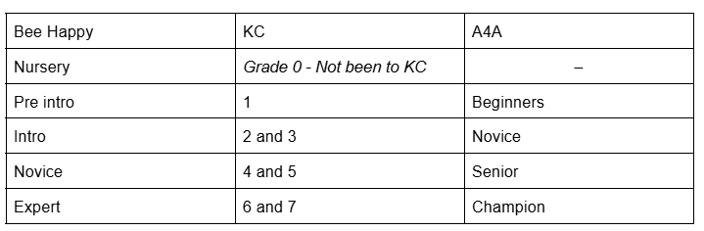

For the winter series Bee Happy IDA will be combining the Novice and Expert grades until numbers increase in each grade.

Veterans

Veterans will run the nursery course which will not have weaves or seesaw and will have lowered contact equipment. Veterans will be awarded separately into two categories which are split by age. Veterans 7 to 10 years and Veterans 10+ years. To enter as a Veteran, you will need to select which Veteran category your dog is in at the height selection part of the entry form.

Heights Conversion and Jump Heights
Bee Happy will use the KC cut off heights for dogs entering. However, dogs with A4A measurements have the option to submit their exact height in order to be placed in the most suitable category. You may also compete with your dog in the height one level lower to your dog's official measure. The following table shows the height cut off and the jump heights they can compete in.
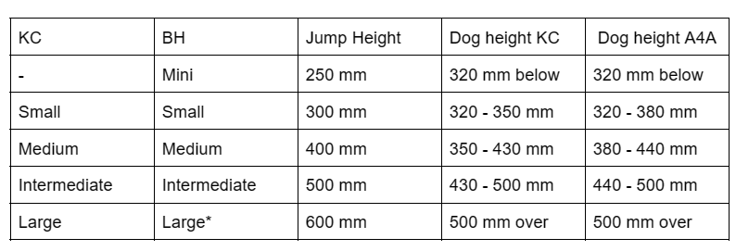
*If your dog has measured Large and is over 25kg you can select intermediate for their measure.

!!! If your dog has not been measured prior to the show then this will take place on the day before 9am. On your arrival please locate Sian. Currently will be the one wearing the air cast boot.

Classes:
Jumping (morning)
Triple A (morning) explanation of class can be found here
Steeplechase (afternoon)
Agility 2 (afternoon).

Prizes: Rosettes will be rewarded to first and second place in each grade and height catagories. If your dog is the only one in the grade and height entered into a class, they must run a clear round in order to be placed as 1st.

Clear round rosettes available.

Steeplechase: The Steeple Chase class at every Bee Happy show will be the same course for every grade and height. The running order will be done in order of heights no matter the grade starting with mini.

Each grade and height will be awarded separately.

Equipment:
- Jaycee Aluminium contact equipment
- Dog agility Thing jumps
- Performance Long Jump and Wall
- Jaycee break away tyre
- Naylor tunnels.

Rules for Agility Shows
Safety and welfare for your dogs whilst at any events organised by Pinkfox Dog training is our priority. A lot of our terms and conditions are in place for that very reason. Please read through them; by clicking the box on the entry forms you are agreeing to them. It is our focus that everyone who attends Pink fox or Bee Happy events have the opportunity to gain whatever experience from our shows they want.

- Our aim is to provide an event for those starting out on their competition journey with their dog or for new to competition dogs with an experienced handler. With this, our first priority is to the welfare of any dogs entered into any of our shows and if a member of our team has any concerns they have an obligation to raise them with the show organizers, Pinkfox dog training, who will act accordingly. If you as a competitor have any concerns over a dog’s welfare we ask you to raise them in a timely manner to the show manager who will deal with the matter.
- Our shows are designed to bring in new competitors into dog agility so we ask that anyone entering into our shows respects and supports their fellow competitors. No one's journey or experiences in Dog agility is exactly the same to someone else's therefore we would like to ask you to be considerate and helpful where possible. If you are found to be disrespecting someone else at our show you may be asked to leave. We all were beginners once.
- By entering a dog into a Bee Happy show we will expect that you have trained them to safely use the agility equipment that is provided by the organizers. This includes jumps, a wall jump, a long jump, tyre, A frame, dog walk and tunnels. Seesaw and weaves will not be in Nursery , Veterans or Anysize classes. Pre intro, Intro, Novice and Expert will have weaves and Seesaw. Nursery, Anysize and Veterans run the same course and have lowered a frame and dog walk.
- Any points gained whilst running at Anysize for a show, will not count towards progression or any leagues they may be in.
- All persons entering this show do so at their own risk. Whilst every care will be taken, Bee Happy IDA and the owners of the showground will not accept any responsibility for loss, damage or injury caused to persons, dogs or property.
- Training in the ring is permitted and you will be given the course time which is one minute. If you are planning on using your run as training you will need to let the Scrime know you are running not for competition (NFC) prior to your run. You are then welcome to use a toy to reward whilst in the ring or none crumbly, highly visible, large treats.
- Judges' decisions are final and no person is permitted to challenge a Judge either in person or on social media. If you have any concerns please report the incident to the show manager on the day.
- Nursery classes you are welcome to run with a silent toy in your hand.
- If you have any comments about how the event is run or any of the procedures at our show please raise your concerns officially in an email to the show organizers at Pinkfox dog training. You are not permitted however to post a complaint or negative opinions about the show or any persons running or attending the show on any public group or page on any social media platform. If you are found to be doing so, you will not be welcome at any future Bee Happy shows and any event organized by Pinkfox dog training. We will not hesitate to take matters further if required.
- Competitive runs, a handler is not permitted to carry a toy or food in their hands whilst in the ring and whilst under examination of the Judge except for Nursery, you are welcome to run with a silent toy in your hand.
- Please ensure you reward your dog outside of the ring when you have completed your competitive run.
- Dogs are to wear flat collars only when in the ring. It is law that when your dog is in a public place they are to wear identity tags. These will need to be a flat tag that lays flush along your dog's collar for being in the ring or their details can be embroiled directly onto their collar. Nothing is to be dangling off a dog's collar whilst in the ring.
- A dog is not permitted to wear any apparel eg coat, jumper, harness or headcollar whilst in the ring.
- No harsh handling will be tolerated. Any persons doing so could face a lifetime ban from entering any future Bee Happy shows or any events organized by Pinkfox dog training, You will also be reported to the relevant authorities.
- No prong collars, retractable leads, e collars, vibrating collars or choke chains are permitted at any Bee Happy show or any events organised by Pinkfox dog training. If you are found to be using any of the above whilst attending any of our shows you will be asked to leave and could face a lifetime ban from any of our events.
- Each dog entered will be given a running order number. It is your responsibility to enter the queue as close to your order number as possible. There will be 5 max in a queue at any one time. For example, there are 20 dogs entered in a class and your dog has a running order number 19. You will be expected to run your dog towards the end of the class. If you book into a class too early you will be asked to return at a more appropriate time. If you have a just cause to run out of order please speak with the ring party whilst course walking for that class is occurring and before the class has started to agree when to book in.
- Bee Happy grades are independent of any progression within KC or A4A. Progression will only occur at the end of either the Summer season or Winter season. However, if you have gone up by 2 grades at a KC show within 1 season you can write to Kelly@pinkfox.co to request 1 grade progression at Bee Happy IDA.
- Parking marshals will be available to monitor the parking area; however, they will not be held responsible for any loss or damage to your property that may occur.
- No squeaky toys around the ring
- You must clear up after your dog and use the bins provided.
- Dogs are to be on lead at all times unless in the ring or exercise area. This includes around the car park.
- If you encounter a dog on a leash while yours is off-leash, do not allow your dog to approach the other dog.
- Dogs between 15 and 18 months may enter at Nursery only with the provision that they run at one height lower than their official measure. From 18 months, normal Bee Happy rules apply.
- Judges may run their own dogs for competition when they are not scheduled to judge.
- In the unlikely event the show has to be canceled Bee Happy IDA reserves the right to defer expenses incurred by deducting such expenses from the entry fee received.
- Bitches in season may compete and regardless of their running order they are to run at the end of the class. Please notify the ring party if your bitch is in season for each class you have entered. Handlers must provide their own mat from which they will start from.
- Marking of faults will be as per Kennel Club rules. Any variation to standard classes will be given by the judge in their briefing.
- There will be no refunds except in the event of item 25.
- Closing date 10 days before each show date unless numbers are reached. Please check entry fees as over-payments will go to charity and underpayments will be chased.
- Once you have received your running orders it is your responsibility to ensure everything is correct. Please report any amendments to the show Secretary before 4 days of the planned show.
- No ball flingers at the show.

