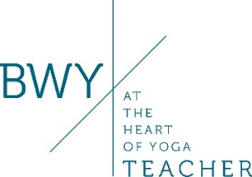 BWYQ Level 4 Certificate in Teaching Yoga
Introductory Session – Sunday 17th July 2022
Time - 10am- 2pm
Session Fee - £30

Course Tutor - Carolyn Clarke BWY Dip: DCT

Course Venue – Jasmine Trust Yoga, Babworth Court, Babworth, Retford, Notts DN22 8EW

Contact details – Tel: 07561 107660 Email: carolynclarkeq@gmail.com

During the session, Carolyn will outline the following:
- Aims and Intended learning outcomes for the BWYQ Level 4 Certificate in Teaching Yoga.
- Dates and times of tutorials including short Zoom tutorials at times to consolidate learning.
- Information delivery of subject matter to be developed throughout the course.
- Progression in learning and teaching.
- Discussion around Tutor and Student expectations including participant suitability, practice and home study including assignment completion and commencing teaching to the general public.
- BWY Membership, Course Fees, Tuition Fees plus payment time scales.
- Time for questions and answers.

There will also be time for a short physical practice session.

I have attached further information to your email, along with this booking form.
It is also available on www.jasminetrust.co.uk where you will also find the link for payment of the session fee.

I look forward to seeing you and offering a new step on your yoga journey – that of becoming an inspiring, safe and confident yoga teacher.

Carolyn Clarke
The Jasmine Trust

I would like to book a place on the BWYQ Level 4 Certificate in Teaching Yoga Introductory session

Phone:
Email:

Please write a short passage about why you would like to train to become a yoga teacher:

If there is anything else you wish to mention in confidence, please add it here:

Name:

