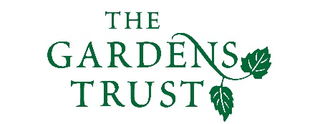

Online Winter Lecture Series 2020/21 organised jointly by The Gardens Trust and The London Gardens Trust
Monday, 5 October 2020, 6-7pm

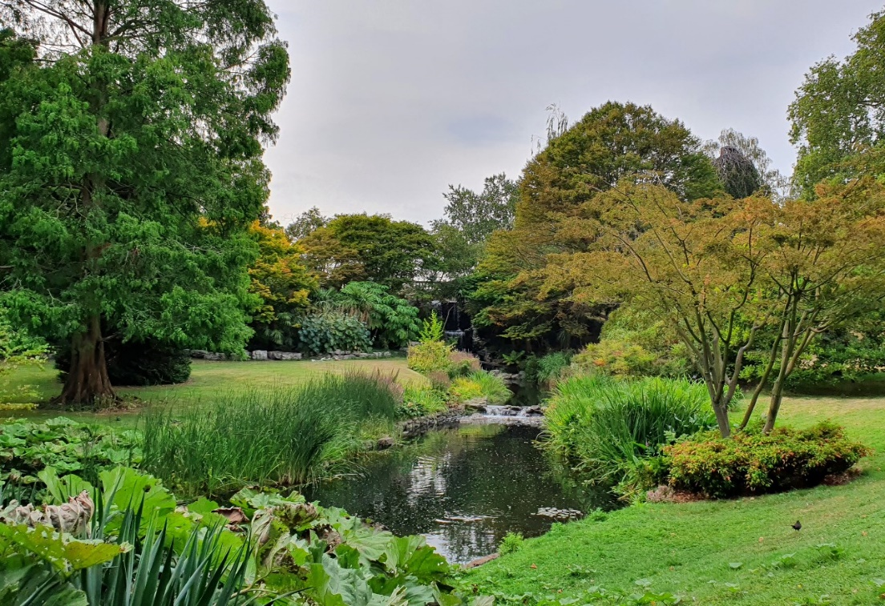

Hyde Park: A History of Trees
Greg Packman, Senior Tree Inspector, London Borough of Islington and former Tree Officer,
Royal Parks

Hyde Park is one of London’s oldest and arguably Britain’s most famous park. It has a long and varied history that has seen continual change and evolution in its landscape and use. From the site of a monastery to royal hunting ground and from private royal grounds to one of the first public parks for the upper classes; some of the most significant moments in British cultural and societal history have involved Hyde Park. Through the centuries of change, the trees have evolved with the landscape and are a key part of its history. Join us for a different historical perspective on one of London’s finest and most famous public parks.

All lectures and booking online. Tickets: £4 for Gardens Trust/London Gardens Trust/all County Gardens Trusts members, £6 for non-members; season tickets £40/£60 via The Gardens Trust http://thegardenstrust.org or London Gardens Trust https://londongardenstrust.org/

