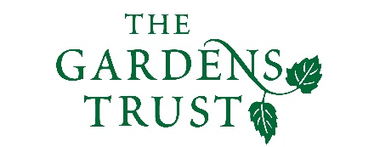

Online Winter Lecture Series 2020/21 organised jointly by The Gardens Trust and The London Gardens Trust
Monday, 2 November 2020, 6-7pm

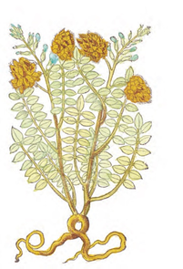

The use of plants in the home in the 17th century
Margaret Willes, publisher and author

Margaret will talk about the use of plants in the home in the 17th century, the subject of her recent book, The Domestic Herbal, published by the Bodleian Library.
Plants were employed in every room of the house in the seventeenth century, not just for the purposes of decoration, but for flavouring food, brewing and distilling, scenting rooms, washing linen, dyeing cloth, warding off pests and caring for the sick. Even the most elaborate and fashionable gardens had areas set aside for growing herbs, fruit, vegetables and flowers for domestic use, while those of more modest establishments were critical to the survival of the household. It was also a time of exciting introduction of plants from overseas.

All lectures and booking online. Tickets: £4 for Gardens Trust/London Gardens Trust/all County Gardens Trusts members, £6 for non-members; season tickets £40/£60 via The Gardens Trust http://thegardenstrust.org or London Gardens Trust https://londongardenstrust.org/

