Online Winter Lecture Series 2020/21 organised jointly by The Gardens Trust and The London Gardens Trust
Monday, 16 November 2020, 6-7pm

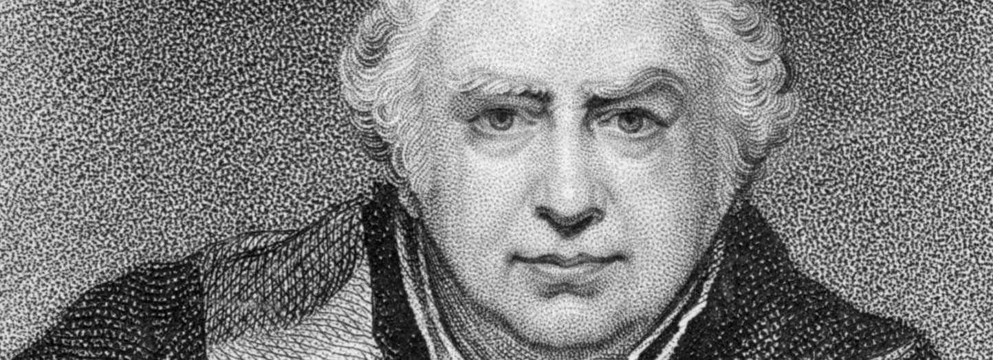
“To promote his Majesties purpose”: Joseph Banks and his Global Botanical Projects, 1770-1820
A lecture to celebrate the bicentenary of the death of Joseph Banks by Professor Jordan Goodman, Honorary Research Associate, Department of Science and Technology Studies, University College London

Not long after returning from the circumnavigation of HMS Endeavour in 1771, Joseph Banks met George III at St. James’s to discuss the results of this remarkable scientific voyage to the Pacific. It was the beginning of a very long friendship which lasted for more than forty years and which Banks used to help make the royal gardens at Kew the finest of their kind. Whenever an opportunity arose to influence a particular expedition, Banks, who was extremely well-connected, tailored it in many different ways to bring living plants from all over the world to Kew. My talk will tell the story of several of these most challenging projects.

Jordan Goodman's book, Planting the World – Joseph Banks and his Collectors: An Adventurous History of Botany (William Collins, £25) was published earlier this year.

All lectures and booking online. Tickets: £4 for Gardens Trust/London Gardens Trust/all County Gardens Trusts members, £6 for non-members; season tickets £40/£60 via The Gardens Trust http://thegardenstrust.org or London Gardens Trust https://londongardenstrust.org/

