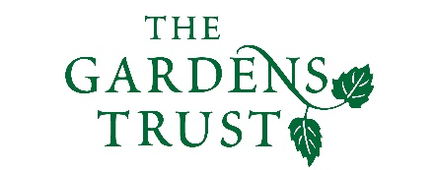
Online Winter Lecture Series 2020/21 organised jointly by The Gardens Trust and The London Gardens Trust
Monday, 22 February 2021, 6-7pm

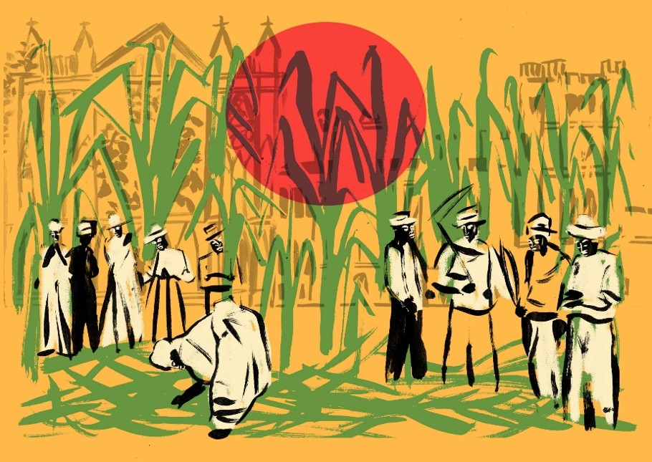

Transatlantic Slavery’s Long Reach: The impacts of direct and indirect slavery connections on eighteenth century estate gardens and parks in Britain

Dr Susanne Seymour, Associate Professor in the School of Geography and Deputy Director of the Institute for the Study of Slavery, University of Nottingham

There is increasing evidence of a wide and deep connection of Britain and its people to transatlantic slavery which reaches beyond the port cities. This presentation introduces the range of direct and indirect economic, social, political and cultural impacts of slavery connections on landed estates before examining examples of eighteenth century garden and parkland design from my own research. These include Moccas Park and estate, Herefordshire, developed by Sir George Cornewall who was directly involved in slavery as owner of La Taste plantation, Grenada, and its enslaved African population. Two other Nottinghamshire examples illustrate the impacts of less direct involvement in slavery, at Welbeck Park and gardens owned by leading Whig politician, the 3rd Duke of Portland, and Thoresby Park owned by Sir Charles Pierrepont, veteran of the Royal Navy.

All lectures and booking online. Tickets: £4 for Gardens Trust/London Gardens Trust/all County Gardens Trusts members, £6 for non-members; season tickets £40/£60 via The Gardens Trust http://thegardenstrust.org or London Gardens Trust https://londongardenstrust.org/

