Online Winter Lecture Series 2020/21 organised jointly by The Gardens Trust and The London Gardens Trust
Monday, 19 October 2020, 6-7pm

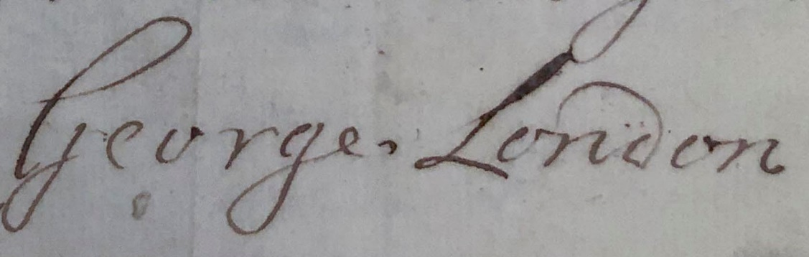
George London and the Brompton Park Nursery, 1681-1714
Dr Sally Jeffery, Garden and Architectural Historian

George London’s is probably one of the best-known names in the history of gardens and gardening in reigns of William & Mary and Queen Anne. He is particularly famous as co-founder in 1681 of the successful nursery at Brompton Park, London, which developed into the most important horticultural business of its time. Eight years after its foundation, three of the original four partners had gone and London was joined by Henry Wise. The two remained in partnership until 1714 when London died. Wise lived and worked at the nursery arranging the despatch of trees and plants of all kinds, while London travelled 50 or 60 miles a day (according to an account of 1715) to give advice on ‘most of the Noblemens and Gentlemens Gardens in England’. This talk will explore the origins of the nursery, the way London and Wise organised their work, and some of the gardens both large and small which they designed and supplied with plants.

All lectures and booking online. Tickets: £4 for Gardens Trust/London Gardens Trust/all County Gardens Trusts members, £6 for non-members; season tickets £40/£60 via The Gardens Trust http://thegardenstrust.org or London Gardens Trust https://londongardenstrust.org/

