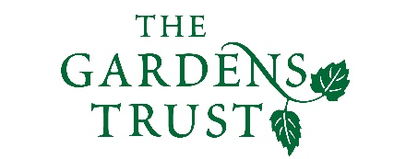

Online Winter Lecture Series 2020/21 organised jointly by The Gardens Trust and The London Gardens Trust
Monday, 14 December 2020, 6-7pm

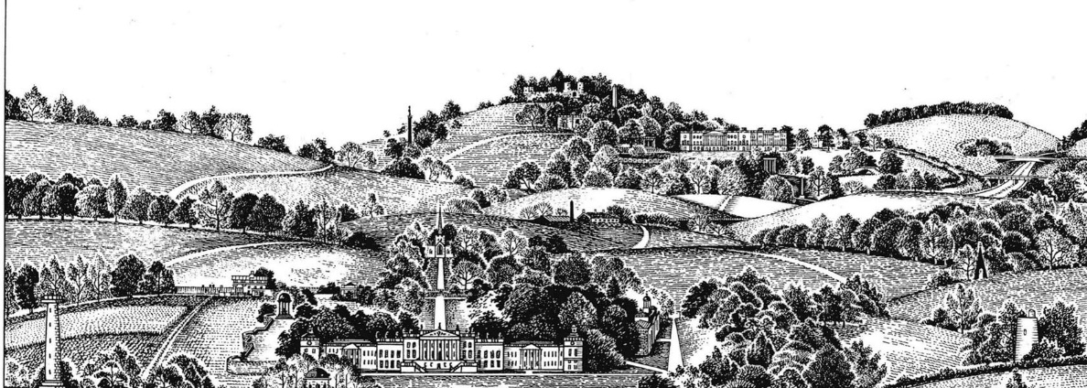

Wentworth Castle and Wentworth Woodhouse: Georgian rivals united through 21st-century restoration and public access.
Dr Patrick Eyres, Editor of the New Arcadian Journal

The family rivalry was both dynastic and political. Until the mid-1740s, the Wentworth Castle dynasty was superior in aristocratic rank and cultural display. It was once the Hanoverian monarchy was securely embedded, that the Whigs at Wentworth Woodhouse began to eclipse their Tory cousins in social status and estate embellishment. We are fortunate that the rivals are being united by the endeavours of charitable trusts to conserve as a public amenity this magnificent legacy of competitive country house building and landscape gardening.

For over a decade, the Wentworth Castle Heritage Trust restored the splendour of the mansion, estate buildings, gardens, park and monuments, and the future of Wentworth Castle Gardens is now secure in the care of the National Trust. At Wentworth Woodhouse, the Fitzwilliam Wentworth Amenity Trust has restored the Georgian fabric of the landscape monuments and the four serpentine lakes, while the Wentworth Woodhouse Preservation Trust is undertaking the Herculean task of re-roofing the gargantuan Palladian mansion.

All lectures and booking online. Tickets: £4 for Gardens Trust/London Gardens Trust/all County Gardens Trusts members, £6 for non-members; season tickets £40/£60 via The Gardens Trust http://thegardenstrust.org or London Gardens Trust https://londongardenstrust.org/

