Online Winter Lecture Series 2020/21 organised jointly by The Gardens Trust and The London Gardens Trust
Monday, 8th February 2021, 6-7pm

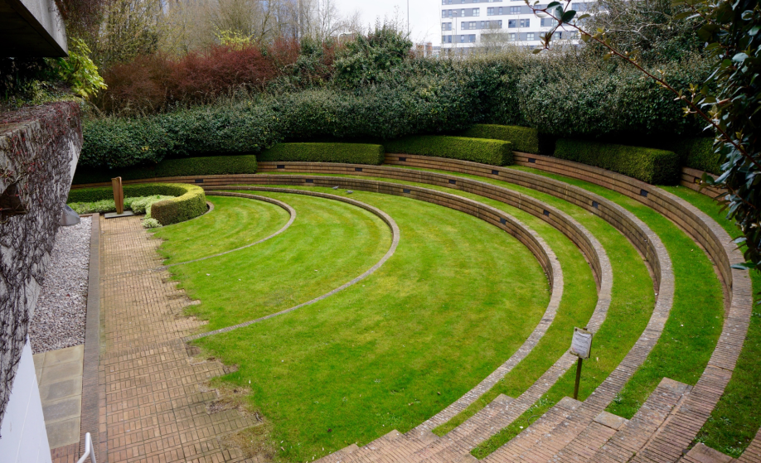

Too Young to be Loved? Post-war designed landscapes of London and environs

Karen Fitzsimon CMLI – landscape architect and garden historian

While the heritage value of post-war architecture is growing in appreciation, that of its designed landscapes is less understood. Despite Historic England’s addition of 24 sites from this period to the National Heritage List for England by last summer, built works from these decades are disappearing at an alarming rate, and very few are protected. From public gardens to commercial landscapes, and everything in between, this illustrated talk will consider some of the amazing sites already protected and others that might merit our consideration.
Karen Fitzsimon has worked with the Gardens Trust on compiling the Record and is currently undertaking PhD research about Preben Jakobsen at School of Architecture and Cities, University of Westminster.
All lectures and booking online. Tickets: £4 for Gardens Trust/London Gardens Trust/all County Gardens Trusts members, £6 for non-members; season tickets £40/£60 via The Gardens Trust http://thegardenstrust.org or London Gardens Trust https://londongardenstrust.org/

