Online Winter Lecture Series 2020/21 organised jointly by The Gardens Trust and The London Gardens Trust
Monday, 25 January 2021, 6-7pm

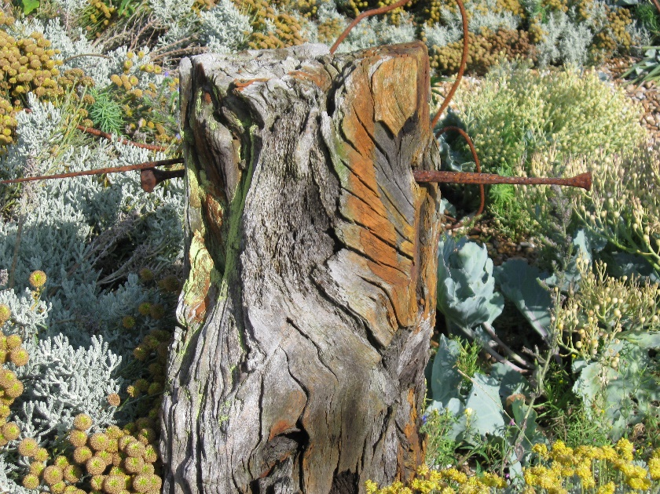

The Integration of Derek Jarman’s Garden
Professor Michael Charlesworth, University of Texas

Dungeness, Kent, presents a strange landscape that contains at least one strange garden. How can we comprehend the place and make sense of the garden? This talk will emphasize the way in which Derek Jarman's garden at Prospect Cottage was for him an act of integration: of his past with his present, his works in other media (painting and film) with making the garden; and of his new home with the territory around it, and even the past of that territory. All the while the garden set him towards a future, which was, however, tragically curtailed. The garden has therefore been quite rightly described as "a tribute to Jarman's defiant spirit".

All lectures and booking online. Tickets: £4 for Gardens Trust/London Gardens Trust/all County Gardens Trusts members, £6 for non-members; season tickets £40/£60 via The Gardens Trust http://thegardenstrust.org or London Gardens Trust: https://bookwhen.com/londongardenstrust#focus=ev-s7y7-20210125180000

