Online Winter Lecture Series 2020/21 organised jointly by The Gardens Trust and The London Gardens Trust
Monday, 30th November 2020, 6-7pm
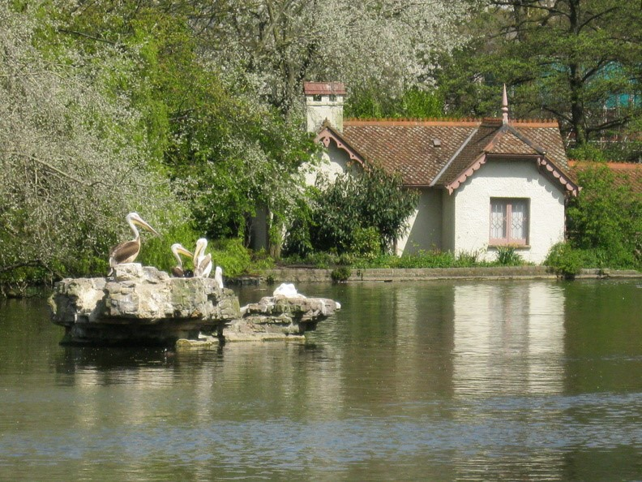

Pulhamite in London 1820-2020: How one man's rocky creation became the fashionable garden feature of the Victorian and Edwardian eras

Valerie Christman –The Pulham Legacy and direct descendant of the Pulham family

James Pulham moved to London in 1824 and in 1827 started a business that would be passed from father to son for four generations and all called James. Spanning a period of approximately one hundred years, the four James and their brothers would become one of the most famous landscaping families of the Victorian and Edwardian eras.
During their time the Pulhams created and constructed various gardens, grottoes, ferneries and terracotta work throughout London, from the roof gardens at Selfridges to the rear gardens at Buckingham Palace, from the colonnade at the Victoria and Albert museum to the rock features at Regents Park, London Zoo and the waterfall at Battersea Park to the Pulhamite rocks beside Duck Island Cottage in St James's Park.
This talk will take you through some of their work in London, we will discover the mysterious Pulhamite recipe for the artificial rock that the Pulhams were renowned for. The talk will also cover how after one hundred years many of the gardens have fallen into a sad state of disrepair, and how if possible careful restoration can be carried out.

All lectures and booking online. Tickets: £4 for Gardens Trust/London Gardens Trust/all County Gardens Trusts members, £6 for non-members; season tickets £40/£60 via The Gardens Trust http://thegardenstrust.org or London Gardens Trust https://londongardenstrust.org/

