Charnwood Lodge Directions

Nearest Postcode (this does not take you directly to Charnwood Lodge): LE67 4UA
The marker below is on the parking location. This is located up a track off Abbey Road.

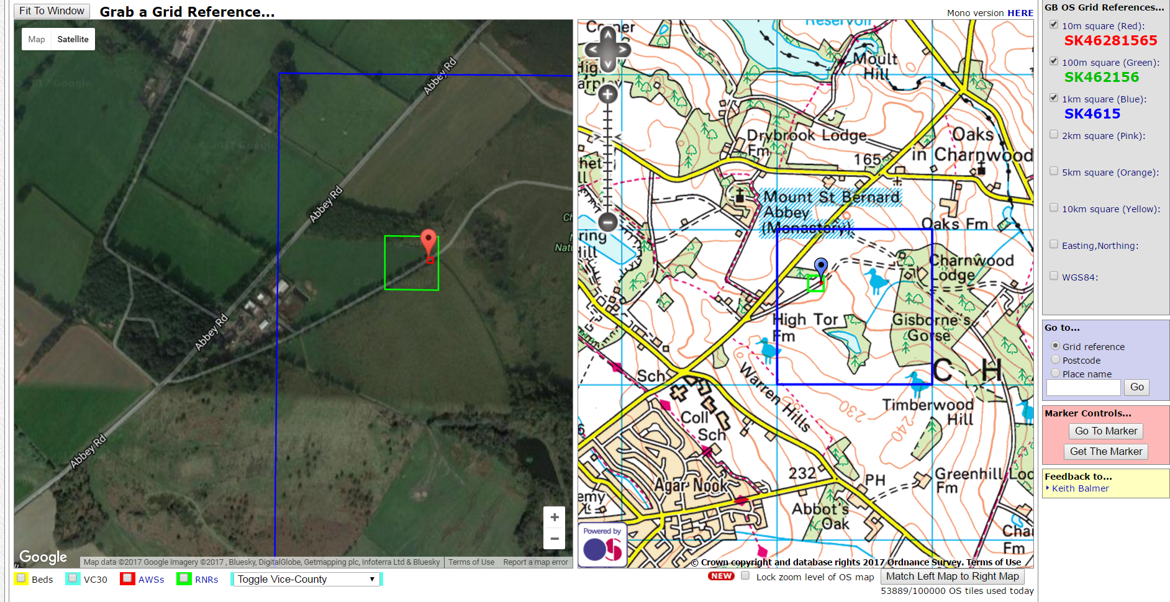

The map below shows the general location:

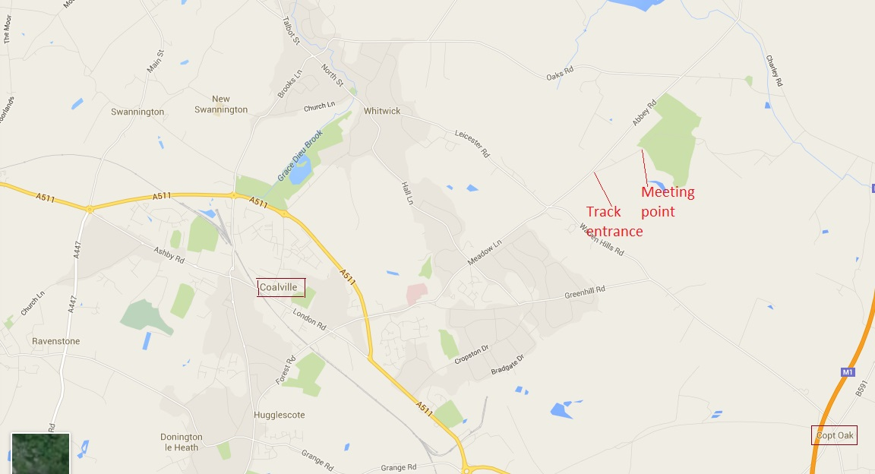

As you approach Charnwood Lodge from Abbey Road, the following photos show what the track looks like when approaching from either direction.

Below is what the entrance to the track (on right) looks like when you approach from Coalville / Leicester / Copt Oak (South):

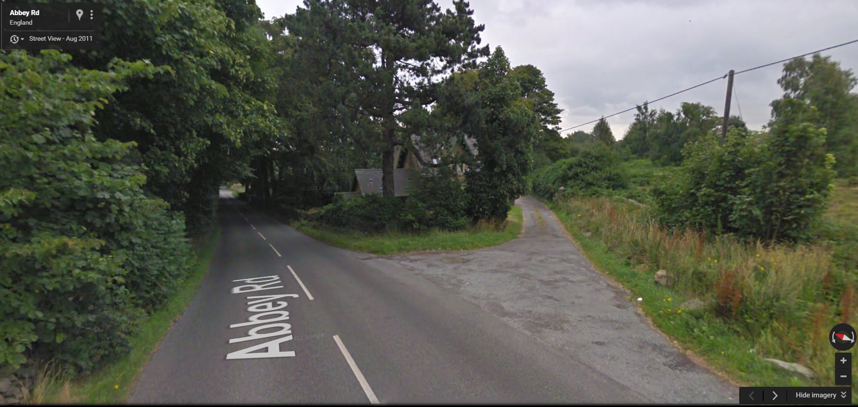

Below is what the entrance to the track (on left) looks like when you approach from Shepshed / Loughborough / Oaks in Charnwood (North):

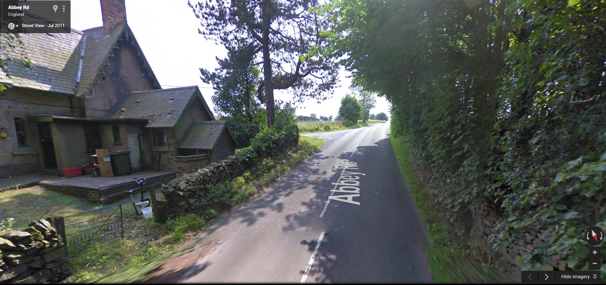

Once you turn onto the track, you will need to go through a silver-coloured gate, lift the chain to open and make sure the gate is shut and chain returned once you have driven through. Follow the track to another gate with an information board to the right of it and you can park on the right – leave space for turning near the gate. We will then walk to the buildings from the parking area – this will take about 10 minutes.

