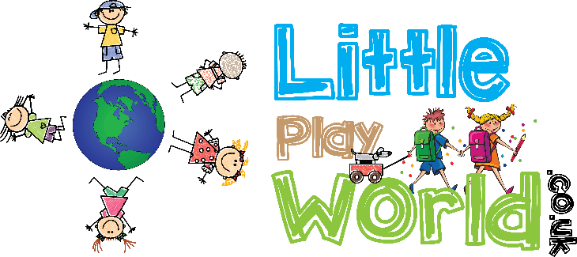

**Terms and Conditions**

Little Play World aims to provide high quality play sessions for all our customers. We are committed to the safety of all people that attend and deliver a high standard of service.

1. Participating in Little Play Word is entirely at your own risk, parents/ carers are solely responsible for their child/ children at all times. Little Play World staff are present during sessions to enhance the play session; however, they are not responsible for the supervision and behaviour of the children.
2. Payment is through our online paying system unless it has been stated otherwise, that a ticket can be purchased at the session. All children playing at Little Play World must have purchased a ticket; this will entitle them to a 90-minute session. However, the session will be start and finish at the time stated, the 90 minutes does not start at the time of arrival.
3. No refunds will be given for tickets purchased online; however, tickets can be transferred to another session if more than 24 hours’ notice is given.
4. Any child or adult causing wilful damage to equipment, facilities, fixture or fittings will be liable to pay for any damage caused.
5. Little Play World has the right to a person to leave should they pose a danger or threat to staff. Fighting, bullying, abusive language or illegal activity of any kind will not be tolerated and persons will bae asked to leave without a refund.
6. To prevent the spread of infection children who are unwell, or have been unwell must not attend Little Play World within 48 hours. Our refund policy applies.
7. If a child or adult becomes sick or infectious at Little Play World they will be politely asked to leave the session.
8. The privacy of other children / adults must be respected. Photographs can be taken of their children for personal, private and non-commercial purposes only, unless permission has been expressly granted by Little Play World pictures and images cannot be reproduced in any format or media purposes.
9. Little Play World only shares photographs on or at of children playing on social media or promotional material with prior written consent form parents/ carers.