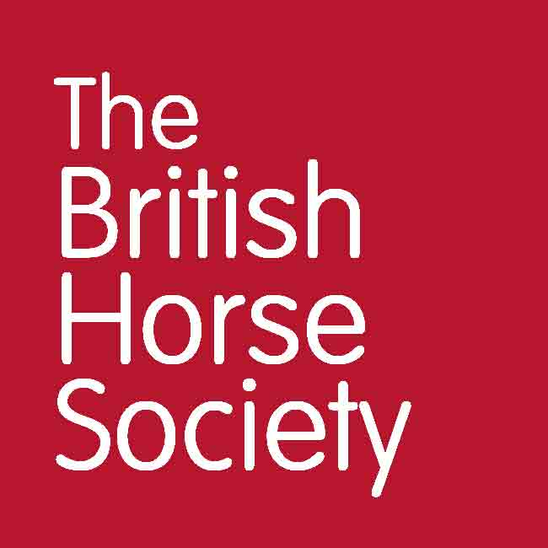

BHS Terms and Conditions Ride Safe Training for Trainers

General
• Online entries only, no cash will be taken on the day.
• Please report to the organiser on arrival.
• Always follow the instructions of marshals and officials.
• You will be asked to provide emergency contact details at the point of booking.
• Everyone attending the event is responsible for ensuring the safety of themselves and others.
• The BHS, or the training venue, cannot provide supervision for attendees under the age of 18. It is a recommendation that
any attendee below the age of 16 years should be accompanied by a responsible adult who remains at the venue for the
duration of the course or event. For attendees aged 16-17, or an adult at risk, it is at the discretion of their parent or
guardian.
• We may use photos, video, and information about you on BHS social media, website or magazines. You have the right to
withdraw your consent at any time by emailing dataprotection@bhs.org.uk.
• For more details about how your personal data is used please take a look at our Privacy page: www.bhs.org.uk/privacy or
contact dataprotection@bhs.org.uk.
• Dogs are NOT permitted unless they are an essential support dog.

Cancellations and Refunds
• All British Horse Society events are checked for viability around ten working days beforehand. Any that have insufficient
numbers may be cancelled. In this case, delegates who have booked will receive a full refund or free transfer should
another suitable event be pending.
• Cancellations can be made via email to lisa.supple@bhs.org.uk.
• A refund, less a £5 administration fee will be given to anyone who cancels up to 10 days before the event.
• Cancellations made within 10 days of the event will only be refunded if the place can be filled from any waiting list we may
hold, and this will be subject to a £5 administration fee.
• Strictly no refunds for anyone who has booked and does not attend.

www.bhs.org.uk
www.facebook.com/TheBritishHorseSociety
www.twitter.com/britishhorse (@BritishHorse)

Disclaimer
The organisers have taken reasonable precautions to ensure the health and safety of everyone present. For these measures to be effective, everyone must take
reasonable precautions to avoid and prevent accidents.
The British Horse Society is a Registered Charity Nos. 210504 and SC038516B
www.bhs.org.uk
www.facebook.com/TheBritishHorseSociety
www.twitter.com/britishhorse (@BritishHorse)
Disclaimer
The organisers have taken reasonable precautions to ensure the health and safety of everyone present. For these measures to be effective, everyone must take reasonable precautions to avoid and prevent accidents. Neither the organisers nor the British Horse Society accept responsibility for any accident, injury, loss or illness to horse, rider, spectator or property whilst at this event.

The British Horse Society is a Registered Charity Nos. 210504 and SC038516

