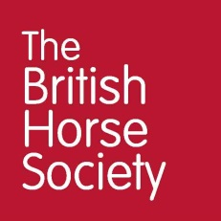
Dressage Training with Adam Kemp FBHS
Demo horse/rider application form
Thank you for your interest in being a demonstration rider for our BHS Training day on Monday 17 October. The day will be structured around Dressage and will be presented by Adam Kemp FBHS. It will take place at Badgeworth Arena, Somerset, BS26 2QU
Please complete the details below and return this form to bhssouthwest@bhs.org.uk or post to Julie Garbutt, Quarry Lodge, Leighton, Frome, BA11 4PN.
__________________________________________________________________________________
We want you to be able to be a part of the whole day as much as possible. Please indicate whether you would like a stable for your horse so that you can watch the other sessions.
I would like the use of a stable ☐ I do not require the use of a stable ☐

Rider Information:
Name:

Contact No:

Email:

Biography:
(please tell us a bit about yourself and your riding experience, level, qualifications, strengths, weaknesses etc.)

Horse Information:
Name:
Age:
Height:
Breed (if known):
Is your horse up to date with annual Flu Vaccinations?
Biography:
(please tell us a bit about your horse, name, experience, level, competition record, strengths, weaknesses etc.)

Photograph:
(please insert a photograph/s of you and your horse)

