BHS Terms and Conditions
CPD Day - Jumping the smart way with Jayne Smart - 27.08.25
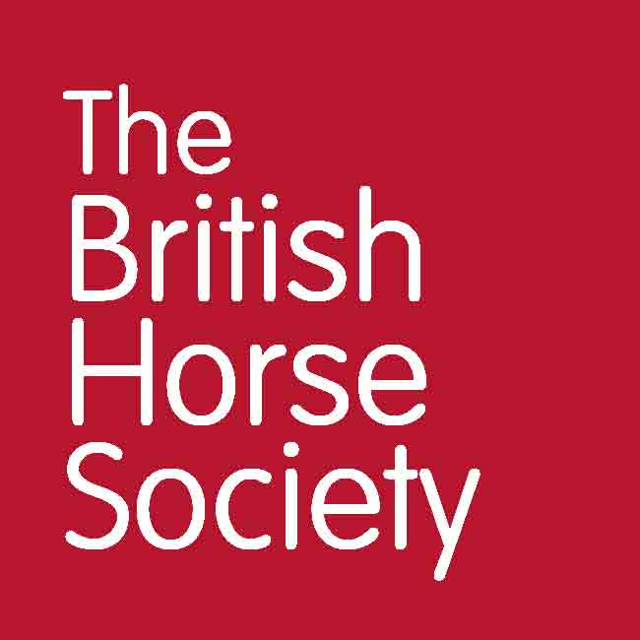
General
- Online entries only, no cash will be taken on the day.
- Please report to the organisers on arrival.
- Always follow the instructions of marshals and officials.
- Registration opens at 9.30am.
- You may be asked to provide emergency contact details, vehicle make, model and registration on arrival.
- Everyone attending the event is responsible for ensuring the safety of themselves and others.
- The BHS, or the training venue, cannot provide supervision for attendees under the age of 18. Any attendee below the age of 16 years should be accompanied by a responsible adult who remains at the venue for the duration of the course or event. For attendees aged 16-17, or an adult at risk, it is at the discretion of their parent or guardian and agreed in advance with the BHS or the training venue.
- Accompanying adults may need to pay to attend the event, this is at the discretion of the event organiser.
- We may use photos, video, and information about you on BHS social media, website or magazines. You have the right to withdraw your consent at any time by emailing dataprotection@bhs.org.uk.
- For more details about how your personal data is used please take a look at our Privacy page: www.bhs.org.uk/privacy or contact dataprotection@bhs.org.uk.
- This event is being run under the BHS Code of Conduct for Welfare of Horses at Events and Activities.
- It is the responsibility of the attendee to ensure they have joined the training in time for the start at 9.30am. CPD hours will only be allocated if the participant attends the whole event. Anyone joining the training late will not be allocated CPD hours.

Cancellations and Refunds
- The event will be checked for viability around ten working days beforehand. If there are insufficient numbers, the event may be cancelled. In this case, delegates who have booked will receive a full refund or free transfer should an alternative date be scheduled.
- If the event is cancelled by the BHS for any other reason, a full refund or free transfer will be offered to those who have booked.
- Anyone who has booked and wishes to cancel should notify this by email to lisa.supple@bhs.org.uk or phone 07821 637309.
- A refund, less a £5 admin fee will be issued to anyone who cancels up to 10 days prior to the event.
- Cancellations made with 10 days of the event will only be refunded on medical grounds. A valid medical note needs to be emailed to lisa.supple@bhs.org.uk
- Strictly no refund for anyone who has booked and does not attend

www.bhs.org.uk
www.facebook.com/TheBritishHorseSociety
www.twitter.com/britishhorse (@BritishHorse)
Disclaimer
The organisers have taken reasonable precautions to ensure the health and safety of everyone present. For these measures to be effective, everyone must take reasonable precautions to avoid and prevent accidents.

The British Horse Society is a Registered Charity Nos. 210504 and SC038516

