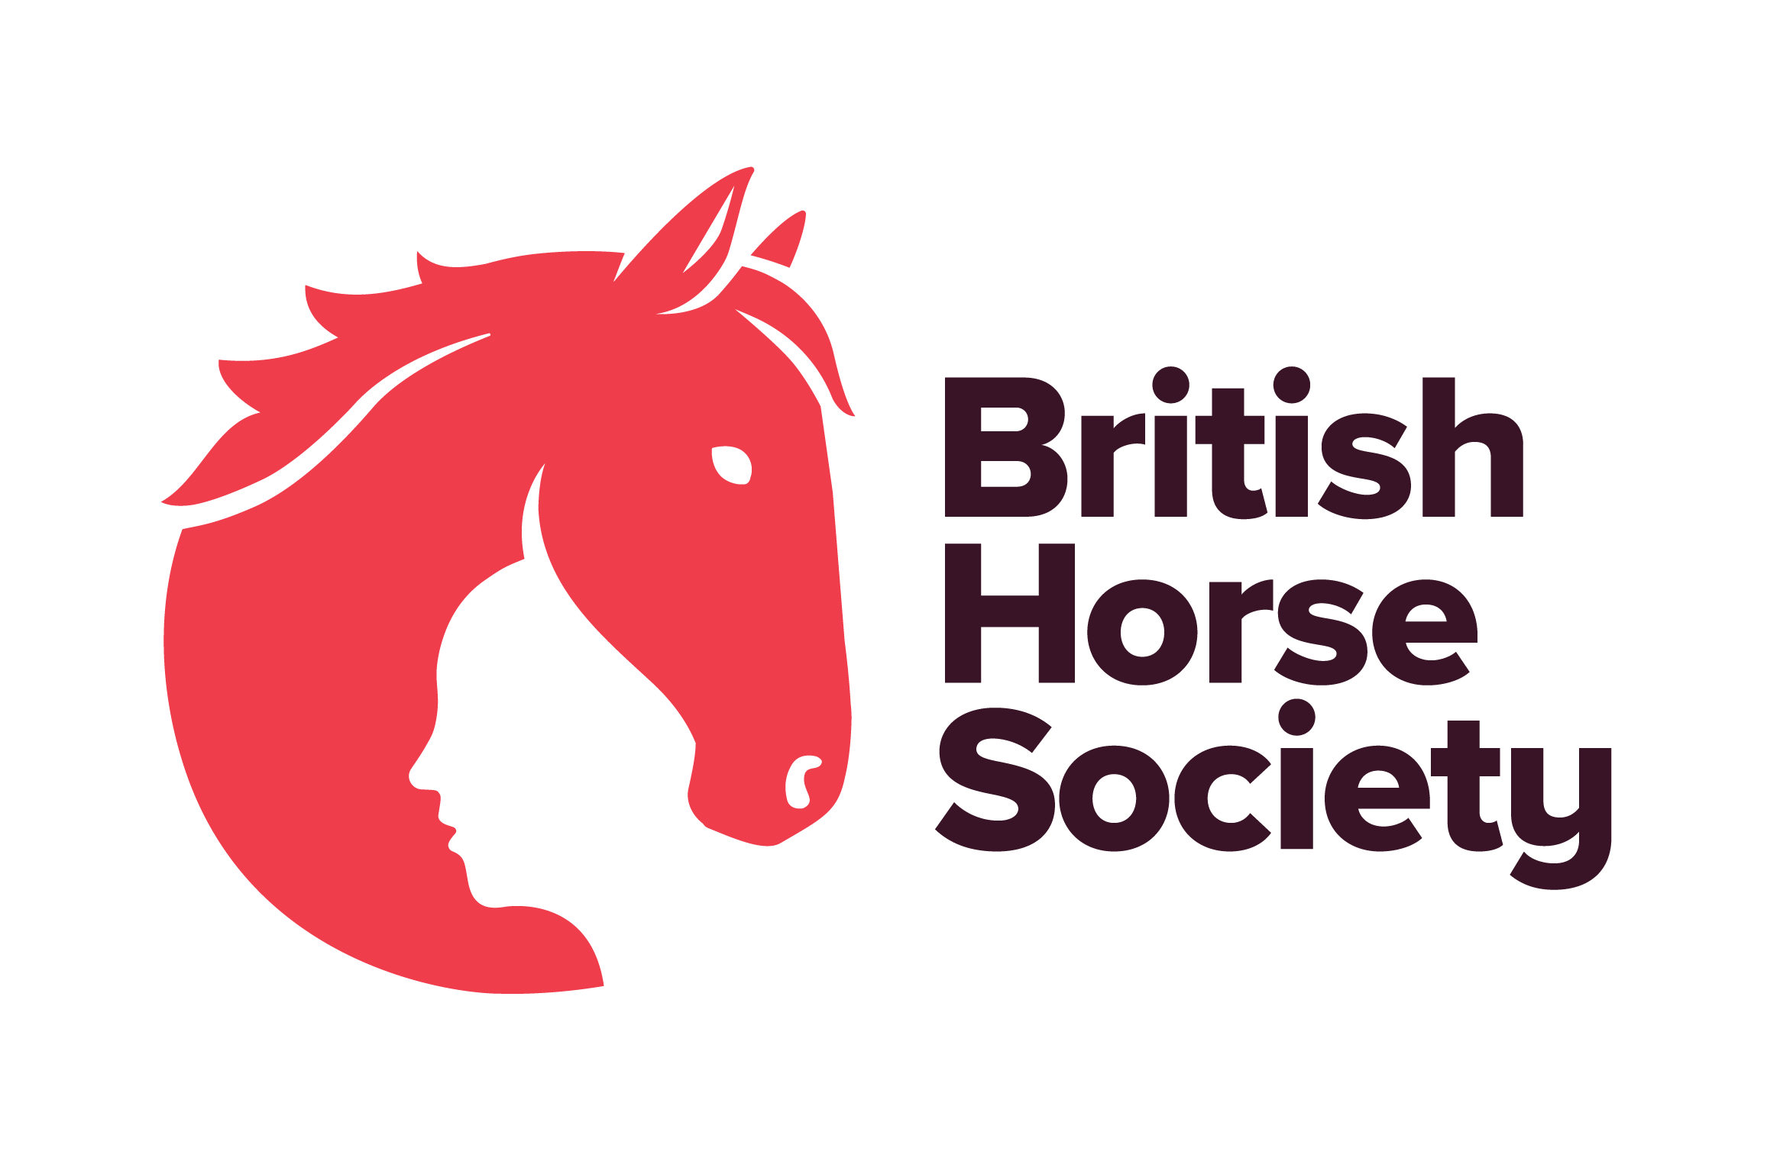

BHS Terms and Conditions

General
- Online entries only, no cash will be taken on the day.
- Tickets are non-transferable.
- Please report to the organisers on arrival.
- Always follow the instructions of marshals and officials.
- Registration opens at 12.30pm and closes at 1pm.
- Everyone attending the event is responsible for ensuring the safety of themselves and others.
- BHS, or the training venue, cannot provide supervision for attendees under the age of 18. Any attendee below the age of 16 years should be accompanied by a responsible adult who remains at the venue for the duration of the course or event. For attendees aged 16-17, or an adult at risk, it is at the discretion of their parent or guardian and agreed in advance with BHS or the training venue.
- Dogs are NOT permitted.

GDPR
- We may use photos, video, and information about you on BHS social media, website or magazines. You have the right to withdraw your consent at any time by emailing dataprotection@bhs.org.uk.
- For more details about how your personal data is used please take a look at our Privacy page: www.bhs.org.uk/privacy or contact dataprotection@bhs.org.uk.

Cancellations and Refunds

- Full payment is required at the time of booking.
- If you wish to cancel your booking, notice must be given via email to lisa.supple@bhs.org.uk.
- Cancellations made 10 days or more before the event will receive a refund, less a £5.00 administration fee.
- No refunds will be given for non-attendance
- Tickets are non-transferrable and may only be used by the person named on the booking, unless the organiser agrees in advance and all attendee details have been updated.
- The organiser accepts no responsibility for any personal expenses incurred as a result of cancellation, postponement, or changes to the event.
- If the event is cancelled by the BHS for any reason, the entry fee will be fully refunded.

www.bhs.org.uk
www.facebook.com/TheBritishHorseSociety
www.twitter.com/britishhorse (@BritishHorse)
Disclaimer
The organisers have taken reasonable precautions to ensure the health and safety of everyone present. For these measures to be effective, everyone must take reasonable precautions to avoid and prevent accidents.

The British Horse Society is a Registered Charity Nos. 210504 and SC038516

