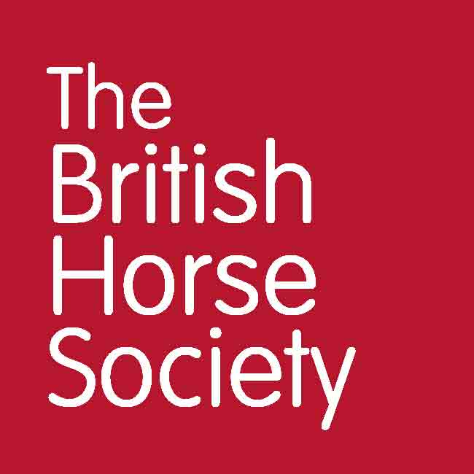

BHS Terms and Conditions

Mechanical Horse Clinics Avon 2023

**General**

* All entrants must hold third party public liability insurance either through being a Gold member of The British Horse Society or via proof from another provider.
* Online entries only, no cash will be taken on the day.
* Please report to the organisers on arrival.
* Always follow the instructions of marshals and officials.
* You will be asked to provide emergency contact details, vehicle make, model and registration on arrival.
* Everyone attending the event is responsible for ensuring the safety of themselves and others.
* The BHS, or the training venue, cannot provide supervision for attendees under the age of 18. It is a recommendation that any attendee below the age of 16 years should be accompanied by a responsible adult who remains at the venue for the duration of the course or event. For attendees aged 16-17, or an adult at risk, it is at the discretion of their parent or guardian. Accompanying adults may need to pay to attend the event, this is at the discretion of the event organiser.
* Please leave the parking area as you found it – don’t muck out your trailer or lorry in the parking area and take dung home with you.
* Dogs are NOT permitted.

**Riders**

* Riders under 16 years must be accompanied by a responsible adult for the duration of the event.
* Riders over 16 and under 18 may ride unaccompanied at the discretion of their parent or guardian.
* Hats to the current standard must always be worn and correctly secured when mounted. Please check yours meets current standards which can be found at<http://www.bhs.org.uk/headwear>
* Hats and body protectors (if you choose to wear a body protector) will not be checked. It is your responsibility that these are to the current standards. Please refer to <https://www.bhs.org.uk/advice-and-information/tack-and-equipment/what-to-wear>.
* All riders must wear suitable riding footwear. Wellington boots and trainers are not allowed.

**Cancellations**

* Strictly no refunds for anyone who has booked and does not attend.
* Cancellation can be made via email to jorawlins@googlemail.com up to 10 days prior to the event.
* A refund, less the booking fee charge, will be given to anyone who cancels up to 10 days prior to the event via email.
* If the event is cancelled by the BHS, the entry fee will be fully refunded.
* All British Horse Society events are checked for viability around ten working days beforehand. Any that have insufficient numbers may be cancelled. In this case, delegates who have booked will receive a full refund or free transfer should another suitable event be pending.

**www.bhs.org.uk**

www.facebook.com/TheBritishHorseSociety

www.twitter.com/britishhorse (@BritishHorse)

Disclaimer

The organisers have taken reasonable precautions to ensure the health and safety of everyone present. For these measures to be effective, everyone must take reasonable precautions to avoid and prevent accidents. Neither the organisers nor the British Horse Society accept responsibility for any accident, injury, loss or illness to horse, rider, spectator or property whilst at this event.

The British Horse Society is a Registered Charity Nos. 210504 and SC038516